THEME
Town Hall and University of Padova, Italy
10TH ICEVI EUROPEAN CONFERENCE
SUPPORTING CHILDREN
AND YOUNG ADULTS
WITH VISUAL IMPAIRMENT:
What can we do? What can be done?

MAY 15-17, 2025
This conference will focus on the need for a multidisciplinary approach in offering support aimed at ensuring the best quality of life for children and young adults with visual impairment

TARGET AUDIENCE
> Professionals and practitioners working with children and young adults with visual impairment

FINAL GOAL
The final goal is to provide to those professionals who wish to offer a global approach a document of key principles which will support their work with children/young adults with visual impairment and their families

CALL FOR ABSTRACTS
Submissions will be open in May 2024

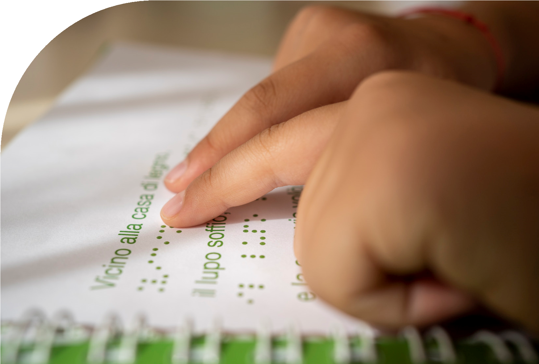
> Caregivers, parents and families
With the patronage of
>

Individual development and assessment
>

Education and learning
>

Habilitation and rehabilitation
>

Access, participation, engagement

in society
4
AREAS OF INTEREST
STAY TUNED AT
www.icevieurope2025-hollman.it
•
lc@lccongressi.com

