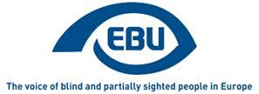

EBU Members' Newsletter 2022

Number One, January.

Croatia - Making a difference with joint efforts!
The European Blind Union promptly expressed its support to the Croatian Blind Union in advocating and fighting for the elimination of the draft provisions containing means testing for exercising the right to disability allowance for persons belonging to the fourth (most severe) degree of disability, currently regulated by the Social Welfare Act in Croatia. EBU President Cattani sent letters of support to the Croatian President, Prime Minister, and the Minister and State Secretary of the relevant Ministry of Social Policy, pointing out and explaining the articles and paragraphs of the CRPD Convention that the mentioned provisions would violate if adopted. Moreover, the letters reflected EBU’s concerns about the present and future employed blind and partially sighted people who would lose their rights to disability allowance, which, in the first place, should serve to compensate increased costs of living caused by a disability.
The Croatian Ombudsperson reacted positively to this initiative, while the Croatian President did not show a particular interest to seriously intervene. Nevertheless, the Croatian Prime Minister, Mr. Andrej Plenković, announced the elimination of the provisions related to any kind of means testing, along with an increase in the amount of disability allowance.
The President of the Croatian Blind Union, Mr. Vojin Perić, along with the CBU’s staff and blind and partially sighted members, would like to express their gratitude and appreciation for the sincere concern, honest backing and brilliantly elaborated letters of support in this matter. We are glad and proud to be part of the EBU!

OUR CAMPAIGNS

Accessibility

Books - Marrakesh Treaty
In the EU Disability Rights Strategy 2021-2027 the European Commission announced that it will “assess the availability of printed works for persons with disabilities taking account of the existing EU law” (i.e. the Marrakesh Treaty Directive). We are liaising with DG CNECT to enquire about the timing and scope of this assessment, to allow EBU to prepare a contribution.
In the meantime, we continue to gather feedback from our members in the EU about national implementing legislation and how the cross-border exchange of works is proceeding.
In wider Europe, we have mobilised our members in Albania, Montenegro and North Macedonia to push for ratification in 2022 and offered EBU help to achieve this objective.

Accessible lifts
We responded to the ANEC request for comments on draft EC standardisation request on lifts. In particular we welcome the repeated stressing of the relationship between EN 81-20 (general safety standard on passenger and goods lifts) and EN 81-70 (accessibility to lifts standard).

Accessible web
We sent to our members in Albania, Bosnia-Herzegovina Montenegro, North Macedonia, Serbia and Turkey a call for expression of interest to engage on promoting web accessibility rules at national level with the EU Directive as a role model.

Accessible payment and self-service terminals
We sent to our members in the EU a call for nominations to an EBU working group, to prepare recommendations to the EU for the implementation of the Accessibility Act as far as payment terminal are concerned, and possibly also self-service terminals.

Digital Services
The European Parliament adopted its final position on the Digital Services Act, which includes requirements for accessibility of online platforms for persons with disabilities. See detailed article with EDF’s analysis of the Parliament’s position of the DSA.

Political participation
The vote on amendments at the European Parliament’s Constitutional Affairs committee on the reform of the EU electoral law, due to take place in January, postponed sine die due to shadows not yet agreeing on some important compromises.
We were invited by EDF to comment, and did, on their draft “Human Rights Report on political participation: right to vote and stand as candidate”.

Social security and welfare
Our letters of December to Croatian authorities in support to our Croatian member organisation about means-testing for disability benefits and incompatibility with work in the draft new national Social Welfare Act, have received positive response: a letter of support from the Disability Ombudsman; an expression of interest from the President of the Republic; and more importantly, the information from the Prime Minister that the contested features of the Act were withdrawn and the amount of the disability benefits even increased. This was confirmed by our Croatian member.
We brough these issues—which are relevant in other EU countries too—at the Strategic Dialogue online meeting of 28 January on a "Council Recommendation on adequate minimum income schemes in the EU".

Mobility
On 20 January we participated in International Transport Forum’s Annual Consultation Day with International Organisations, to obtain a slot at ITF 2022 to present the PASCAL output on connected and automated vehicles. Encouraged by the initial reaction, we followed up with a more elaborated proposal to the ITF 2022 Secretariat.

Representation – European Disability Platform
After the first meeting of the Platform in December, EDF is to coordinate input from EU-level civil society organisations. It invited to suggest 6 priority topics for the three plenary meetings in 2022. We suggested the following:
- The role of public funding to promote the accessibility of culture
- Inclusion in employment
- Unblocking the horizontal Equal Treatment Directive
- Good electoral practice
- The EU Disability Card
- Disability benefits and means-testing

Review of the EU by the UN CRPD committee
All our comments and suggestions are now well reflected in the EDF alternative report.
We participated in an EDF coordination meeting on 18 January. As a result, we decided to express our interest to participate in the private meeting with the CRPD (date still to be determined, probably in the third week of March) and to address the following issues:
- Re. Articles 9 (accessibility) and 24 (education) of the CRPD – The Marrakesh Treaty Directive allows Member States to opt for giving a so-called “compensation” for rights-holders and publishers.
- Re. Art. 30 (culture) – The EU provides considerable funding to culture, namely through the Creative Europe programme, but the European Commission and the executive agency for the programme have failed so far to proactively use that leverage to promote access to culture for PWDs (looking specially at MEDIA funding to the film industry and the need for audio description and audio subtitling).
- Re. Articles 9 (accessibility) and 29 (participation in public and political life) – The Commission is increasingly using online consultations which are not adapted to VI people and there are accessibility defaults, even in surveys explicitly targeting persons with disabilities and their organisations.
In the meantime, we already had the opportunity to raise these issues in an informal meeting with the CRPD Rapporteur, on 26 January.

Continuously improving: External evaluation of EBU’s action in 2021 available
It’s good and annual practice that EBU undertakes an external evaluation of its work and functioning. Also in 2021, the external evaluator, Dominique Danau, guided EBU through that external look at what we did, what we achieved and how we worked. Many of you took the time to contribute your views to that important learning process to constantly improve EBU, and I would like to thank you for your precious input! Important recommendations result from that assessment, which you can read in the full evaluation report. The EBU leadership will take a close look at the improvements suggested by the evaluator and integrate them in the actions moving forward.
Lars Bosselmann

New EBU video on the right to culture and sport
A new awareness-raising video on the right to culture and sport for blind and partially sighted persons, according to Article 30 of the UN Convention on the Rights of Persons with Disabilities (CRPD), is now available. It’s the fifth video in the series of ten.
More information and the previous videos can be found on the project information page.
This series of videos is part of a wider European campaign coordinated by EBU and supported by the European Commission to raise awareness of blind and partially-sighted persons rights. The campaign is based on the UN CRPD and involves altogether 10 EBU member organisations.

Bosnia and Herzegovina - The Union of the blind of the Republic of Srpska has opened the “Braille Resource Center”
During 2021, with the financial support of the Government of Japan and the Ministry of Education and Culture of RS, the Braille Resource Center was established. The center is equipped with three sets of printers for Braille printing, two of which have the possibility of simultaneous printing of Braille and ink. The center is also equipped with ten Braille displays with 40 rows. Licensed software programs (Jaws, Windows, Duxbury) were also purchased.
Instructors and trainers are prepared and trained for quality handling of newly acquired equipment as well as the transfer of knowledge and skills to trainees. A quality training program has been developed and a methodology for conducting it has been established. The resource center was opened on November 12, 2021 in Banja Luka.
The first training was completed with ten participants who are fully trained to independently handle the new equipment. The center will primarily serve for training, as well as for printing services. We express our gratitude to the Government of Japan and the Ministry of Education and Culture of RS for contributing to the more successful application of Braille and new technology in our region.
The establishment of a center during the pandemic in difficult working conditions is a great success and significantly contributes to the popularization and application of Braille technology.
Branko Suzić
President of the Union of the blind of the Republic of Srpska (a branch of the Union of the Blind in Bosnia and Herzegovina)
More information about the activities of the Union on: facebook.com/SavezSlijepih

Russia - a new President for VOS
The All Russia Association of the Blind (VOS) would like to inform EBU members of the newly elected VOS President - Vladimir SIPKIN (Mr), aged 69, blind.Mr Sipkin was born in 1953 in Siberia (Ekaterinburgh), he is a radio-engineer by profession.
In 1987 - 2012 he was chairman of the Krasnoyarsk regional VOS organisation, in 1996 - 2012 director general of VOS factory in Krasnoyarsk. Mr Sipkin has been a member of VOS Central Board since 1991 and in 2012 he was elected as vice- president of VOS. It means he worked hand in hand with Alexander Neumyvakin and of course will continue to pursue his policy.
On December 15, 2021 Vladimir Sipkin was elected VOS President at the extraordinary VOS congress.
Mr Sipkin is a very active person, member of numerous commissions in Russia, awarded with many medals. He used to be a member of the EBU commission on employment, headed by Philippe Chazal, some years ago. He recollects his impressions of that period with great pleasure.

News from Union of the Blind of Montenegro (UBM)
- On the twelfth day of the Fifth Session of the Second Regular (Autumn) Session in 2021, December 29, 2021, MPs adopted the Bill of ratification the Marrakesh Treaty with 71 votes in favor.
- The UBM has accredited a program of services for support for community living and support for the visually impaired, Seeing companion, which will enable visually impaired people to socialize and become more actively involved in social life.( https://ss-cg.org/?p=2911 )
- The UBM continues its activities in the field of gender equality and accessible elections.
Through the project "Empowered towards change" which aims to strengthen the capacity of the UBM for more effective and quality dialogue, gender dimension of the EU accession process and improved accountability of government institutions, through the EU accession process.
By establishing cooperation with the OSCE and participating in the Parliamentary Committee for Comprehensive Electoral Reform, the UBM will emphasize changes in the field of independent and secret voting process for the visually impaired.

Slovakia - Join us online for the EDI conference on 22-02-2022
We love twos and zeros… joking. Anyway, on Tuesday 22-02-2022 we at the Slovak Blind and Partially Sighted Union organize the EDI conference on accessibility for people with visual impairment under the motto: Accessible Life – More Inclusive Life. It’s not only us who organize this final project conference, but also our two skilled partners: Teiresiás, Support Centre for Students with Special Needs, the Masaryk University, Brno, Czech Republic and the organization Funka, Sweden. What time? At 9:00 – 11:10 AM as we are not crazy lovers of twos and zeros!
EDI (From Education to Inclusion) is the Erasmus+ project which we have undertaken for the last two and a half years. And now at the end of this interesting project story you can join us as we would like to share with you worth experience gained during our EDI days and sometimes nights, too. So, what is waiting for us? Two hours (as we still love twos:) of an online programme dedicated to accessibility for people with visual impairment in the areas of built environment, transport, information and communication in the context of public administration.
Main topics of the conference:
We will show examples of good practice in Slovakia and other European countries.
We will discuss accessibility in your environment.
We will offer tips and tricks for people with visual impairment how to explain what you need to enjoy all your rights concerning accessibility.
We will show representatives of public administration what the advantages of being accessible are.
We will present results of our 2.5-year cooperation in the field of education of local administration staff and leaders with visual impairment in the area of accessibility for VI people and self-advocacy.
Languages of the conference are English, Slovak and Czech (Slovak/ English and vice versa interpretation will be provided). For more information on the project visit our project web page at https://www.unss.sk/edi. The programme of the conference will be released on the project webpage shortly. Should you be interested in this online event, please register as soon as possible – copy this link to your browser: https://tinyurl.com/2p8c5rrb.
Any questions? Do not hesitate to contact our two (must be) colleagues: for practical questions, please, contact sokol@unss.sk, for content-related questions, please, contact hajdukova@unss.sk. And feel free to share this invitation with whomever is concerned. But, remember, at least two people. Thank you, see you at the conference.
Stanislav Sokol, on behalf of EDI team

Scotland – Encouraging first-time voters
Four young people in Scotland are supporting a campaign to encourage more first-time voters to take part in elections, especially those like themselves who have sight loss.
All four are members of sight loss charity RNIB Scotland's 'Haggeye' youth forum and have posted short videos on its social media channel to highlight 'Welcome to Your Vote Week', which starts today [Monday, January 24th] and is being promoted by the Electoral Commission in schools throughout the country.
"As a visually impaired young person, or as any young person, I think that voting is important because we need to get our voice heard in politics," said Jordan Anderson (21), who is studying at North East Scotland College.
Sixth-year school student Rosie Murray from Motherwell said: "I'm 17 and I haven't voted yet, but I think that it's very important that people do, especially those of us who are visual impaired and blind. We don't really get as much opportunities as sighted people to get our voice heard."
Strathclyde University student Abdul Eneser said: "I think it's really important for us to vote because politics is all around us and affects our everyday life. One way to shape these decisions is to participate in democracy and vote for your local councillors in your local area. So please make sure that you do register to vote and make your voice heard."
Claire Forde (25) from Greenock, a former Member of the Scottish Youth Parliament, said: "As a seldom heard group in society, you could be making a difference, for not just yourselves but for other people's lives and more importantly, changing other people's lives. If you're 16 or over and are eligible, please think about voting. You could make a difference."
Elections for Scotland's 32 local authorities take place on Thursday, May 5th, this year.
Andy O’Neill, head of the Electoral Commission in Scotland said: “We’re delighted that RNIB Scotland’s Haggeye youth forum is supporting our 'Welcome to Your Vote Week' campaign, which is designed to raise awareness amongst young people who will be able to vote for the first time on May 5th.
"We want to ensure all young people have the information they need to cast their vote with confidence at the council elections, and a range of resources for new voters and schools are available on our website at www.electoralcommission.org.uk/learning.”
James Adams, director of RNIB Scotland, said: "Local authorities play a vital role in helping blind and partially sighted people to live as independently and inclusively as possible. It's vital that young people understand that their vote counts just as much as anyone else's, and that they do have a democratic say in how their community is served."
RNIB Scotland is launching its own manifesto, 'Local Vision', for the Scottish local authority elections later this month.
For further information, please contact Ian Brown at RNIB Scotland ian.brown@rnib.org.uk.

News from WBU - A fond farewell and a warm welcome
Marc Workman has been appointed to the position of Chief Executive Officer of the World Blind Union. Following an extensive competition among many well-qualified candidates, Marc accepted our offer earlier this month and he has officially started in the role as of January 24.
Marc will lead the WBU from his home office in Edmonton, Alberta, Canada. He joins us from the Canadian National Institute for the Blind (CNIB) where he most recently held the role of Manager, Programs and Operations for the Alberta and Northwest Territories Division. In addition to his employment with CNIB, Marc is an experienced public servant, having spent over five years in a variety of roles with the Alberta Public Service.
With Marc’s appointment, this of course means that José Viera will be fully transitioning over to his new role as the Director of Advocacy with the International Disability Alliance.
We congratulate José on his new venture and express our deep gratitude for all his contributions to the WBU!
These are exciting times for the WBU. We are all optimistic that we will soon find our way out of this pandemic, and with a new CEO in place, along with a new strategic plan to guide our actions, we are well-positioned to bring about significant gains towards our goal of creating a world where people who are blind or partially sighted can realize their full potential and pursue their goals however they choose.
I hope you share my optimism and will join me in bidding a fond farewell to José and a warm welcome to Marc as we embark on the WBU’s next exciting chapter!
Martine Abel-Williamson, WBU President

Astronomy - IAU Inclusive Outreach for Astronomy: A Community Worth Joining
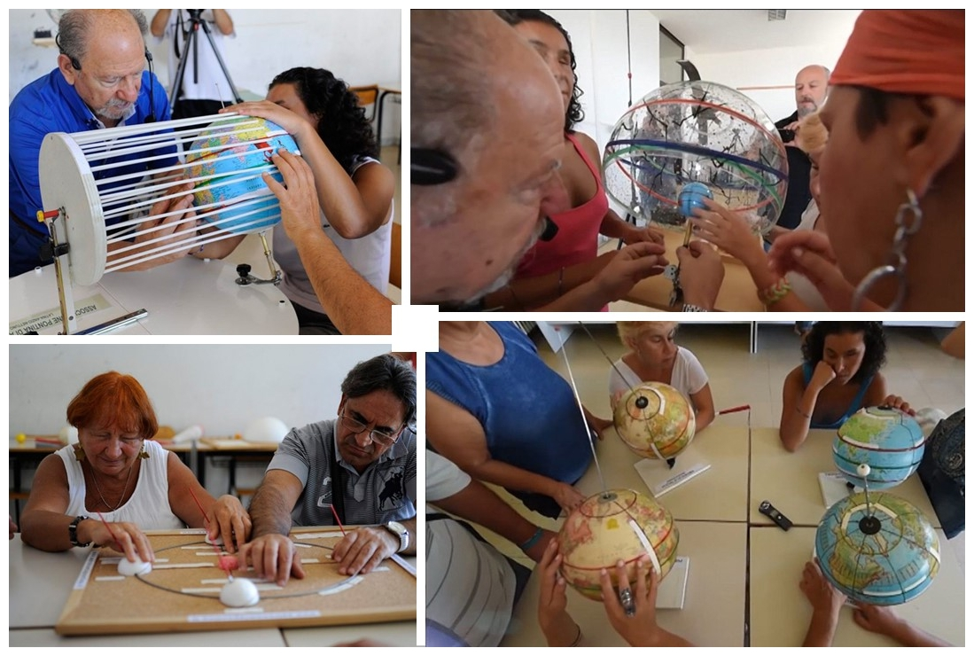
Blind people exploring tactile models of Earth’s motions and the seasons at an inclusive astronomy class
How do you explain the solar system, Earth motions, and the seasons to someone who has never seen a sunrise or a sunset? These are the challenges that some amateur and professional astronomers are undertaking, and this is their story.
Science is a key part of human culture, a key component of informed citizenship, and the basis for societal progress and a healthy democracy. Astronomy is perhaps the most universally fascinating science, and is often the “spark” that encourages people of all ages to become passionate about investigating how our world works; in other words, science.
Many astronomers, both amateur and professional, enjoy sharing their knowledge and passion with others, leading them to invest time in outreach activities: conferences, practical activities including sky observation with the naked eye or through telescopes, formal or informal classes, and many others. But these activities are not always designed to be accessible to people with disabilities; they are not inclusive.
Starting 2009, the “International Year of Astronomy”, some astronomers have focused on accessibility. The first inclusive programs launched that year to great feedback and enthusiasm from participants that has grown since then. An example is the amateur astronomy community in Italy, which now has 21 local associations participating in the National Program for Inclusive Outreach (“Stelle per Tutti” – Stars for all) project, with support from Unione Italiana Ciechi e Ipovedenti (Italian BVI union) and others (see www.uai.it/stellepertutti/ for details; in Italian).
Fast forward to 2020: the International Astronomical Union, focused on inclusion in general, created a special working group focused on increasing adoption of inclusive outreach practices worldwide. A description of the working group is available at iau-oao.nao.ac.jp/iau-inclusion/inclusive-outreach/. One approach the working group has adopted is to gather and share existing “good practices” and tools, and to foster the development of new ones. The working group has also created a community including outreach practitioners and the primary national and international associations of disabled people.
The working group has delivered a “starter kit” to facilitate the first steps into inclusion practices. The kit includes step-by-step instructions on building simple educational models and a set of good practices for arranging and performing inclusive activities. There is also a Facebook page and a group for the community. Materials and contacts are available at iau-oao.nao.ac.jp/iau-inclusion/inclusive-outreach-2/.
Experience has shown that cooperation with associations of disabled people is fundamental since they can provide expert feedback, specialized training, and connections to communities of blind and visually impaired people. The Inclusive Outreach working group is represented in several countries and can reach out to many others through the vast IAU network. We look forward to welcoming national association members of EBU who are interested in joining our community and contributing to the spread of inclusive practices in astronomy outreach activities. Please contact us through the link above.
Cesare Pagano - General Secretary of Unione Astrofili Italiani - Ccoordinator of IAU Inclusive Outreach (Inspiring Stars) subWorkgroup
Fabrizio Migliorini – Unione Astrofili Italiani Inclusive Outreach national program - IAU Inclusive Outreach (Inspiring Stars) subWorkgroup

The annual Holman Prize for Blind Ambition for 2022
LightHouse for the Blind and Visually Impaired is pleased to announce applications for the annual Holman Prize for Blind Ambition for 2022 are now open!
Now in it’s sixth year, the Holman Prize for Blind Ambition annually awards three blind people from anywhere in the world, up to $25,000 each to carry out an incredible idea that will involve personal growth and shatter misconceptions about blindness.
The Holman Prize is named for James Holman, a blind 19th century explorer who is the most prolific private traveller of anyone, blind or sighted, before the era of modern transportation. The only qualifications to submit an application to win a Holman Prize are that you must be blind or legally blind, be 18 years old by October 1, 2022 and speak English. When applications open on January 21, all you have to do is make a 90-second video pitching your idea and upload it to YouTube, and fill out the application form on the Holman Prize website.
But if you’re not quite ready to upload your 90-second YouTube pitch and fill out the application, there’s no need to worry:
Applications close on March 20 at 11:59 pm Pacific.
The full announcement, links and practical information are available on this news page from WBU Website: https://worldblindunion.org/blog/news/2022-holman-prize-for-blind-ambition-application-are-now-open/
Should you wish to contact a LightHouse member of staff about The Holman Prize itself, sharing this information or other publicity opportunities, please email Lee Kumutat, Vice-President – Communications: lkumutat@lighthouse-sf.org

Volunteering Opportunity with Views International
VIEWS International is currently looking for a young visually impaired, 18-30 years old who has a basic level of French. The volunteering project could last up to 9 months and the activities will be hosted in the city of Liège (Belgium).
The project can start this spring.
If you want to know more about these projects, please check these videos about past volunteering experiences (both in EN and FR):
https://www.lebij.be/programmes/corps-europeen-de-solidarite/volontariat/
https://www.youtube.com/watch?v=tlc14IN3WRU
You can check more testimonials (video/articles) via our Youtube channel or our website.
Pre-registrations will be possible till Monday, February 14th 2022 at 12am CET via e-mail at: office@viewsinternational.eu .
Further procedures will be explained afterwards (European Youth Portal matching).
@Sending organisations
Please remember that in order to become a promoter for this project you need to be accredited as sending association (as promoter able to send volunteers with disabilities) by your NA, and that you need to have the PIC. Please check this link: http://ec.europa.eu/education/participants/portal/desktop/en/organisations/register.html
If you have young people interested in one of these projects, please let Views International know.
ENDS.
European Blind Union
6 rue Gager Gabillot, 75015 Paris, France
+33 1 88 61 06 60 | ebu@euroblind.org | www.euroblind.org

