Vision for Work - promoting confidence and independence
for future life.

Focus: What are the changing demands for the person with a visual impairment?
Topic:

Nicola J. Crews
Manager: Education and Children's Services
RNIB Cymru
Trident Court
East Moors Road
Cardiff
CF24 5TD
Wales

029 2044 9567
Nicola.crews@rnib.org.uk

Introduction:

There are approximately 1300 blind and partially sighted children and young people (aged 0-16) in Wales. 15% of these are under the age of 5, 48% are aged 5-11 years and the remaining 37% are aged 12-16. 70% of these children and young people are in mainstream schools and 3.5% are braillists. Wales has two living languages, English and Welsh, which presents additional demands for service delivery. Moreover the geographical terrain makes movement difficult around the country and leads to social isolation and deprivation of opportunity for many blind and partially sighted children and young people.

RNIB research (2004) reported that 90% of employers rate blind or partially sighted people as either 'difficult' or 'impossible' to employ and recent figures suggest that only 33% of visually impaired people of working age are in work. In addition, we know that young people with disabilities find transition into adulthood 'very difficult' and JRF research (2005) demonstrates an increasing discrepancy between the aspirations of disabled young people and their outcomes. At age 16 their aspirations were to have the same income as non-disabled young people for a full time job. However by age 26 the research found that young people with disabilities were four times more likely to be unemployed and were earning approximately 11% less than others with the same qualifications.

Against this background RNIB Cymru undertook research to investigate the critical success factors that would make work experience successful for these young people. This led to an analysis of the prerequisite skills they need to support their learning and improve their employment opportunities. The work experience research was supervised by Jennie Sparks of University of Wales Newport as part of the author's professional development. The research was a starting point for looking at the factors that contribute to the educational and personal success of blind and partially sighted young people and a positive strategy of partnership working has evolved to promote these factors.

Work Experience

The aim of the work experience research was to investigate the range of placements available to young people with visual impairments, discover the support networks available and explore the young people's satisfaction with their work placements, therefore identifying the critical success factors inherent in the process.

The author was fortunate to receive excellent support from Careers Wales (an umbrella organisation for six regional careers companies) and the Local Authority Teachers of Visually Impaired Children and Young People across Wales who responded to questionnaires. Young people themselves were involved through focus groups. Two were held that were specifically for young people with visual impairments and a further consultation workshop was held with a pan-disability group through Children in Wales. Unfortunately it proved very difficult to reach employers and only seven of the one hundred employers (small and medium sized enterprises) responded to the questionnaire sent, despite constant chasing.

Evidence gained showed that the majority of placements were in the public service sector (figure 1). The profile of placements closely mirrored the employment trends of 2003 by sector, published by the Welsh Assembly Government.

Figure 1

Comparison of placements taken by sector with employment trends 2003.
Both Careers Wales and the specialist teachers were asked to state the range of roles that, in their experience, were commonly filled on work experience placements. Responses showed a fairly even split between reception and administration roles, and child care placements. Eight of the teachers said that work experience had involved shadowing professionals rather than actually attempting a role themselves. Other placements listed involved catering, retail work, taking care of animals, manual work and stock taking (Figure 2). Information from careers companies emphasised that young people with visual impairments were more likely to have their placements 'brokered on a bespoke basis' (Careers Wales 2005 p3), whereas one public sector company felt it had no suitable placements, two were unable to be specific about roles and the remaining four responding companies offered administration, reception and nursery assistant work.

Interestingly, none of the young people in the special school focus group would want a careers related to their work experience placement. Of the eighteen young people at the pan-disability focus group, only five had had work experiences in areas they had specifically requested. Discussions showed that ALL young people wanted more say in the placement. They wanted it to be more relevant to their needs and aspirations. Most frequently dissatisfaction with the placement related to lack of understanding of their abilities, staff attitudes and lack of choice in the placement venue.

Figure 2

Work Experiences taken by young people with visual impairments as known by the specialist teacher and special needs careers advisors.

An analysis of the support available for Work Experience placements proved that the specialist teacher (Visual impairment) role is critical. Of the thirteen teachers responding, none were involved in identifying the placement, three in providing necessary equipment, five in providing a 1:1 support worker, eleven in liaising with the employer and seven in the post-placement evaluation. Where specialist teachers were not involved, support from Careers Wales varied between the six companies.

Critical success factors

As part of the research process young people, specialist teachers, employers and special needs careers advisors were asked to grade various factors according to their importance on a scale of 1-6 (6 being highest priority and 1 being lowest). The severity of the visual impairment of the young person was taken out of the equation as all young people are entitled to work experience regardless of the degree of disability. However each of the groups concerned expressed slightly different priorities (figure 3).

The closest agreement was on the importance of clear aims and objectives for the placement. Young people and specialist teachers were unanimous that this was high on the scale and the employers put this only one point behind. This must therefore be a critical success factor. With at least three of the other factors the professionals were in fairly close agreement.

The few employers who responded to the questionnaire stated good social and independence skills, availability of a personal support worker and clear aims and objectives as critical to them.

Figure 3

Importance of critical success factors by participating sector
(6 = highest priority)

The biggest differences occurred between the professionals and the young people themselves. They radically disagreed that their social and independence skills should feature and made the provision of specialist equipment their major priority. One group even added a post-script to the card they had been asked to place on the ranking sheet: Their perception was clearly that this wasn't anything they should be concerned about as they were entitled to more support should this turn out to be a deficit.

Figure 4

Young people's perception of social and independence needs

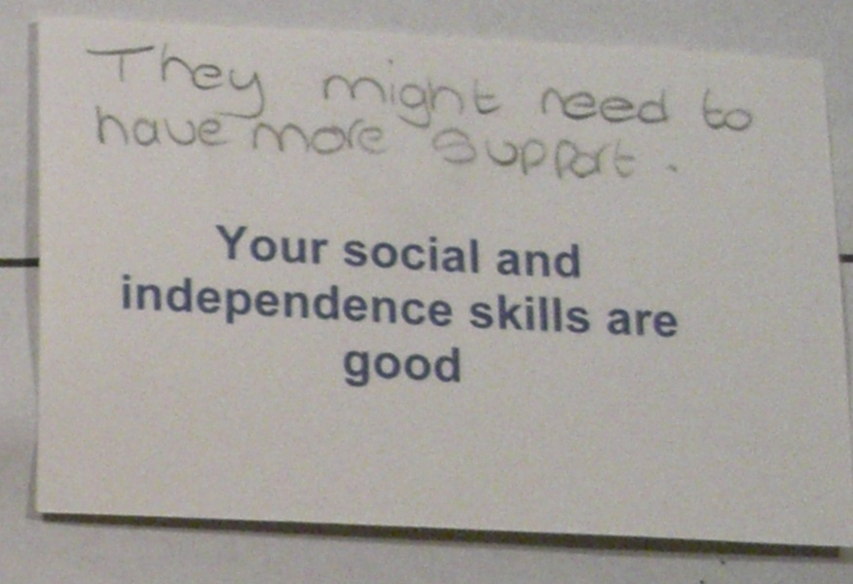

The conclusion to the work experience research was that this introduction to the world of work must be meaningful and successful and give a valid impression of what work entails. Young people should be consulted and their wishes for placements taken into account where possible. In addition there must be targeted programmes to address the acquisition of the social and independence skills that employers clearly value.

What makes success?

Following the research exercise, the Education and Children's Team at RNIB Cymru mapped what we felt were the prerequisites for success for our children and young people.

Figure 5

Suggested prerequisites for educational success

Appropriate
Placements and support

Positive
parenting
Timely
intervention
Independence
and mobility
Emotional
wellbeing
Use of
residual vision
Personal
confidence

Educational
Success

Each of these elements will have a bearing on the success of the young person. Timely intervention is needed - at point of diagnosis, when vision worsens or at other times when some emotional support is necessary. Positive parenting is vital for the young person's development and wellbeing - and there are times when parents / carers need support too. Appropriate school placements and support - including quality curriculum materials, support with independence and mobility skills is also important. The ability of the young person to use their residual vision also contributes greatly to their educational success.

As a result of this model (figure 5 above), RNIB Cymru's Education and Children's team has actively developed a network of partners who can, with us and on our behalf, encourage that success. Examples of our successful partnerships include:

Welsh Assembly Government - Children's Low Vision Advocate

As part of the Welsh Eye Care Initiative (www.eyecarewales.nhs.uk), the Welsh Assembly Government is funding a Children's Low Vision Advocate post attached to the RNIB Cymru Education and Children's team. The role of this post is to promote the use of residual vision, especially the take-up of free low vision assessments for children and young people and subsequent use of the prescribed free low vision devices. During 2008, 158 low vision devices were prescribed to 54 children and young people who accessed the free assessments. As part of their work, the Low Vision Advocate has written the Low Vision Toolkit, published this Summer, that gives a structured training programme for specialist teachers and other professionals to use to train children and young people to use their low vision devices effectively. The Advocate also facilitates inter-disciplinary discussion groups (education, social services and health) across Wales and monitors the referral pathways for children and young people.

UCAN Productions - Developing personal confidence

Since 2007 RNIB Cymru has partnered UCAN Productions (www.ucanproductions.org) in a Big Lottery Funded programme of drama workshops across Wales. In 2008/09 over 200 blind and partially sighted children and young people and their sighted peers were involved in regional workshops culminating in a performance within a professional theatre. During the workshops friendships are developed between young people, they are encouraged to devise their own drama / musical pieces with support from a team of professional actors, and given a professional stage on which to showcase their abilities to parents, staff and peers. Noteable gains have been increased confidence, team work, body awareness, negotiation skills and long term friendships.

Careers Wales - Appropriate placements and support

As a direct result of the work experience research, the Welsh Assembly Government funded a three month secondment of a special needs careers advisor to RNIB Cymru. During this period the findings of the original research were validated and documents produced to support work experience for blind and partially sighted young people. The existing work experience booklet was revised and extended with relevant activities, becoming three discrete booklets - 'Preparing for Work Experience', 'My Work Experience Diary' and 'Planning for My Future' produced in a complete range of alternative formats and in both English and Welsh languages. Young people were involved in the rewrite and contributed their own ideas. A booklet for employers on support for visually impaired young people during work experience and a guide for parents were also produced. All documents have been very well received in Wales and will be freely available for download from the Careers Website (www.careerswales.org.uk) this Autumn.

Neath Port Talbot College - Beyond Vision Project

Neath Port Talbot College of Further Education is working with RNIB Cymru to establish a 'learning and employment centre' providing blind and partially sighted people in Wales with support to attain equality of educational and employment outcomes with their sighted peers whilst remaining in their communities and studying through their language of choice. The centre of excellence aims to 'join up the journey', supporting the transition from childhood to adulthood. It also aims to work with adults with acquired sight loss enabling job retention and compensatory skills. It is envisaged that this will be a residential centre with specialist facilities to support learning activities at the college. Plans are currently being drawn up and funding is being sought for the build.

Conclusion

The work that RNIB Cymru has done has proved that researching a problem is not enough. Research is vital in that it provides us with evidence to plan new interventions and to work with others for the benefit of blind and partially sighted children, young people and their families. Partnership is the way forward - encouraging the expertise of others and working with them to enable young people with visual impairment to take full part in a changing world.

We need well-educated, well-rounded, confident young people who are employable and able to engage with society. Through working with partners we can make a difference, reach more young people and help to join up the journey from school through further / higher education and on into worthwhile employment in a career of their choice.

MORRIS and SMITH (2008) Educational Provision for Blind and Partially Sighted Children and Young People in Wales, London: NFER/RNIB
RNIB (2004) Beyond the Stereotypes - Blind and Partially Sighted People and Work. London: RNIB
JOSEPH ROWNTREE FOUNDATION (2005) The education and employment of disabled young people. [WWW] http://www.jrf.org.uk/knowledge/findings/socialpolicy/0565.asp (25 November 2005)
CAREERS WALES (2005) Careers Wales Report: Work Experience Placements for Young People with Visual Impairments. Cardiff: Careers Wales.

