BrailleStudio - Developing braille activities to learn braille

- Age: children and adults who are dependent on braille
- Category: individuals who are blind or partially sighted using braille
- Theme: learning the braille code
- Focus: adaptive software method to learn braille
- Topic: use and understanding the philosophy behind the software BrailleStudio

Eric de Quartel
Research and development, ICT teacher.
Bartiméus Education
Urtrechtseweg 84
3702 AD Zeist
The Netherlands

0031 030 - 698 22 11
e.d-quartel@bartimeus.nl

BrailleStudio teaches young children and adults the braille code. It does this with the aid of a braille display and the capabilities of sound and text to speech provided by modern computers. An extensive number of activities have been developed by specialists involved in braille education in the Netherlands. In the scripteditor part of BrailleStudio, it is possible that teachers of braille edit and develop their own activities to match the specific needs of their pupils. New activities can be up and downloaded from the web enabling everyone to take advantage of new developments. In this presentation practical demonstrations will be given of how to write and implement new activities in BrailleStudio. BrailleStudio is available in English, French, German and Dutch.

BrailleStudio
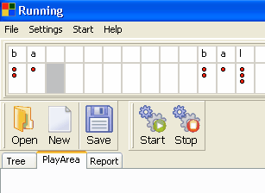
BrailleStudio is the program which teaches students braille. The program shows on screen what is written on the braille display – see screenshot above.

Braille skills will be taught through activities. E.g. in the activity braille a letter, a letter will be shown on the brailledisplay and has to be typed in by the user on the keyboard or braille display. Many activities are already produced or will be developed. Activities are stored in separate files and each file can be downloaded from the web.

The student has to go through a sequence of activities, which should result in the student being able to read and write braille.

The order in which a student has to go through activities is determined by the progress off the student. BrailleStudio tracks the development of the student. The student will be rewarded at a certain point with a special activity - like a game - when it has made substantial progress. If the student needs more practice, alternative activities are provided by the program. The development of the student is recorded and can be printed at any time.

BrailleStudio uses project files. Project files are built up of many different activities. There are different project files for different groups who want to learn braille. Young children who have never used a computer need a different approach than students who are older and may already have work experience before they became dependent on braille.

ScriptEditor
Every activity is written by using the program ScriptEditor. It’s written in the programming language pascal.

Activity
An activity is made up of an icon, code and variables. The icon will be used in the toolbar of BrailleStudio. The code determines how a specific skill will be taught. Variables are for example the letters which have to be learned. Variables can be changed in the program BrailleStudio. For example letters BAL can be changed in the letters POR. The way the letters will be learned stays the same.

Example
Writing a Simple Activity in program ScripEditor

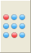 | Get a Icon  Icons will be used in the activity toolbar in BrailleStudio.
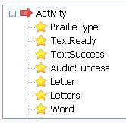 | Get some global variables  These variables can be changed in BrailleStudio.  For example Letters.
Write some code

Var text:string;
Begin
text:=’BAL’
Braille(text);
Voice(text);
End.

