Challenges of Alternative Format Provision
The National Braille Production Centre of Ireland from 2000 – 2008
and its Future Development

Focus: School Age
Topic: What are the Implications for the Professionals?
Ilka Stäglin M.A.
Manager NBPC
National Braille Production Centre (NBPC)
St. Joseph’s Centre for the Visually Impaired
Gracepark Road
Drumcondra
Dublin 9
Ireland
00353 1 8373635
istaglin@braille.ie
- 2000 - 2008
The National Braille Production Centre of Ireland (NBPC) was established in 2000 to provide all children with a registered visual impairment attending school in the Republic of Ireland with alternative format transcriptions of the textbooks required by them. It was a unique approach in Western Europe to start a new central national service without being able to build on any previously existing associated Braille transcription facility .Full funding was provided by the Republic of Ireland’s Department of Education and Science. The location decided for was on campus on one of the then two schools for the Visually Impaired (today: St. Joseph’s Centre for the Visually Impaired) and four staff members were recruited.
Prior to the establishment of the NBPC, Braille was produced in the Braille unit of Arbour Hill prison and in the two schools for the Visually Impaired for day-to-day use. There was no large print or text file production at professional level anywhere in the country. However the need for transcriptions into all formats was rising with the move towards mainstream education for children with a visual impairment and an increasing variety of textbooks used in the schools. Strong lobbying and a report commissioned by the DES into the provision of services for children with visual impairment led to the opening of the NBPC and expectations were very high.
In its first year of operation (school year 2000/2001), 4 staff members produced 52 transcriptions for 17 students in Braille and large print.
In 2007/2008, 23 staff members produced 2162 transcriptions for 360 students in Braille, large print, text files, DAISY and MOON.
This immense progression and development of the service can be traced through the following statistics:

Table 1: NBPC Statistics 2000-2008
Developments of Client Numbers, Order Numbers, Fulfilled Orders, Staff Numbers

Year | Orders received | Orders fulfilled | Overall Production (including orders carried over from previous term) | Number of Clients | Number of Staff Members (+ seasonal student helpers)
2000/2001 | 69 | 52 | 52 | 17 | 4
2001/2002 | 465 | 229 | 299 | 80 | 8
2002/2003 | 303 | 189 | 321 | 97 | 11
2003/2004 | 400 | 269 | 478 | 120 | 14
2004/2005 | 431 | 366 | 557 | 206 | 20 (+2)
2005/2006 | 838 | 568 | 915 | 235 | 21 (+3)
2006/2007 | 1,367 | 951 | 1,322 | 301 | 26 (+3)
2007/2008 | 2,039 | 2,162 | 2,342 | 356 | 23

The following main challenges presented themselves during that time:
Awareness and Expectations
During the first years, the NBPC needed to make stakeholders aware that the service existed and that it could be accessed via the visiting teacher service for the visually impaired, who is providing the link to the students and their schools. This was especially important for young children who were newly diagnosed. It was largely achieved by building up a network of connections within Ireland and by using the advantage of working within a campus with multiple services for children with a visual impairment. However, once clients and their stakeholders were aware of the NBPC, their expectations in relation to production time and availability of transcriptions tended to be unrealistic, because there was a lack of knowledge and understanding of how time-consuming alternative format production can be. This applied particularly to a developing service whose staff needed to gain experience and to build up a back catalogue totally. Information and communication were and are key strategies in overcoming unrealistic expectations.
Order Numbers
Order numbers have increased dramatically throughout the last 9 years. This did not always happen in line with, from a production point very importantly, staff number increases and often left the NBPC staff under high pressure to produce transcriptions for the beginning of each school year.
The increases experienced between 2000 and 2002 led to the introduction of order limitations for large print transcriptions of 2 per student, whereas Braille orders were, and are, exempt from limitations. The result is a slight reduction in order numbers in 2002/2003. This restriction was completely lifted in 2006, due to higher staff levels and the high increase in 2006/2007 is immediately apparent. Unfortunately order restrictions for all formats except for Braille have to be reintroduced in 2009 due to lack of funding.
Client numbers
Client numbers built up quickly in the first 5 years of the NBPC’s existence, as can be expected for a new service. However, the increase has continued and even intensified between 06/07 and 07/08. This trend continues, so that the figure for March 2009 is 400. Taking into account that the estimated number of children of school-going age with a registered visual impairment currently stands at around 650 and assuming that not all of them require the NBPC’s services but use magnifiers and other visual aids, it is still anticipated that the NBPC’s client numbers will rise by another 150. This puts increasing additional pressure on the service.
Quality Control
It is important for any transcriber, especially a developing service, to apply stringent quality control mechanisms. This has been achieved throughout by proofreading of every transcription leaving the centre. This ensures correctness, according to Braille production guidelines, which the NBPC adheres to. The NBPC was also subject to repeated external scrutiny exercises. In 2005 this led to the recommendation of the NBPC model to the Scottish Executive.
Timely Placing of Orders
The universal challenge in the field of alternative format production is the timeframe often required to transcribe material. The NBPC requires as long a notice time as possible for scheduling transcriptions, because 95% of orders have a the same deadline (first day of school year). The schools however, often only make decisions on books to be used in May or even later, which does not leave much time for production. Here, the NBPC has worked closely with the VTVI service and has introduced a guarantee scheme for books which are ordered before certain cut-off points. This has enabled the two services to move forward the peak of orders received over the last two years and has resulted in 100% of all guaranteed Braille volumes and 97% of all guaranteed other format volumes being delivered on or before 01.09.2008. See table 2:

Table 2: NBPC Order Distribution 2005 - 2008
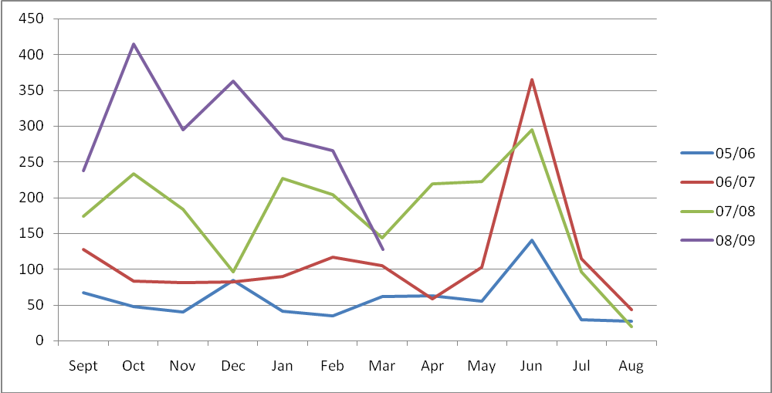

Different Formats and Prioritisation
The NBPC was founded as a centre for a range of alternative formats, not exclusively for Braille. 34 of its 400 users (in March 2009) are Braille users, 297 large print users and the remainder text-file or DAISY users, with multiple format use not taken into account. The order numbers for the different formats over the last 3 years are as follows:

Table 3: NBPC Orders received by Format 2005-2008
Year | Braille (grade 1, grade 1 adapted and grade 2) | Large print (customised fonts and font sizes) | Text-file (pure text, e-file, edited for use with particular software), DAISY
2005/2006 | 154 | 491 | 193
2006/2007 | 162 | 957 | 248
2007/2008 | 198 | 1,343 | 498
The most significant percentage increase can be observed for text-files, e-formats etc. However Braille orders are increasing steadily and large print orders widely in line with new client registrations for large print users.
The challenge for NBPC is how to prioritize these orders, especially in times of decreased funding for staff. Following the guidelines given by the Irish Department of Education via its VTVI service and the NBPC Advisory Group (comprising of representatives of stakeholders), the NBPC currently operates and merges three different sets of prioritising criteria:
- Braille has priority over large print and text files/e-files/DAISY
The working assumption here is that clients who are blind and braille users have less alternatives of access to learning material than partially sighted clients.
- Leaving Certificate orders have priority over Junior Certificate orders over Primary School Orders.
This immediately reflects the emphasis given in the Irish school system on the two major secondary school exams.
- Orders received in a guarantee timeframe have priority over orders not received in the guarantee timeframe (except for emergencies; new client, sudden sight loss etc.)
Copyright Agreements
Ireland has a high rate of educational publishers for a relatively small market, which in turn means that there are no agreed core texts from a particular publisher for a particular subject of the curriculum. In addition to this, the NBPC has experienced several major curriculum changes in core subjects with associated new orders.
The co-operation with educational publishers has been good to excellent. Individual copyright agreements are in place for alternative format production.
Source Files
In its first two years of existence it became apparent that there was neither the time nor the staff available for the scanning of textbooks to obtain a source file for alternative format production. Several solutions were applied:
- The introduction of a volunteers scheme. About 40 volunteers scan textbooks from home and commit to a certain number of hours per week.
- High-speed scanning facilities within the centre.
- pdf files provided by publishers.
NBPC Staff Recruitment and Progression
The staff members of the NBPC work under constant and increasing pressure. Recruitment and training of staff presented a major challenge, especially when building up the centre. Time and cost implications for recruitment were significant. With two exceptions, all staff members were trained on the job, i.e. acquired alternative format production knowledge and studied Braille up to RNIB certificate level, resp. FETAC level 5. Specialisation, for example music or maths Braille, requires further training which needs to be sourced, arranged and funded.
Staff numbers have increased significantly until 2007/2008. Since then funding restrictions have been implemented and no new staff appointments will be made in the foreseeable future.
Since 2005, a model of career progression within the NBPC, as agreed with the DES, has been applied. However, under the current economic climate, this remains static. Seeing that the expertise, motivation and dedication of its staff are the NBPC’s biggest asset, this is a very worrying development.
IT and AT
Information and Assistive Technology products are vital tools for alternative format production. A lot of specialised software packages assist with the transcriptions, but staff members have to know how to use them appropriately, the different software and hardware products have to be compatible and files have to be stored securely. As mainstream IT providers do not cover the specific requirements, the NBPC had to appoint an in-house IT/AT specialist to progress in electronic alternative format production.
Feedback from Stakeholders
Feedback from clients’ and other stakeholders was largely positive throughout the years. The main point criticised in the first years was delays of books and transcriptions, which was improved on steadily resulting in high guarantee levels. The quality of the NBPC’s transcription work has been overwhelmingly positively remarked on throughout by clients and stakeholders.

- Expected Future Developments
Following on from the development of orders for different formats, a trend towards electronic formats emerges which can be traced further into 2009. This is also supported by anecdotal evidence in the form of client feedback . Orders for text files, e-files and DAISY files have increased dramatically, both for sole source users and for dual format users.
Since this author’s 2003 survey on assistive technology progress has been made in the provision of children with a visual impairment with appropriate assistive technology and feedback from clients shows that the better a student is equipped to access electronic formats, the more they play a part in his/her education. (“DAISY is deadly”, client feedback, NBPC Review 2007/2008). To allow for increased orders of this format, NBPC staff have been trained to edit and produce DAISY files accordingly.
As part of its initial brief the NBPC also works as an advocate for Braille. This goes hand in hand with increasing electronic format production, as Braille can also be accessed via Braille displays attached to laptops/PCs and therefore both Braille books and files have their place in alternative format provision.
Over the last 5 years some individual orders for MOON have also been received. Those were mostly for individual word flash cards. It is expected that with the changing clientele, the NBPC will receive increasing orders for MOON and is well equipped to deal with them.

Funding Implications
The biggest challenge at the time of writing are funding uncertainties and their implications. The service that was already chronically underfunded (in relation to the client and order numbers) now has to deal with further declining funding whilst demand grows steadily. The immediate effects are order limitations, emergency measures and other temporary measures. The nature of the service is already changing from an “on-demand” service based on individual client’ requirements to a “supply-based” service based on the existing catalogue due to financial constraints. The current situation will also most probably translate into longer waiting times for clients and in an overall reduction of service provided per individual client.
Since its foundation, the NBPC has proven to be very flexible and accommodating for all its clients. A very sound knowledge-base in the area of alternative format production has been built up and can now be drawn on. Therefore, the centre is in a good position to explore new avenues, adapt and change existing services and still remain a core provider of educational material to all children with a visual impairment in Ireland who require same.

The NBPC is also the only national provider of braille, large print and text file transcriptions of textbooks for primary and secondary school level in the Republic of Ireland. The following sources seem to support the uniqueness of that situation when comparing the reports on the individual countries’ situations to the Republic of Ireland: Sue Keil, Delyth Parris, Rory Cobb, Angela Edwards and Richard McAllister: Too little, too late, Provision of school textbooks for blind and partially sighted pupils, Research report , RNIB 2006; www.bbi.at/Lehrmittelzentrale für Regelschulen; www.keat.gr (Library-Printing Office); www.bibciechi.it/ (the action in respect of school); ICEVI-Europe France.mht; Service Catalogue, Norwegian Support System for Special Education, 2003, www.statped.no; www.once.es (Web of Education); different centres in Germany (Leipzig, Marburg) et al.
Based on different figures (service users, registrations, patient numbers) from St. Joseph’s Centre for the Visually Impaired, National Council for the Blind of Ireland and Temple Street Children’s Hospital.
Braille Authority of the United Kingdom: British Braille, RNIB Peterborough 2004; RNIB Braille Primer; relevant guidelines for different subjects (Maths, Science, Music, Foreign Languages etc.)
Linda Sorensen : Feasibility Study for a National Transcription Service, Uddingston Grammar School, Scotland, 2005
In this context it is interesting to note that the usefulness of a multi-format approach can also be observed in the amalgamation of different alternative formats’ interests groups in the UK to the UK association for Accessible Formats (UKAAF).
Each volume of a transcribed book/CD with files contains a feedback form for clients. While by far not everyone returns these forms, the NBPC monitors the feedback and implements changes, where required. Feedback documentation is held at the NBPC.
“The Role of Assistive Technology in the Provision of Educational Material for Children with a Visual Impairment in the Republic of Ireland” by Ilka Stäglin, in: G. Craddock et al. (Eds) Assistive Technology, Shaping the Future, IOS Press, 2003)

