COMPARISON OF READING SPEED BETWEEN VISUALLY HANDICAPPED CHILDREN AND SIGHTED PEERS
*Songül Atasavun Uysal, PT, MsC., *Esra Akı, Assoc.Prof.
(*Hacettepe University School of Physical Therapy and Rehabilitation Ankara/Turkey)

Vision is the sense that enables humans to perceive simultaneously an object in its complete form and the object’s relationship to other objects in the environment (1,2,3).
Academic skill is most important daily living activies in the children who go to school. The basic of academic skill is reading speed. Reading speed is needed a sufficient visual acuity and acquired reading experince (4,5).
Aim
The aim of this study was to compare the reading speed between total visually impaired children and sighted children.
Subjects and Methods
This study was included 30 sighted to 30 total visually impaired children who were continuing education in Ankara primary school. Their age range’s was 7- 14 years. Sighted children read a page in a one minute which letter sized 12. Same page was read by Braille in total visually impaired children. Reading words of children were detected by counting totally reading letter and dividing it to six as a word is formed by 6 characters (including space) (2).

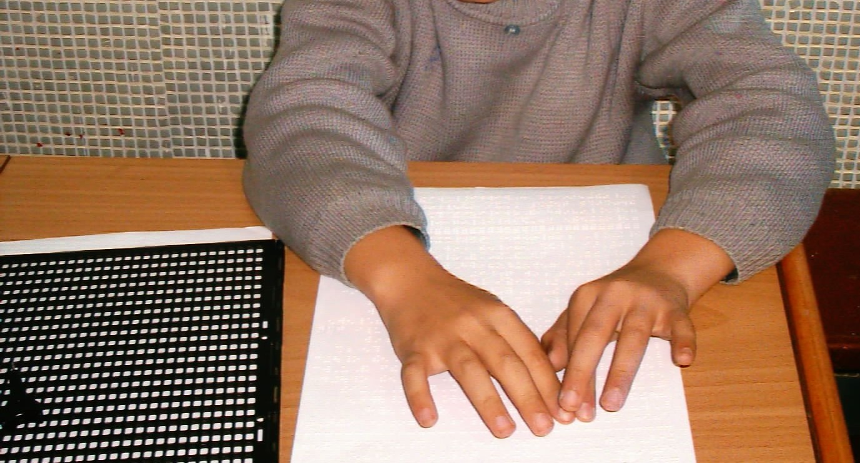

Results
Reading word in a minute was 97.66±54.88 in sighted children and 17.63±15.87 in total visually impaired children. There were significant differences between groups (p<0.05).
Conclusion
Children are continuing their motor and mental lerning education to take information around the enviroment. In the loss of sensory input, children’s developmental cycle is affected (6). Reading speed is also affected. Reading speed is very important activity in students. Dekker and Coole was emphasied to relationships between reading speed and academics skills (3).
Bailey and colleagues was stated to important to the eye fixation and control of eye in a reading speed. Especially, visual ability was important in knowing a word then composed to letter and remember a sentence. Absence of visual memory experience and lack of interest and lack of brave was a reason for slow reading (4). Rubin was stated to normal visual function’s persons have read approximately 200- 400 word in a minute (2). In our study we preferred the Rubin’s method to calculated reading words. According to this method, read words and space counted and divided to 6. This method is so simple, short and valid. Therefore, we choosed this method.
As a conclusion, it was found that sighted children read a letter better than visually impaired children like other researchers. It was thought that as total visually impaired children reading a book with Braille less, therefore they do not develope their reading skills. This method was simple, valid and took a short time. It was concluded that the increasing the reading speed of visually handicapped children might help to academic success. In our country, a few visually handicapped person work in a different area. If visually handicapped children may success their academic life they will be find a better job in a future.

References
- Collanbrander, A. ve Fletcher, D. C. ‘‘Basic concepts and terms for low vision rehabilitation”. The American Journal of Occupational Therapy, 49: 9, 865-869, 1995.
- Rubin, G. S. “Vision and reading”. Ophthalmology Clinics of North America, 7:2, June, 237- 241, 1994.
- Dekker, R. ve Koole, F. D. “Visually impaired children’s visual characteristics and intelligence”. Developmental Medicine and Child Neurology, 34, 123- 133, 1992.
- Bailey, I. L. , Lueck, A. H. , Greer, R. B. , Tuan, K. M. , Bailey, V. M. ve Dornbusch, H. G. “Understanding the relationships between print size and reading in low vision”. Journal of Visual Impairment and Blindness, June, 325- 334, 2003.
- Erden,G., Kurdoğlu,F., Uslu,R. ‘’İlköğretim okullarina devam eden Türk çocuklarının sınıf düzeylerine göre okuma hızı ve yazim hatalari normlarinin geliştirilmesi’’.Türk Psikiyatri Dergisi, 13(1):5-13,2002.
- Murphy, M. F. ve O’driscoll, M. “Observation on the motor development of visually impaired children”. Physiotherapy, 75:9, 505- 508, 1989.

