Playing with Food
Evaluating the First Three Years

Focus: Evaluation of a ‘Fun With Food’ program over the past three years

Topic: Helping children with sensory and behavioural difficulties with feeding

Authors: Jenny Trundle
Speech and Language Therapist
St Josephs Centre for the Visually Impaired, Dublin 9
Tel: 01 8373635
E-mail: jtrundle@stjosephs.ie

Jane Mythen
Occupational Therapist
St Josephs Centre for the Visually Impaired, Dublin 9
Tel: 01 8373635
E-mail: ot@stjosephs.ie

Audrey Darby
Occupational Therapy Manager
St Josephs Centre for the Visually Impaired, Dublin 9
Tel: 01 8373635
E-mail: adarby@stjosephs.ie

Joanne Ui Chinneide
Senior Speech & Language Therapist
St Josephs Centre for the Visually Impaired, Dublin 9
Tel: 01 8373635
E-mail: juichinneide@stjosephs.ie

Introduction
In 2004, it came to the attention of the therapy department in St Josephs centre for the Visually Impaired, that there were a number of children in the organisation who had significant issues with feeding. These issues were making eating an unpleasant and sometimes frightening experience for the children involved. We set about exploring previous research and evidence base treatment for sensory feeding difficulties in children with visual impairments, and found that there was very little specific information available. Therefore, we designed a ‘Fun with Food’ group, which targeted children presenting with sensory and behavioural issues around eating, which are often found in children with visual impairment.

The main focus of the Fun with Food programme incorporated a group approach highlighting the social element of eating. The groups followed a structured routine involving sensory-motor play, circle time, oral-motor preparation and food exploration. Further, groups were rooted within the context of a mealtime routine designed to create a fun, non-threatening, relaxed atmosphere in which the students could explore new food types and textures and there was social reinforcement through peer modelling.

The Group Participants
The clients in our service who avail of the Fun with Food group have a range of visual impairments, including Retinopathy of prematurity (ROP), Cortical Visual Impairment (CVI), Nystagmus, Myopia, Glaucoma, Albinism, Optic Nerve Hypoplasia, and Septo-optic dysplasia. Our clients also present with a range of additional disabilities including Learning disability, Physical disability, Hearing impairment, Cerebral palsy, Developmental delay, and Autistic Spectrum Disorder.

Table 1: Summary of participants
Client | Age | Visual Diagnosis | Medical Diagnosis
A | 6; 0 | Albinism | Global Developmental Delay
B | 4; 0 | Nystagmus, Myopia | None
C | 6;09 | Retinopathy of Prematurity | Autism Spectrum Disorder
D | 9;07 | Septo-optic Dysplasia | None
E | 12;07 | Anophtalmia | Autism Spectrum Disorder
F | 10; 0 | Visual Field difficulties | Autism Spectrum Disorder
G | 9;07 | Optic Nerve Hypoplasia | Learning Disability
H | 8; 0 | Blind | Hydrocephalus

The group was designed for children with sensory issues around feeding. The majority of the students who participated in the Fun with Food programme have difficulties processing sensory information. The two most common sensory issues are Sensory Processing Disorder (SPD) (ineffective processing of sensory information by the Central Nervous System leading to the child having difficulty functioning in daily life), and Autism Spectrum Disorder (ASD) (This falls under the umbrella of Pervasive Developmental Disorder (PDD). Children with ASD have difficulties with communication (verbal & non-verbal), imagination, problem solving, social interaction, sensory modulation & discrimination, sequencing and motor planning). (Stock Kranowitz, C. 2005)
The Group Routine
The group is run on a rigid routine, ensuring that the children can become familiar with and feel safe within this environment, and therefore feel less threatened about food issues. The food presentation is the only section of the routine that changes.

The routine is as follows:

00:00-00:10 – Sensory/proprioceptive play
(Swinging, tunnel play, trampoline, therapy ball)
00:10-00:15 – Circle time “Hello song” / “The Ants go Marching”
00:15-00:20 – Oral motor prep
(Wash hands, pat faces, brush teeth with tooth brush song )
00:20-00:30 – “Fun with Food” time, introduce foods to explore
00:30-00:40 – Clean up time
(Clean up foods, wash hands, brush teeth with tooth brush song )
00:40-00:45 – End of group (Good-bye song)

There are three levels of participation in the group. Children are allocated to a group depending on a number of factors, but taking into consideration their ability to participate in the meal time routine. The levels of the groups are as follows:

Level 1 – Playing with food
Clients are encouraged to adjust to the group routine and the other members, play creatively with the food. They can move around the room, although placement at the table is gently encouraged. There is no expectation to eat food at this stage.

Level 2 - Exploring food
At this level there is increased exploration of food through play and games. There is increased emphasis on getting food to the mouth, and mealtime place settings are used. There is increased emphasis on social mealtime behaviour – sitting at table, passing food and objects as requested.

Level 3 – Manipulating food
At this stage there is increased emphasis on eating food through biting, chewing, sucking, swallowing etc. and food presentation is as would be for normal mealtime. Appropriate mealtime communication is encouraged.

Review of groups over the past 3 years
Student Allocation:
Over time, it has emerged that the allocation of children to groups has not solely depended on their ability to participate in the mealtime routine as originally suspected but a number of additional variables arose that required consideration including the age of the student and their sensory difficulties.

Development of the Fun with Food Group:
The focus of the groups continued to follow the original routine as discussed previously however since the innovative pilot group in 2004 the following developments have taken place:

The first fun with food group was held in the school year 2004-2005. As it was the first year a trial group was formed with 4 students. These students were identified as being suitable for the group through parental / teacher report. Each of the children had some difficulty processing sensory information and limited repertoire of food or sensory problems with food.

In the school year 2005-2006 the group expanded into 3 groups with 3 students being involved in each. Again, the children were identified as having sensory feeding difficulties or a very limited repertoire of food. The groups were divided and formed on the basis of the children’s sensory needs and age.

During the school year 2006-2007 there were no fun with food groups running due to staffing changes.

The school year 2007-2008 saw two groups being formed with 3 students per group. As per the previous years, the students had varying diagnoses, each with difficulties in processing sensory information.

In the current school year, we have 2 groups running to accommodate the need for intervention. Children are grouped according to sensory needs.

The importance of Sensory Input
In the case of the children we were seeing and identifying as potential candidates for participation in the group, it was noted that they all had some level of difficulties with sensory processing. Each of these children already had some form of sensory diet in place, and were benefitting from sensory input in other aspects of their lives. Therefore sensory activities were implemented more rigidly to facilitate and increase the child’s participation rate in the Fun with Food session. It was identified that sensory activities, tailored to the needs of the individual, would be vital to the success of the group. Hence, the sensory activities became an integral and more prominent element to the structure of Fun with Food programme in year 3 (2008-9) term 2. Sensory activities were further structured by tailoring activities to each individual child and restricting time limits (alarm would trigger end of activity).
Individual data was collected on a weekly basis and analysed post 8 week block.
This sensory input was a vital part of the success of each session. The activities take place in the Occupational Therapy gym. Each child is set up and assisted with an activity that is known to have a regulating effect on their sensory system. This section of the group lasts for 10 minutes, by which time it is hoped that the child will have regulated effectively enough for them to participate in the group experience.
Samples of activities carried out are:
Lying under a weighted blanket with relaxing music
Prone over a therapy ball, weight bearing on hands and carrying out a task
Balance beam
Working on the suspension swing
All these activities are aimed at arousing or calming the individual child, as is known to be needed to help their sensory system balance.

Further activities are carried out right through the group these include;
Clapping and tapping feet add proprioceptive feedback during circle time
Oral motor preparation includes deep pressure to the face and sensory stimulation to the inside of the mouth
Washing hands at start and end of group can provide sensory feedback through deep pressure with the towel etc
Clapping and singing to the last song extends the sensory activities right to the end of the group

In the recording of each child’s performance in the group each time they attended, there was a section to complete which referred to their sensory arousal level before, during and after the group. This was a basic way of looking at the effect of sensory preparation on the child’s performance.

Data Collection
Data was collected on a weekly basis using 3 separate forms. The forms record the effect of sensory activities on performance, textures of food tried in the group by each participant and finally a note sent home to parents to provide feedback on the child’s progress (See Appendix 1-3). The forms used to document the group’s progress have been constantly updated and revised based on information needed. The original form recording food tolerance recorded 9 various textures of food tried on a tolerance scale of 1(not attempted) to 6(ate food). The revised forms include only 6 various textures with reactions being monitored on a scale of 1 (not tolerated) to 11 (eats, chews and swallows independently) (see appendix3).

Results
The following chart’s (Chart 1-8) represents a sample portion of the results we have obtained over the past few years.

Chart 1: Comparative analysis of student E, year 1 to 3
***Insert basic info from 8 slides

Chart 1: represents student E’s progress with tolerating different textures of foods over a three year period. In year 2, student E progressed well above his performance for year 1. In year 3, initially there was progress. This slowed somewhat, but it is felt that external factors were influencing student E’s ability to benefit from the group.

Chart 2 &3: Random sample over 10 sessions of Student B’s tolerance to different textures
Chart 2
Rating Scale 0-11 (see appendix 3)

Grainy

Number of Sessions

Chart 3
Rating Scale 0-11 (see appendix 3)

Number of Sessions

Charts 2 & 3 are graphs from student B. It is a random sample over 10 sessions of student B tolerance to six different textures.

Chart 4 – Student B, effects of structured sensory input as part of the group

This chart represents the effect of sensory input on student B’s participation in the group and performance in relation to food.

‘Before’ represents an earlier stage in the group where sensory input was involved, but in a less structured way. ‘After’ refers to more recent sessions when the sensory input was tailored specifically to the needs of the individual child. It is clear that structured sensory input had a positive effect on the child’s ability to participate in the group and tolerate food.

Chart 5 & 6 –are graphs from student C. It is a random sample over 10 sessions of student C’s tolerance to six different textures.

Chart 5
Rating Scale 0 -11 (see appendix 3)

Number of Sessions

Chart 6

Rating Scale 0-11 (see appendix 3)

Number of Sessions
Number of Sessions
Chart 7 – Student C, effects of structured sensory input as part of the group

As noted with Student B, again, the more structured sensory input has shown to have a positive effect on the student’s performance in the group.

Chart 8 – Progress of students at home according to parents

Rating scale 1-5

Student

Chart 8 represents parental subjective reports regarding their child’s individual progress in relation to eating before participating in fun with food, and after attending for some period. Each parent was asked to use a scaling system to record their progress pre and post participation in the Fun with Food group. The scale ranged from 1-5 (1 = child not sitting down or tolerating food at the table; 5 = child will sit and eat independently). In general, parents feel their children benefited from the group.

Findings
Having tracked the data of 8 clients (labelled Client A-H - Table 1) from 2005-2008, the evidence we have gathered strongly supports Fun with Food as an effective therapeutic intervention for children with sensory feeding disorders.

It is important to note that external factors may have affected results, these include;
Behaviour: children with significant behavioural issues showed a more erratic pattern of performance in the group.
Taste: some children progressed well initially however on a number of weeks their progress decreased dramatically on textures that were previously tolerated. Taking this into consideration statistics were analysed and it was established that the tastes of foods varied considerably on these particular sessions.

Additional prevailing factors may also have impacted the children’s performance in improvement through the group process. These included changes in staff, Special Needs Assistants no longer being involved in groups, carryover of the routine to home, transfer of skills to different settings, group dynamics (sensory needs changed), additional changes to routine/ natural environment, trust & development of therapeutic rapport.

Conclusion
From the research above, the students have shown significant improvement since the beginning of the school year (September 08). Data obtained from parental reports provides evidence of an overall increase in tolerance to different foods and repertoire of food since starting the fun with food group.

Areas for further development will include re-introduction of direct parental involvement, looking at the effect of the taste of foods (e.g. sweet/sour/spicy etc.), further investigation of group dynamics, looking closer at peer relationships, and encouraging independence in the group through leadership roles.

Reference

Kranowitz, C.S. (2005) The Out-of-Sync Child: Recognizing and Coping with Sensory Processing Disorder. New York: Penguin Group.

Further Suggested Reading

Babbitt, R. et al., Coe, D., Cataldo, M., Kelly,K. et al (1994). Behavioral Assessment and Treatment of Pediatric Feeding Disorders. Developmental and Behavioral Pediatrics, 15(4), 278-291.

Brody, J. & Webber, L. Let’s Eat: Feeding a Child with a Visual Impairment. Blind Children’s Center, Los Angeles, CA.

Ernsperger, L. & Stegen-Hanson, T. (2004). Just Take a Bite. Arlington, Tx: Future Horizons, Inc.

McCurtin, A. (1997). The Manual of Paediatric Feeding Practice. Oxon, UK: Winslow Press Limited.

McKain, S. & Wood, L. (2000). Group Therapy for Children with Feeding Disorders. Workshop in Bellevue, WA: Kindering Center.

Morris, S.E., Klein, M.D. (2000). Pre-Feeding Skills, 2nd Edition. Therapy Skill Builders.

Winstock, April (1994). Eating and Drinking Difficulties in Children. Oxon, UK: Speechmark Publishing Ltd.

Appendices

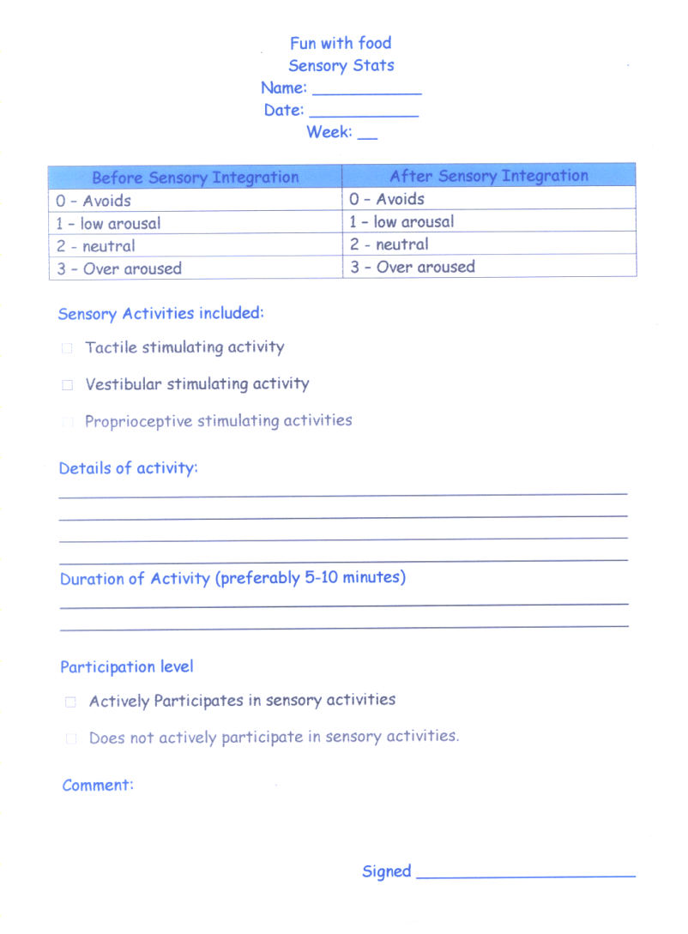

Appendix 1: Sensory Statistics - individually documented for each child, giving detailed information regarding a child’s sensory arousal level pre and post sensory integration activities.

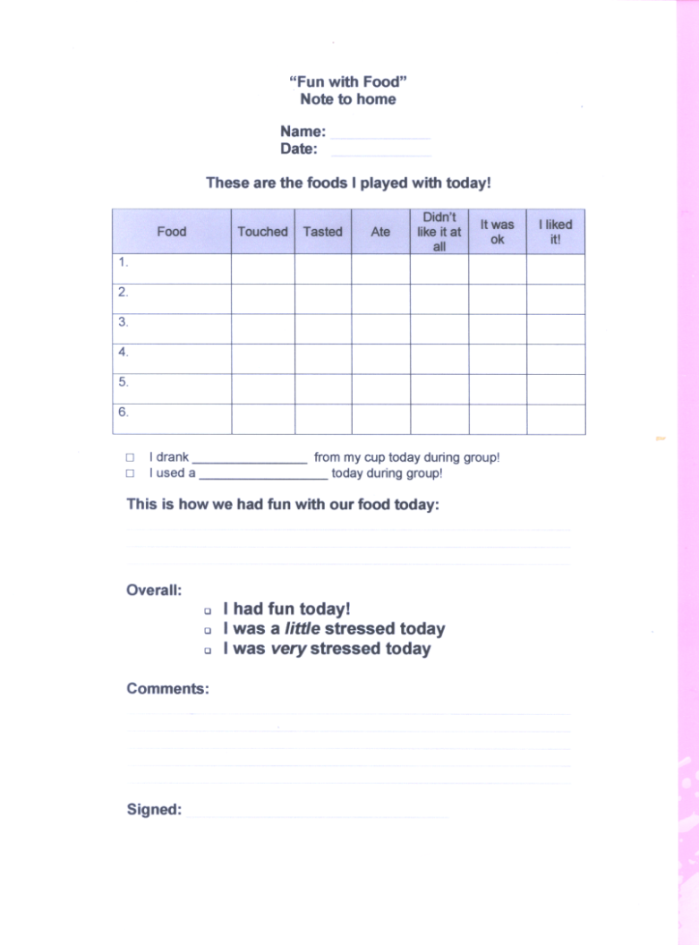

Appendix 2: Fun with Food – Note to home. This allows therapists to provide feedback on the children’s individual weekly performances.
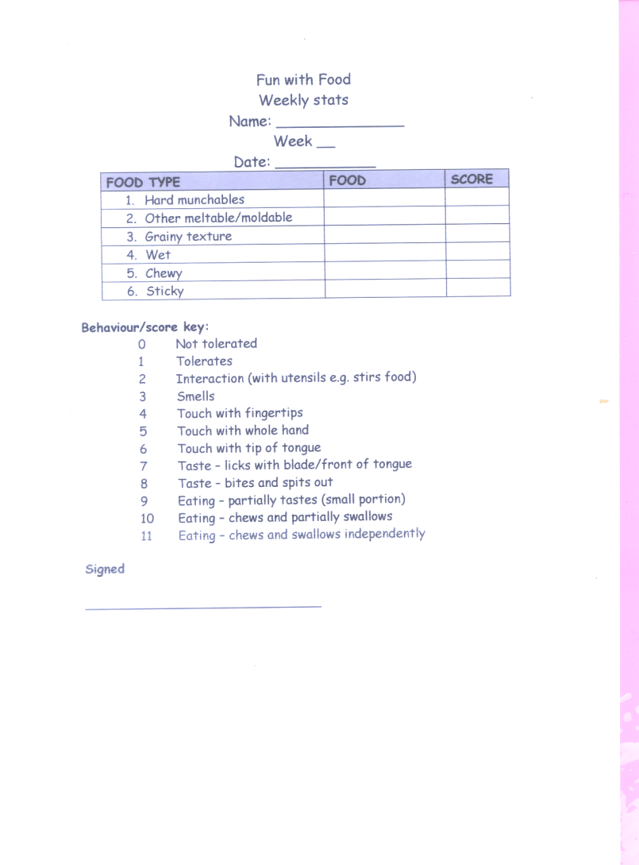

Appendix 3 – weekly statistics. This allows therapist to document a child’s tolerance of food using a scoring system ranging from 0-11

