How to teach mathematics in Braille? (146)

Gyntha Goertz
Teacher/ Master SEN (special educational needs)
Sensis Education for the visual impaired
Frankendaal 70-138
3075 XS Rotterdam
The Netherlands
0031(0)88-5858330
ggoertz@sensis.nl

Sylvia Buit
Itinerent teacher
Sensis Education for the visual impaired
Frankendaal 70-138
3075 XS Rotterdam
The Netherlands
0031(0)88-5858330
sbuit@sensis.nl

In this workshop we’ll give suggestions about teaching mathematics in a tactile way.
Target group: teachers working with children from 5 up to 12 years

On behalf of Sensis International we have given arithmetic and mathematics courses to Braille instructors in Gambia.
We developed a mathematic box for blind and partially sighted children in primary education. This box with material and instructions can initiate a more ‘tangible’ way to teach mathematics and demonstrates the use of teaching aids for blind and partially sighted children. The materials can be used as a basis for developing numerical comprehension and geometric perception, to prevent future arithmetical deficits.

What is mathematics?

- Mathematics is the action in which the rational thinking and order play an essential part. Understanding and notion are the main things.
To express the action is important. How did you do it, how do you find the answer? Deed put into words. (A is for action)
How about the sum in this story? This is the formula. (F is for formula)
A to F
F to A

- Carry out operations internalized. Quickly solve a formula.
A to F
F to A
- Carry out inwardly a required formula in a shortened way.

The basic functions of mathematics:

Visual or tactile development
Spatial orientation and body awareness
Linguistic development
Memory
Rational thinking / intellect
Auditive development
Motor development
Concentration
Attitude towards work

Difficulties in teaching mathematics to blind and partially sighted children:
We assume that teaching a visually impaired child, especially in this subject, is no sinecure. An extra effort in the field of didactics and arrangement is needed, but there may be more.
In what way does the visual handicap interweave the learning performances?
If we realize that our brain functions are fixed not only by giftedness, but also are moulded by stimulated use in a direct and indirect way, it will be clear, that with missing or reduced incoming visual stimuli, many fields come reduced or even not to development at all. We read/know that in the first three years in our life the base is laid for our functioning later. In that stage the understanding round space, movement and connection has to be developed.
The lack of visual information interferes with the experience of your own body, the space around you and moving in that space. The replacing sources of information like hearing, touch, and sensation of muscles demand for a much stronger concentration and motivation.
With a visually impaired child in mathematics, especially concerning figures, there is no question of “surveying” the figure. Piece by piece the figure will be filled in and put to a whole. There won’t be any information from one glance, like with people without a visual impairment.
The pupils are required to arrange fast incoming information, based on significance and usefulness. This is demanding a high form of concentration of the pupil.
Blind and partially sighted pupils are quite often characterized as having no enterprise and lack an active “watch/tactile/search behaviour". That will increase the problems on planning and carry out spatial based actions. In case of congenital blinds the consequences might be expected more likely, but you’ll find problems with other visual impaired too in three-dimensional thinking, perception of time and computation of time. At the same time, in the spatial memory, and the reason back, the way there turns out to be different from the way back.
With particular subjects it is advisable to give extracurricular help to visually impaired children. So the subject can be discussed in advance. In this way questions and delays are prevented in class. The lesson itself will be a review more or less, recognition of the matter.
How to explore materials in a tactile way?

Exploratory procedures in relation to object properties:
Tactile awareness is very important for exploring objects in the absence of vision. Additional exploratory procedures have to be used:
- Lateral motion by finger pads to explore the texture
- Pressure by using muscles in the hand to explore hardness
- Enclosure with both hands to explore the global shape/ volume
- Contour following to explore global and exact shape
- Unsupported holding by using the arms to explore the weight
- Static contact to explore the temperature

An example:
From bead string to number line:
There are 5 round beads and 5 beads shaped differently. While calculating the children may use either the string of beads or the finger images.
So we also have a string with 20 beads and 100 beads.

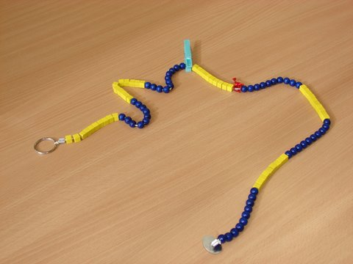

The following step is a tactile numerical line designed and brought out by our school.

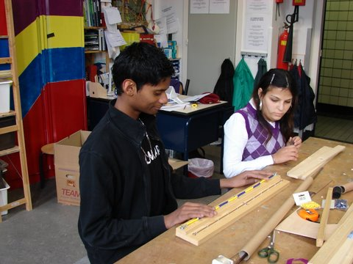

Pupils of the secondary school of Sensis in Rotterdam made it themselves in a
practical training program, that lead to work.

The workshop:
During the workshop participants can group themselves to experience material in a tactile way for the following subjects:

- Counting in a five and ten structure up to 100
- Understanding of relations between numbers
- Number lines
- Geometric figures and their properties
- Fractions
- Measuring

