Digital development: e-learning. A tool to support the education of people with visual impairment

Focus area: Digital development. E-Learning. Moodle.
Theme: Implications and new situations that professionals and organizations working with visually impaired people will face in this changing Europe.
Topic area: Children, rehabilitation of adults, multi disabled, professionals, parents.
Age category: All ages.
Category of visually impairment: low vision, total blindness and other disabilities associated.

M Teresa Corbella Roqueta.
Educational IT department coordinator. Professor. Industrial Engineer.
ONCE Educational Resource Centre, Barcelona.
Gran Via de les Corts Catalanes, 394.
08015 Barcelona.
SPAIN.

Tel. 617324155
mtcr@once.es

Introduction. ‘Living in a Changing Europe’. Starting point.

If we start from the premises set out in the Conference and take its words into consideration, we are in a changing Europe, where the social, economic and political conditions change quickly and at different speeds and directions. Also you can observe that governments have an explicit trend to disengagement and responsibilities have to be taken by every member of society.

People with visual impairment may suffer negative effects until the roles of governments are clearly established in connection with rehabilitation and education. Educational services are transferred to bodies in local communities that are near the family, in its own school, with daily activities. This may be correct from the perspective that responsibility is placed in the community, but sometimes we notice a lack of professional skills.

The concern regarding education that is posed by the Conference undoubtedly seems to be a reference to inclusive education. This educational model assumes that teachers, pupils and parents develop and participate in a sense of community shared among all the members, whether they have disabilities or not.

The aim is to make a functional and organizational reconstruction of the integrative school. We need to change the educational methods in order to provide support to all the pupils. In this model, the common teachers and the specialist teachers work together in a coordinated way in the natural context of the ordinary classroom, in order to promote the sense of belonging to a community and the need of being accepted, whatever the pupils’ capacities may be.

The inclusive school is supposed to accept all the pupils; it implies an increase in the pupils’ active participation (social and academic) and also it involves the creation of a learning environment based on a common curriculum. It also considers that all the members of the school community are qualified to deal with diversity and they have the necessary resources to do that.
In the area of Educational Integration, our experience in Spain is very positive. In our country 95% of pupils with visual impairment are mainstreamed in ordinary schools. The model followed by the Spanish National Organization of the Blind (ONCE) and its staff sets a good example of good practice and gives us some breathing space in this worrying situation. This model will undoubtedly be taking shape and adapting itself during the transition from Integrative School to Inclusive School, and the ONCE will be able to cope with this challenge as a good organization.
In parallel with this trend of educational model, we can find unstoppable technological developments and their use in all areas of education. We should bear in mind the advantages and disadvantages for people with visual impairment of using these technologies. Furthermore, this digital immersion raises some well-known problems, such as ‘Accessibility to digital content’ and, of course, access to the Linux operating system and open source programs.
The support model for teachers and other ONCE professionals during the different educational stages will become indispensable in this changing future. Probably, solutions that help these teachers’ and professionals’ task will have to be found, so that they will become more efficient in their support work.
Now that we have established these concerns, one possible solution could be to increase direct attention to our professionals with a tool that allows distance cooperation, communication, training, etc. of all the professionals involved in education for visually impaired pupils.
- Increase Training for teachers and other professionals helping pupils with vision impairment in mainstream schools, something which at the moment is done through seminars, talks, etc.
- Meet the need to establish communication bridges and spaces for discussion between the teachers and professionals that interact with our pupils.
- Reinforce the work done by ONCE professionals, who are experts in visual impairment, through a specific tracking of ‘attention to diversity’, also from a distance.
In this work context, by taking advantage of the digital development in which we are immersed in this changing Europe, the idea of using the VLE (virtual learning environment) arises as a fundamental tool to support students, professionals, teachers, families and support teachers.
A VLE is a portion of Internet, it is an Intranet specifically configured for training. In a VLE the members of an educational community interact in order to promote certain learning.

The scientific proposal of this communication and what is expected to be developed through the use of a VLE is the construction of a virtual classroom based on the Moodle platform. In this platform the elements involved in the education of pupils with visual impairment can enter into dialogue, participate actively, reflect and share their experiences and materials. In short, it should be a telematic support that reinforces the task that the ONCE support teachers and professionals do day by day in the CRE (Educational Resource Centre).

Justification of innovative proposals.

In the near future, this work tool (the virtual classroom) would help professionals and support teachers in mainstream schools because it would facilitate exchange, on-line cooperation, adaptation and localization of accessible materials and ‘specific attention courses‘ for groups of students with visual impairment and similar needs, etc.

It is suggested to use this innovative technology (the Moodle platform) to obtain the final objective proposed: to reinforce the support and the direct attention given to our visually impaired students.

Questions raised.

In the context of a changing Europe and with the premises described in the first section, the following questions are being raised. We will have to gradually find solutions for these issues. Obviously, we cannot take full responsibility but we will probably direct our actions as professionals and technicians in order to solve all these problems.

Which competences will teachers in mainstream schools and teachers of special education need to have in order to be more competent within the model of inclusive school that we have posited?

Will it be possible to take advantage of the new digital development in order to improve educational action so that support will be given to all the community? Is this model of training and telematic cooperation useful?

With everyone’s cooperation, will we reach agreements and involvement of the central government and other institutions so that their digital educational projects will be accessible to everybody?

In this adventure of ‘free software’, will we be able to reach the same level of accessibility that Microsoft’s standard software has achieved? How long should we have to wait? Will the community meet our requests? (http://en.wikipedia.org/wiki/Free_software)

We will continue to work so that we find an answer to these questions and help people with visual impairment reach a promising future.

Some suggestions.

An interesting section of the virtual collaboration environment that has been proposed is the area of news or recommendations, in which we could find, amongst other things:

- Continuing to watch over accessibility of digital educational content. As we bear this in mind, we suggest:
- Making contact with public services and those institutions those are closer to the reality of our population. Work together and take actions to raise awareness so that these organizations understand the need to make digital design accessible to everybody.
- Carrying out workshops on practical and technical aspects in order to achieve accessible digital developments.
- In the same direction, collaborating with publishers by providing accessibility guidelines and analyzing their digital production.
- Being present in the community, continuously analysing materials and offering constructive feedback in order to promote their improvement.

- Being innovative and continue research, analysis and application of emerging technologies that may offer, advance and support our population with visual impairment in the educational field. —mp3, interactive whiteboard (IWB), Wii, etc. In these cases the following aspects will be fundamental:
- Showing the social educational community (schools, libraries, etc) how the use of certain technologies (IWB interactive whiteboard, graphics tablet, etc) can help the inclusion of visually impaired pupils in their daily activities.
- Designing strategies, work practices and ways to use these technologies to facilitate quick acceptance by the community.

Summary of the main objectives of communication.

The main objectives of communication will be:

- Designing a virtual work environment in the Moodle platform (GNU General Public License) that will allow us to promote participation and collaboration of the professionals involved in the education of visually impaired pupils. Always under the supervision and control of ONCE professionals, technicians and support teachers.
- Establishing criteria for the management and control of the knowledge of the platform.
- Defining the different areas and access rules to the platform (help to support teachers, pupils with visual impairment, etc).
- Analyzing the advantages and drawbacks of using this tool as a support element for the direct attention work with visually impaired pupils provided by our support teachers.
- Analyzing the advantages and disadvantages of using this tool as a support element for the educational work that is carried out with our visually impaired pupils on a daily basis, especially in the case of pupils that live in the farthest areas from the spheres of influence of the CRE.
- Considering the design of learning activities or telematic courses aimed at our visually impaired pupils. Accessible activities, assessment and control of their implementation, etc.
- Studying the use that can be offered by the diverse elements of the platform (courses, learning activities, work questionnaires, cooperation tools – wikis -, spaces for discussion, etc).
- At some point in the future, considering the possibility of including the visually impaired pupils’ families in this virtual environment of learning and collaboration.

Something about the Moodle platform.

Moodle is a Course Management System (CMS), also known as a Learning Management System (LMS) or a Virtual Learning Environment (VLE). It is a free web application that educators can use to create effective online learning sites.

The focus of the Moodle project is always on giving educators the best tools to manage and promote learning, but there are many ways to use Moodle.

We propose to use Moodle in different ways:
- Moodle has features that allow it to train hundreds of “students”, from primary school to higher education or an education hobbyist (parents, professionals, ordinary teachers).
- As an institution we can use it as our platform to conduct fully online courses, or we can use it simply to augment face-to-face courses with other professionals working together with our pupils.
- We can create and use many activity modules (such as Forums, Wikis, Databases and so on) to build richly collaborative communities of learning around the visual impaired subject matter (in the social constructionist tradition).
- Also we can use Moodle as a way to deliver content to students (parents, professionals, support teachers, ordinary teachers, pupils), such as standard SCORM packages and assess learning using assignments or quizzes.

If you need more information you can go to this link http://moodle.org/about/.

Working with the Moodle platform.

In this section you will find the Moodle platform developed at the ONCE ERC in Barcelona. As you can see, it has a very simple design and it meets WAI accessibility guidelines, so students and support teachers with visual impairment can also use the platform.

In the first illustration you will see the categories and the principle courses available: Integrated school, adaptive technology for the blind and ICT, visual training, music area, and society and geography area. You can find the links to the more relevant web pages of the ONCE organization and the community area.

Illustration 1

First page of the ONCE ERC Barcelona Moodle platform

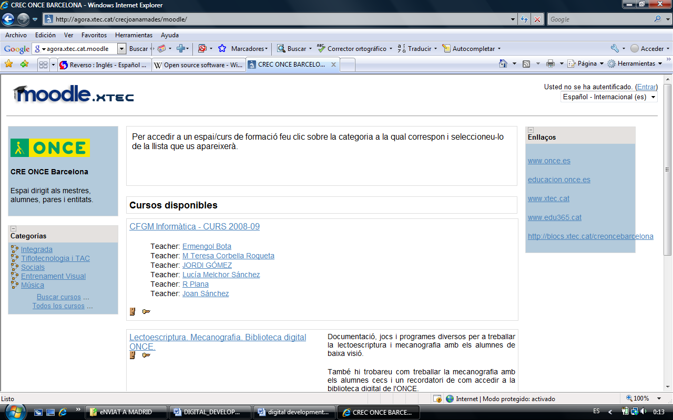

Roles and examples of different courses

We define different roles in our courses. In general we use the Student role except in the case of collaboration with other teachers.

Illustration 2

Types of roles and their description

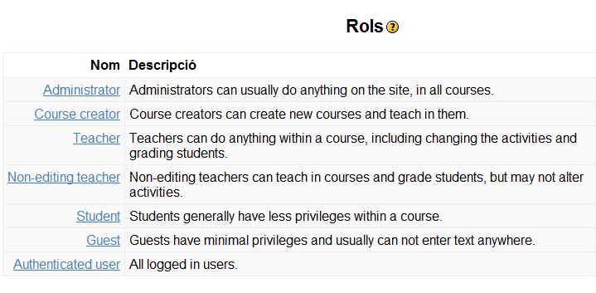

Now, we will show you some examples of courses with different objectives: support and collaboration to ordinary teachers, support with materials and accessible software to support teachers, social forum …

In the category of Integrated School we have created a course to reinforce direct collaboration and support to teachers in mainstream schools.

- CFGM Computing course. This is a special “course” created in collaboration with four mainstream schools in Barcelona (secondary schools, ….). This academic year (2008-09) four students with visual impairment have decided to study higher-level computing at different mainstream schools. Ordinary teachers have all the knowledge to teach their subjects, but they lack experience in teaching blind and low vision pupils. As usual they have the support of a teacher from the ONCE ERC, but we though it was a good idea to use the Moodle platform to promote sharing materials, experiences, solving problems, and so on. The idea is to create a knowledge database of how to teach computer science to pupils with visual impairment. So far the experience has received positive feedback from all the actors. To be more flexible, all the teachers of this course have the role of Teacher, so they can create and add materials, opinions, start forums and questions … everything they need to effectively use this platform.

Illustration 3

Computer course and their teachers

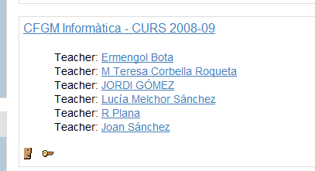

Some courses are created to give information and materials to our support teachers. Support teachers have the role of Student, so they can work with materials, send messages and e-mail the administrator of the course.

- Geography and Writing/reading/typing courses. This means they can use and download from the Moodle platform documentation, software, and so on, to use with their pupil in mainstream school setting. For example, the geography course has accessible maps for blind and low vision pupils, and there is a specific typing course with games and accessible software to learn typing and writing and reading.

Illustration 4

Geography course and typing/writing/reading course

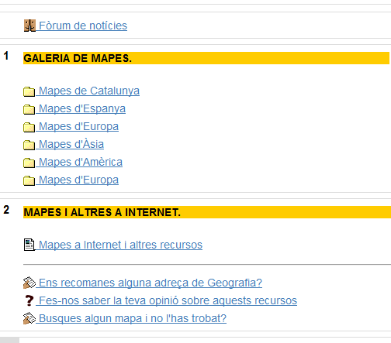
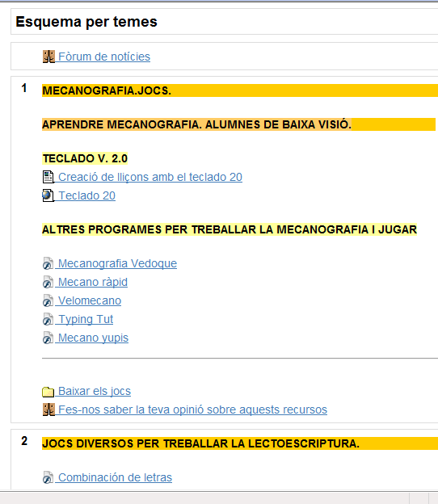

Other courses are created just to be a social forum between different professionals that work together with visual impaired pupils and technicians, specialist teachers or support teachers in the ONCE ERC.

- Music on hands. We have several visually impaired students studying in specialised schools of music. This “course” is the perfect space for ordinary teachers to share experiences, materials and methodologies using the Forum.

Illustration 5

“Music on hands” course. Presentation of the 3rd encounter

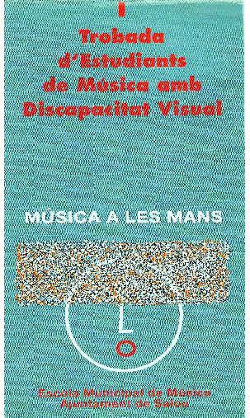
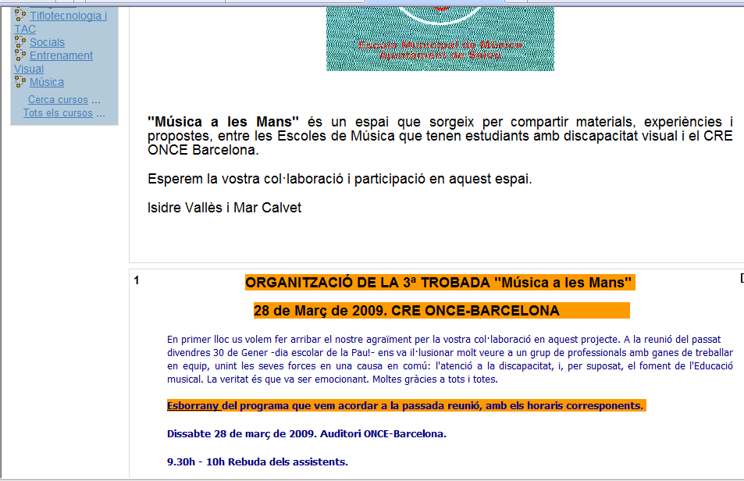

Another example of an interesting course is “The accessibility course” where different institutions or professionals can find documentation, rules and points to make their digital pages or digital books accessible to everybody. For example, we work together with publishers and other organizations that create digital books and other digital content.

Illustration 6

“Digital accessibility” course. Visual criteria, Jclic examples, WAI

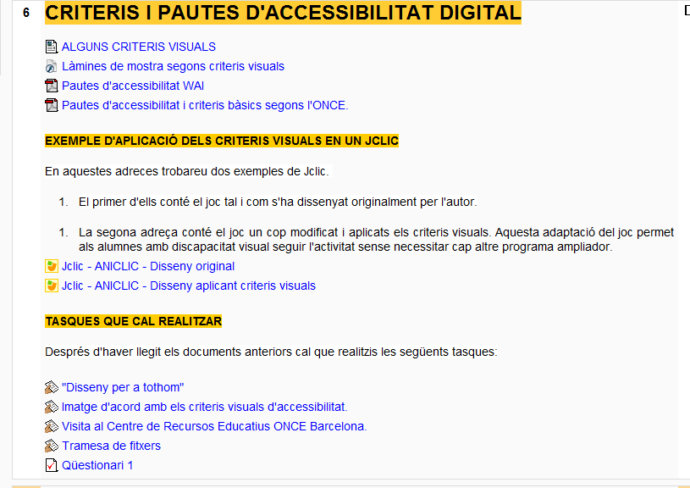
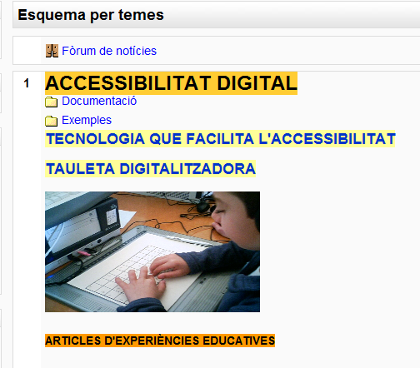

To increase our knowledge we include an area where we promote the participation of clients: a glossary of accessible web pages, a data base with accessible programs, a wiki to create a document (http://en.wikipedia.org/wiki/Wiki ), etc.

Illustration 7

“Help us to increase our knowledge” Accessible web pages, data base of accessible programs, wiki document.

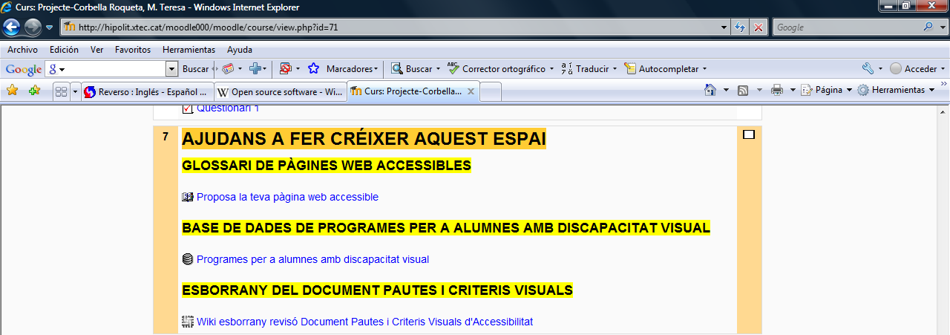

Conclusions of the project.

After designing the virtual work environment in the Moodle platform for the ONCE’s resource centre in Barcelona, we realised that several of the main objectives of the project were accomplished.

The virtual platform promotes participation, collaboration among the professionals involved in the education of visually impaired pupils, and helps our support teachers and technicians to be more efficient in their work. It can also be used to help and share experiences among impaired pupils’ families.

We started to establish criteria for the management and control of the knowledge in the platform, using different kinds of roles to access different courses.

At the moment we are analyzing the advantages and disadvantages of using this tool as a support element for our support teachers’ direct attention work.

This tool is especially interesting in the case of helping pupils that live in the farthest areas from the spheres of influence of the ERC.

All the elements in the platform (courses, learning activities, work questionnaires, collaboration tools –wikis-, spaces for discussion, etc) are very interesting and could be accessible for visually impaired pupils.

In the current economical situation we must be prepared to face budget cutbacks. So this tool will enable us to avoid trips and to share experiences and knowledge.

