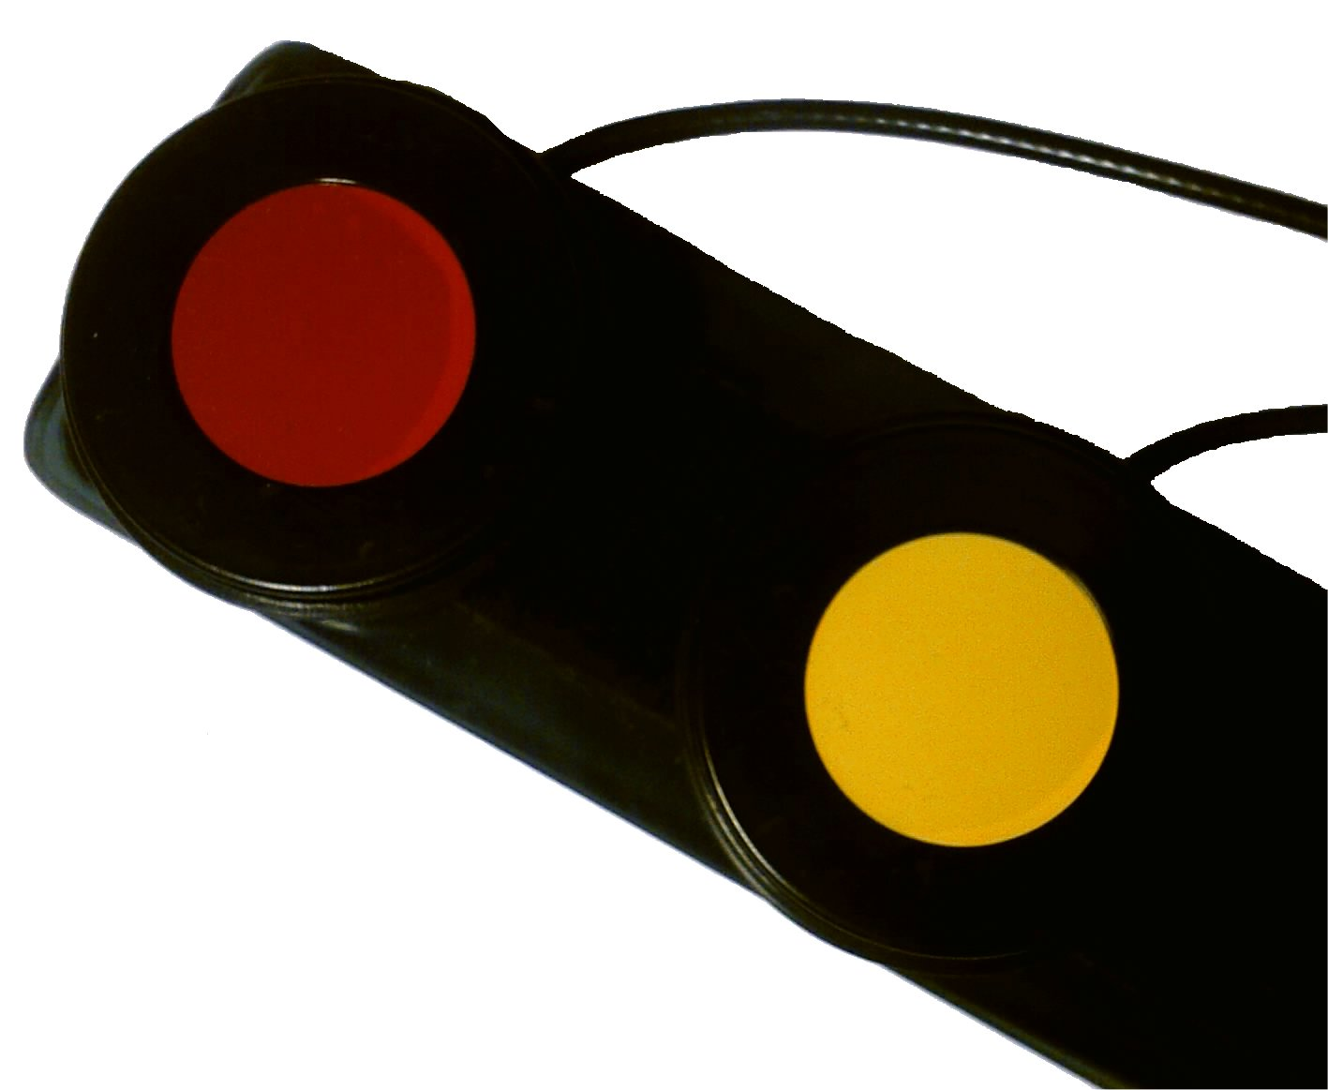
Sarepta
– A powerful multimedia program

Thomas Ragnarsson Johan Björk
Low Vision Instructor / Manager Developer
SPRIDA Communication Center SPRIDA Communication Center
Örebro County Counsil Örebro County Counsil
Box 1515 Box 1515
70115 Örebro 70115 Örebro
Sweden Sweden

+46(0)196024242 +46(0)196024245
thomas.ragnarsson@orebroll.se johan.bjork@orebroll.se

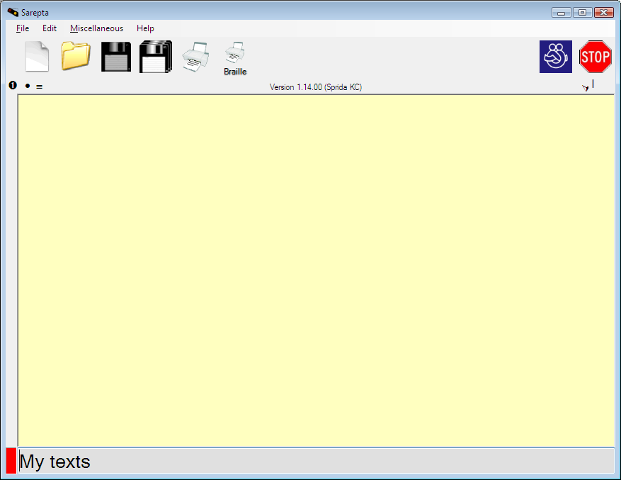
Sarepta is the new Vista compatible version of the program Struktur. It provides tailor-made solutions for a group of pupils that to a great extension lack pedagogical material in school. Teachers, parents etc. fills the program with relevant information. The pupil can then acquaint himself with that material in a number of different ways like text-to-speech conversion, pictures, recorded sound, movie clips etc. Done correctly these preparations give the pupil considerable increased independency.
Sarepta can be controlled with up to five switches. With the help of accompanied software, these five switches can be used to control external applications such as Windows Media Player.

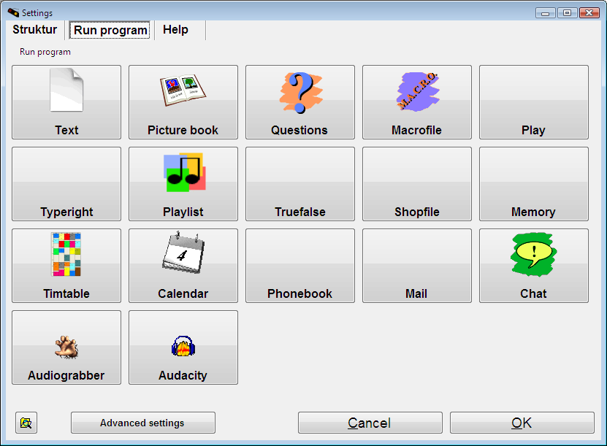
In the program you have access to a number of different modules such as picture book, memory, text, media player, grocery list, email etc. You choose from these modules and pick the ones that will suit your particular pupil. It can range from one module to all modules depending on the abilities of your pupil. Every module can in turn also be adjusted to suit each pupil’s ability and can compensate for vision, cognitive or other interpretation disabilities.

Because Sarepta is flexible, it can be used in basically all subjects. All that is required is that the information is digitalized so that the pupil can access the information in the different possible ways provided by the program.

Our main target group is persons with visual impairment and additional disablements such as motor disorder, Batten disease, autism and cognitive problems in special school, training school or integrated compulsory school.

