THE ORGANIZATION OF THE SCHOOL
FOR VISUALLY IMPAIRED PUPILS
VELJKO RAMADANOVIC

Focus: Achieving Quality in Education: Strategies for Change
Topic: Low Vision

Radmila Laban
School Principal
School for the Visually Impaired Pupils
Cara Dusana 143, 11080 Zemun, Serbia
+311 11 219 611
skolaveljkoramadanovic@yahoo.com

Andjelka Bajic
An English Teacher
School for the Visually Impaired Pupils
Cara Dusana 143, 11080 Zemun, Serbia
+311 11 219 611
skolaveljkoramadanovic@yahoo.com

Far off, in the Town of Berta (Tunisia), in the Barracks of 13 Lamberth Street, in 1917, The Institute for the deaf and blind Serbian First World War veterans started working. It was the predecessor of the nowadays Veljko Ramadanovic The deaf and blinded Serbian first world war veterans were its first clients.

Veljko Ramadanovic was its founder, its first manager and the only teacher who, at that time, knew the principles of the work with the deaf and blind people.

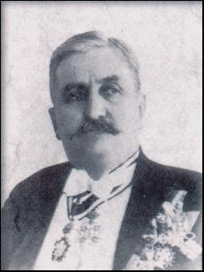

Picture 1. Veljko Ramadanovic

"Lucky should be anyone
who could say:
I was eye to the blind,
ear to the deaf,
legs to the lame and
father and mother to the poor".
Veljko Ramadanovic

Veljko Ramadanovic School for the visually impaired pupils is a recognized state institution, offering the blind and the partially sighted children the opportunities to become independent active individuals.
The work of the school is based upon the mainstream educational syllabus and curriculum adjusted only to the specific needs of the pupils.
It involves:
- The socialization work with the multiple visually handicapped children;
- The early intervention work;
- The preschool work in a kindergarten;
- Eight years elementary academic education;
- Elementary education of the mentally and visually impaired children
- Vocational training.

The vocational training includes:
- In the areas of low, economics and administration;
- Four years training course in the profession of office worker.
- In the area of the PTT communication:
- Three years training course in the profession of switchboard operator.
- In the areas of commerce, tourism and catering services:
- Two years training course for packing skills;
- One years work engagement training course.

In addition, there is a counseling services for the newly blinded, pupils engaged within the inclusive education.

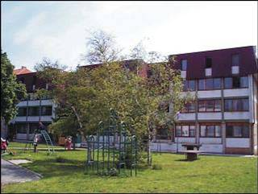

Picture 2. The Boarding School

Boarding facilities offer provide the residents all kinds of entertainment and education.

Only some special programs make a difference between this school and the mainstream ones:

- Orientation and mobility course;
- The Braille literacy training,
- Training in every day living skills;
- Mainstream music school program;
- Special vocational training courses,
- Visual training;
- Tactile-kinesthetic training;
- Psycho - motoric reeducation;
- Physical education adjusted to the specific needs of the pupils;
- Training course in using the assistive computer technologies;
- Youth enterprising.

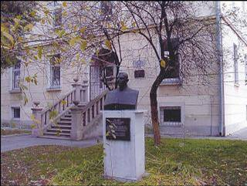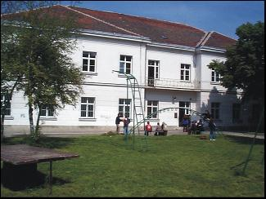

Picture 3. The School for Visually Impaired Pupils

The primary aims of the school are:

- The development of service function for the visually impaired pupils who are included in the mainstream educational system, (methodical help of the tyflologists to the pupils, the vocational help to the teachers and support to the parents).
- The organizing of the inclusion for the pupils who attend our school, and from time to time go to the mainstream schools. (Organizing of the advisory work for the parents of the visually impaired children, early intervention and treatment, the block for the accommodation of the parents and the education of the parents).
- Daily accommodation and programming activities for the children at the age of two to five years, (creation of the centre for the preparing of the materials for the work with visually impaired children). The creation of the new professions for the visually impaired children.

The school site is located in thee central area of Zemun, well-connected to Belgrade City area. The buses: 17, 73, 84, 706, 707, 704.

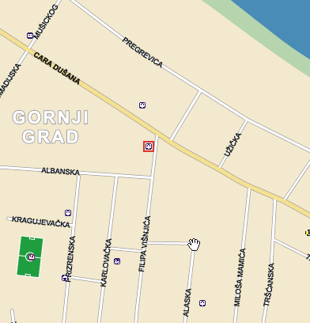

Picture 3. The School Site
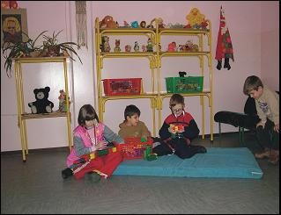

Picture 4. Pupil’s activities

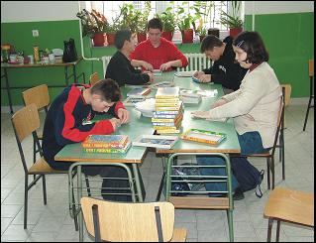

Picture 5. Pupil’s activities

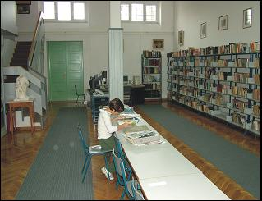

Picture 6. Pupil’s activities

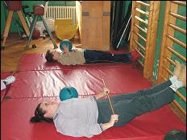

Picture 7. Pupil’s activities

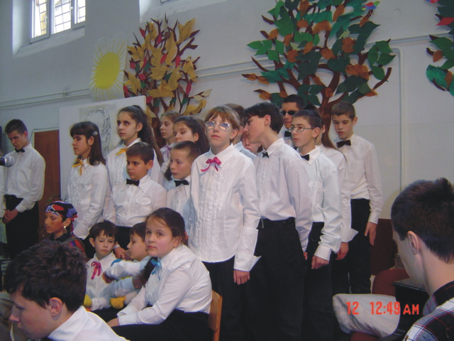

Picture 8. Pupil’s activities

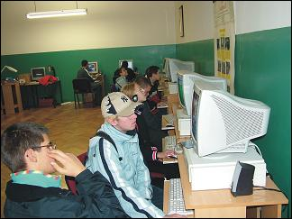

Picture 9. Pupil’s activities

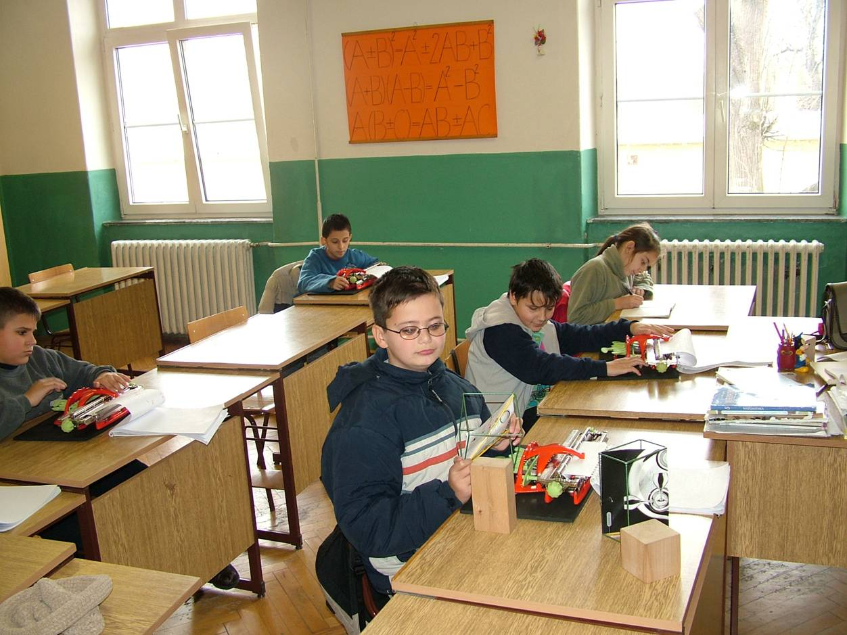

Picture 10. Pupil’s activities

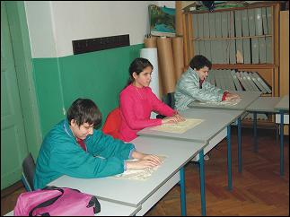

Picture 11. Pupil’s activities

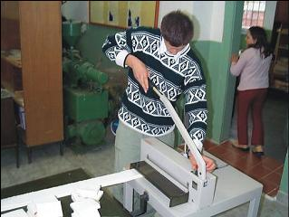

Picture 12. Pupil’s activities

