Teaching deep word knowledge to children with visual impairment

Focus: Early intervention
Topic: language

Mathijs P. J. Vervloed
Behavioural Science Institute
Radboud University Nijmegen
Montessorilaan 3
6525 HR Nijmegen
The Netherlands

00 31 361 60 47
m.vervloed@pwo.ru.nl

Language problems in persons who are blind are well known and mainly concern pragmatics and semantics. An overview is shown in Table 1. Typical problems such as stereotyped speech and echolalia are often only manifest in childhood and disappear thereafter. Still some subtle differences with language development of sighted people may be present in later life, such as appropriate word knowledge and discourse skills. These differences might affect social and emotional development, domains of human life in which persons who are blind often meet serious challenges (see also Table 1).

Table 1
Areas of particular difficulty*

Social Interaction | Personal | Language
- Reactions of stillness  - Non-contingent use of smile and vocalizations  - Does not understand reactions, actions and expressions from adults  - Low social responsivity  - Joint attention  - Difficulty establishing cycles of interaction, social games, routines (regularity and anticipation)  - Absence of typical communicative gestures such as offering, requesting, pointing, etc. | - Problem of social isolation  - Stereotypic behaviours  - Social autonomy: problems with feeding, washing, dressing, moving by themselves  - Physical and personal image  - Understanding social situations  - Relationships with peers  - Social norms | - Tendency to imitate and to repeat (echolalia)  - Excessive use of vocatives  - Egocentric use of talk  - Problems referring to external objects and events  - Some children reverse personal names and pronouns  - Topic maintenance problems  - Behaviours and facial expressions which are not adequate to the communicative context

*Adapted from table 7.2 p. 159 from Pérez-Pereira & Conti-Ramsden (1999)

As can be seen in Table 1 the extent of their vocabulary is not a general problem for children with visual impairment. It is the content of the vocabulary that is sometimes different. They normally are able to properly label objects, persons and situations. However, deep word knowledge might pose a problem for some children with visual impairment. An example is given by Linders (1998). She described a boy with blindness who accidentally stumbled upon a tree. He touched the tree and immediately recognised it by saying, “that’s a big tree”, but he also added, “it must be in a huge pot”. This last remark made completely clear that he did not have a proper understanding of what a tree is. Although he used the proper label, this boy showed that his knowledge of the referent the word “tree” refers to is incomplete and distorted.
For communication about the world people need a deeper word knowledge than simply being able to produce the correct label. Deep word knowledge is more than just knowing the label, it also refers to use of a word and to a proper understanding of the meaning of a word. It has to do with semantic and pragmatic development.

Semantic and pragmatic errors and anomalies are often found in the language of children who are blind. Often these errors and anomalies are called verbalism. Warren (1994) explained their occurrence by the fact that both parents and children with visual impairments adapt their language to the visual impairment of the child. He stated that language learning, and especially learning word knowledge, is difficult for children with visual impairments because language information is often not linked with direct personal experience. As a result of the lack of experience with the referents to which the labels refer, it is hard to develop deep word knowledge.

In this study we took for granted that children with visual impairment show problems in deep word knowledge and started a small intervention study.
Goals of the study were 1) to teach mothers effective strategies for improving their child’s deep word knowledge, and 2) improve the child’s deep word knowledge.

Methods

Table 2 shows some demographic characteristics of the six children that participated in the study with their mother. All children were legally blind, but only one was totally blind.

Table 2
Participants

Number | Age in months | Gender | Aetiology | Visual acuity
1 | 38 | girl | albinism | 7/100
2 | 25 | girl | ROP | blind
3 | 69 | boy | albinism | 7/100
4 | 36 | boy | retinal detachment | 10/100
5 | 43 | girl | congenital nystagmus | 7/100
6 | 28 | girl | unknown | 5/100

The children and their mothers received a six week intervention that was based on current knowledge of language development in children with visual impairment and on techniques from the Hanen language intervention program. Ten unfamiliar words were trained by the mothers, two per week.
Figure 1 lists the techniques parents can use to teach words to their children. The techniques are derived from Manolson (2003).

Figure 1
Intervention techniques for word knowledge
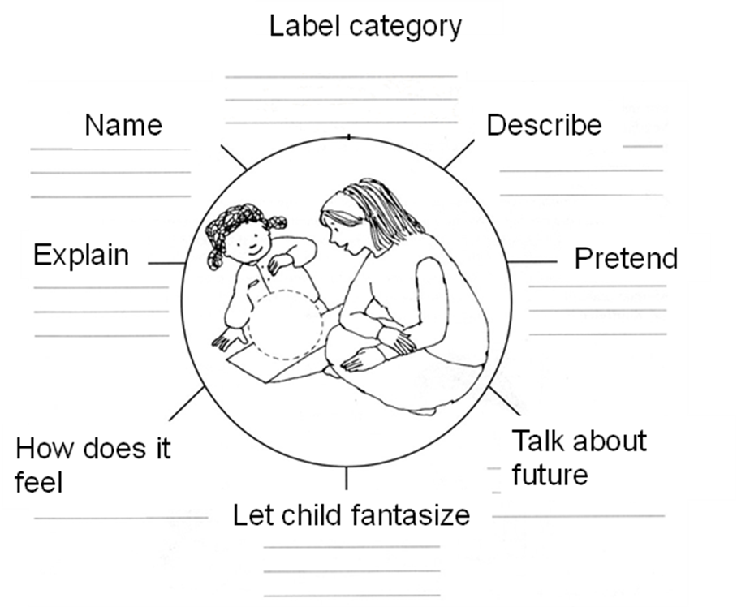

Words were chosen that require visual perception as the easiest way of acquiring proper word knowledge. We did not train words that have referents that can be easily learned and understood by touch, smell or hearing, nor did we train abstract words that can only be learned by applying language itself. Linders (1998) calls the latter two categories nearby-words and abstract-words, respectively. We trained the category which she called further-away-words. These are the words were touch does not give any information or only partial information For instance, dangerous animals, such as crocodiles, cannot be touched. Normally children learn the word ‘crocodile’ by viewing pictures or by watching them in a zoo. An example of a word that can only be partly learned by touch is ‘submarine’. Most children have not visited a submarine. And if they would have done so it is hard to grasp the total picture or meaning of a submarine by only touching it. By interviewing the mothers a list of ten unknown words was constructed for each individual child.
The instruction to the mothers consisted of: verbal explanation, written instruction, exercises/home work, and feedback given from home videos the mothers recorded themselves. If parents did not have a video-recorder of their own we lent them one.
Two baseline measurements and one follow up measurement were performed. So the total study lasted nine weeks. Deep word knowledge was tested by asking the child five questions ( see table 3) in a pre-, post- and follow up test.

Table 3
Measuring deep word knowledge

Number | Question | Aspect of deep word knowledge
1 | How does [word] Look like? | description
2 | Where is a [word] for? | explain function
3 | Where is [word] made of ? | how does it feel
4 | To what does [word] belong? | label category
5 | Can you point to [word]? | correct choice from two pictures

The mothers were taught some techniques to stimulate their child’s language development. First of all they learned some general techniques from the Hanen programme. They were stimulated to follow the child’s lead, to adapt by playing together, and to add language and information to the situation. An example is shown in Figure 2.

Figure 2
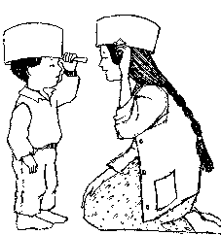

Secondly, they were instructed to use the techniques described in Figure 1. The instructions were given in writing and verbally, but also as verbal feedback on the home videos.
The techniques used by the mothers were assessed by observing videos made by the interventionist during the first and last home visits and counting the number of different techniques used. Inter-observer agreement ranged between 0.85 and 0.99 for the eight techniques.

Results

Table 4 shows the results for deep word knowledge for each individual child. As a group the children improved significantly in word knowledge at the end of the study, t(5) = -8.399, p < 0.001, and at follow up, t(5) = -7.815, p < 0.001.

Table 4
Results deep word knowledge

child | Number of correct answers  range 0-50
child | Pre-test | Post-test | Follow Up
1 | 5 | 28 | 43
2 | 0 | 16 | 16
3 | 1 | 40 | 45
4 | 9 | 36 | 37
5 | 10 | 42 | 43
6 | 13 | 38 | 40

All but one mother used more techniques for teaching word knowledge (see table 5). The most common techniques were labelling, explaining and giving descriptions. To study whether the mothers used a technique more often after intervention we calculated normalized gain scores. Normalized gain scores depict the relative change compared to the maximal gain that can be achieved. Scores were converted to proportions by taking the sum of the number of techniques used in the pre- and post-test per mother as 100%. In this way we could compare mothers with very different base rates. The proportion of techniques used was imported in the equation for normalized gain scores: Gain (g) = (posttest-pretest)/(1-pretest).

Table 5
Techniques used by mothers (n=6)

Technique | Mean pre-test | Mean post-test | mean overall Gain | mean overall Gain minus one mother
Label Category | 0.00 | 0.00 | 0.00 | 0.00
Describe | 3.67 | 5.50 | 0.03 | 0.06
Pretend /act as if | 0.25 | 1.50 | 0.02 | 0.03
Talk about future | 0.42 | 0.50 | 0.01 | 0.01
Let child fantasize | 0.50 | 2.00 | 0.03 | 0.04
How does it feel | 0.50 | 1.17 | 0.01 | 0.02
explain | 4.33 | 10.50 | 0.13 | 0.17
label | 9.92 | 10.33 | 0.00 | 0.01

Substantial changes can be found in Table 5 for describing, pretend/act as if, fantasizing, and explaining. The results were even more prominent if we excluded the mother who did not show substantial gains.
Giving category names and describing how objects feel were hardly used. Most children were subsequently not able to answer questions about how the object felt or to which category it belonged (see Table 6).

Table 6
Correct answers during Follow Up
Child | question 1 | question 2 | question 3 | question 4 | question 5
1 | 10 | 10 | 9 | 4 | 10
2 | 6 | 0 | 0 | 0 | 10
3 | 10 | 10 | 9 | 6 | 10
4 | 9 | 7 | 6 | 5 | 10
5 | 10 | 9 | 8 | 6 | 10
6 | 10 | 7 | 4 | 9 | 10

Discussion

In this small intervention study it was possible to train five out of six mothers how to teach young children the word meaning of ten hitherto unknown words. The Mothers used not only more techniques after intervention but also more diverse techniques. The children’s word knowledge broadened after intervention and this effect seemed permanent given the positive results during follow up. Moreover, the kind of techniques used by the mothers seemed to affect the sort of word knowledge the children acquired. Category names and descriptions of how objects feel were hardly used by the mothers, not before and not after intervention. As a result the children were also not able to answer questions about categories the word belonged to and the material the referent for the word is made of. Given the ages of the children it is not very surprising that they were unable to name the category labels. Normally children will be a bit older before they can categorise. But still the data showed that their mothers did not present them with examples of category labels.
The technique talking about the future was not especially assessed in the children, so it is impossible to conclude at this moment whether this technique should also be a topic in the intervention.
The intervention consisted of several parts: verbal and written information, exercises during home visits, home work and video recording made by the mothers themselves. The video recordings were subsequently scored for intervention techniques and feedback was given to the mother at the next meeting. At this moment it is unknown which part or parts of the intervention caused the behavioural changes in both the children and their mothers. Future research should figure this out, because the intervention was quit time-consuming. Especially the video-recordings, their scoring and the subsequent feedback took much time. However, at the same time we feel that this video-feedback added substantially to the intervention effect. We could comment on real behaviour and not on behaviour that is remembered. As a result we were less depended on the verbal capacities of the mothers. The recordings were made in familiar surroundings which added ecological validity to the measurement. It also provided the interventionist with an extra tool besides techniques such as verbal advise, demonstrations and modelling.
Based on the literature (see e.g. Warren, 1994; Perez-Pereira & Conti-Ramsden, 1999) vocabulary problems seem not to be a great concern in the development of children with visual impairments. In our opinion the point mentioned in table 1: ‘problems referring to external objects and events’, the phenomenon of ‘verbalism’, and the social problems of children with visual impairment and blindness might have to do with deep word knowledge. However, the extent to which children with visual impairment show problems in deep word knowledge should be studied further. Since we think that perception is crucial for the mode of acquisition for learning words, one must differentiate between children who are blind and who are visually impaired. Grouping the children together under the label legally blind does not suffice. Whether or not deep word knowledge is a real problem amongst children who are blind or visually impaired is currently a subject under study at our department.

References

Linders, C. M. (1998). Zweeftaal en andere raadsels in het woordbegrip van blinde kinderen. [ Huizen: Visio.
Manolson, A. (2003). Praten doe je met z’n tweeën. [translation of It takes two to talk] Utrecht: NIZW.
Perez-Pereira, M., & Conti-Ramsden, G. (1999). Language development and Social Interaction in blind children. Hove, UK: Psychology Press.
Warren, D.H. (1994). Blindness and children. An individual differences approach. Cambridge: Cambridge University Press.

