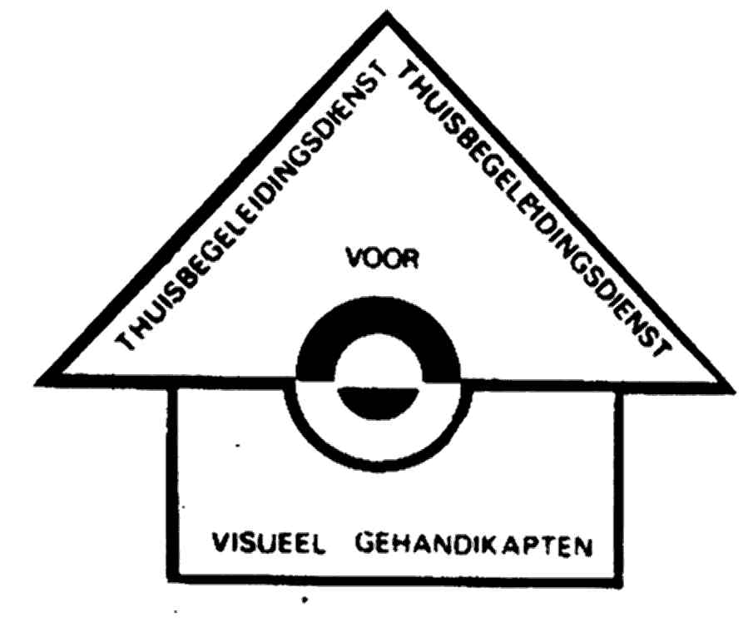

CHILDREN WITH CEREBRAL VISUAL IMPAIRMENT (C.V.I.)

A specific challenge in the care of children with visual impairment
Eliane Bonamie

1. C.V.I. : A variety of appearances

Based on the ICIDH classification, we distinguish C.V.I. on 3 levels :
− impairment
− disability
− handicap

1.1. Level of impairment

C.V.I. is a disturbance of vision caused by a defective function of the retrochiasmatic part of the visual system, caused by a damage of the posterior visual pathways and/or the brainlobes, dealing with vision. We know that 60 % of the braincortex is involved in the visual perception (= the neurological aspect).
Remarquable is that with C.V.I the reflexes of the pupil are normal and nystagmus is rare.

Quiet often occurs also an ocular disease (= ophtalmological aspect), with problems in the visual functions. The acquity, the field and the eye movement can be subnormal, abnormal or normal. Refractive errors and strabismus can be present. Funduscopy can reveal pale optic discs.
The degree of neurological damage and visual impairment depends upon the time of onset : pre-, peri-, postnatal; as well as the location and the intensity of the insult.

1.2. Level of disability

The combination of these different problems has naturally a diversity of consequences for the functioning of the child.

Concerning the general development we notice a continuum of children who function in a bodytied stage to children who attend normal classes. The children of the first group (about 50 %) have a developmental age of six months, and they are oriented to services for severe multiple handicapped children.

About one third of the group is oriented to specific services for visually impaired children, or mental or physical and motorial impaired children.

From 5 to 10 % of the children are ready to follow a programme in the normal schools, thanks to the efforts of home guidance and rehabilitation services.

In this introduction I also want to draw the attention to three special characteristics of the development of children with C.V.I. :

- A disharmonical profile of development : these children have a weak motorial substructure; their performal function is obvious worse than their verbal function.

- A weak to disturbed sensorial integration and a large stress sensibility, that causes difficulties in getting through diverse stimuli at the same time.

- A number of typical personality and social behaviour problems take place in : • regulation of tension and relaxation • frustration-tolerance • quality of contact • know how to deal with structure • attention and concentration

Concerning the more specific visual perception, restrictions occur like : • the visual attention and attentiveness • the arrangement of visual information • the recognition and name (= what-question)
• the visual guidance of acting in space and work (where-question)

1.3. Level of handicap

About the level of handicap we often notice a negation or a delayed detection of the visual perception problems. This has to do with the complexity of the phenomenon C.V.I. and with the discrepancy between the ophtalmological experiences and the visual behaviour.

These children are considered as inattentive, not focused, slow, lazy, mental weak or blind and are not approached as low vison children. This brings feelings of unsafety and insecurity for the children and their parents.

In this lecture I want to draw your attention to the CHARACTERISTICS OF THE VISUAL BEHAVIOUR and adjoining the SUPERVISED PROGRAMME.

I would like to summarize :

- C.V.I. has a variety of appearances ;
- The population of this preschool age is very hard to differentiate concerning the evolution of the general development and the visual perception in particular ;
- Correct statistic data are not available ;
- We based us on our own clinical experiences with pediatric C.V.I. in home guidance in Flanders. Our conclusions need to be interpreted with caution.

2. Service for early intervention at home and cerebral visual impairment

We meet children with C.V.I. in the ambulatory centres (home guidance, centres for rehabilitation, normal and special schools), as in institutions as well.

Home guidance is a service for families with children-youngsters between 0 and 18 years, with a visual (multiple) impairment. It is part of an institute for visually impaired and is financed by the government.
In Flanders (this is the northern part of Belgium) are two authorised centres : ours in Bruges and a colleague centre in Brussels.
Our task is to give educational and psychological care to the families (parents, children,…). About 15 % of our population are children with C.V.I.

The following approach is a description from our CLINICAL PRACTICE WITH BABIES, TODDLERS WITH C.V.I. ON PRESCHOOL AGE.

3. Characteristics of visual behaviour

- Children with C.V.I. are rarely 100 % blind, even when there is no visual reaction during the first year of life.

- Vision appears to be variable : sometimes on, sometimes off, changing minute by minute, day by day. An intermittent lack of visual attention is often seen.

- Children with C.V.I. show a lack of visual curiosity, they have no desire to discover their environment in a visual way. They will prefer to listen and to touch.

- When these children have also a defective in their range of vision (looking through a piece of Swiss cheese, hemianopsie), they will have difficulties to compensate.

- Though a equal luminance is important, one third of the children are photophobic.

- Children may exhibit poor depth perception, influencing their ability to reach for a target and to match their movements to the surroundings.

- Recognition of people can be selectively impaired ; sometimes a child can’t recognize faces at all, even when he can see a person.

- Visual memory, used for copying tasks, is very weak.

- Children with C.V.I. may, in general, use their peripheral vision when presented with a visual stimulus, appearing as if they are looking away from the target.

- Some children look at an object momentarily and turn away as they reach for it.

- Overstimulation and complex situations, can result in fading behaviour by the child or in short visual attention span.

- Close viewing is common, to magnify the object or to reduce crowding.

- Children with C.V.I. may experience a crowding phenomenon when looking at a picture : they have a difficulty with differentiating background and foreground visual information.

- Familiarity with the environment appears to enhance visual performance.

- Vision may be better when either the visual target or the child is moving.

- Visual self-stimulation is rarely ; gazing at sources of light, windows, doorways,… occurs quiet often.

4. Early intervention approach

4.1. Starting-points

- Together with parents (family, grandparents, …) we draw up a realistic programme.
- Intervention of visual perception is part of the integrated offer of the early intervention approach. I explain :

Parent (grandparent)-support : questions of acceptance and assimiliation, information about the visual handicap and low vision expedients, questions about education and social contact, attention for the grandparents, sisters and brothers.

Childfocused support : where we try to observe, to understand and to stimulate the general development : physical and motorial, perception, communication, play, self-help and mobility.

4.2. Intervention programme

4.2.1. In this programme we stress the specific aspects of intervention for children with visual impairment. These aspects are :

- to promote the sensorial stimulation with a lot of attention for the vestibular and vibratial stimulation.
- to create possibilities of acceptance, assimilation and expressions
- to work with motoric discharge and impulse control
- to learn by practice
- to structure time and space
- to draw up a step-by-step programme with games and activities
- to give behaviour support while learning social skills
- to stimulate the tactile and auditory perception
- to stimulate the visual perception

You see that every moment the intervention of the visual perception is part of the general intervention. The aim is to ask, to support and to improve the visual consciousness and attention, the fixation, the pursuit of the eye movements, the scanning and structuration, the reaching and grasping and visual communication.

4.2.2. The programme of intervention can be divided up into three levels :

- Advise that parents can use in the daily living skills, as to show an explicit expression on the face (e.g. wearing lipstick or pointing a lightspot at the parent’s face), the visual emphasize of daily used objects (e.g. to mark a feeding-bottle with a black and white design), to give extra lighting, movement and use of the voice.

- To introduce environment adjustments in the crib, the box, the playcorner and the living area by extra lighting, nearness and colour contrast. E.g. a plain play-blanket in contrast with the colourful toys, a dark corner with black light.

- Focused stimulation by explicit visual activities with the black box, video tapes, slides, flashing light, light box.

4.2.3. Attention to the way of intervention

- Some children find difficulties in isolating the visual stimulus in the ordinary daily environment. For these children it’s better to work in a room with as less stimuli as possible and with a limited offer of materials. Give the child time to adjust to the new environment.

- Give the child an easy and stable starting position, keep the child comfortable when vision use is the goal, this is a must for children with fysical problems.

- Look for a good moment of attention : fatigue, hunger, illness, medicaton, epilepsy, have an influence on the visual perception. Some children need to be alerted by vestibular or vibratial stimulation.

- Stimulate a few times a day for short moments.

- Use familiar and real objects and activities that motivate the child.

- The simpler, more constant and more predictable the visual information, the better the child will deal with it.

- Use great contrasts, bright colours, extra lighting or darkness, a clear distinction between figure and back-ground.

- Movement and noise can provoke the attention.

- Allow for intermittent breaktimes.

- Repeat a certain offer in order to provide familiarity and security for the child.

- Give the child enough time to react (count slowly up to ten). Allow lots of time for the child to see and to respond.

- Stimulate during a long period : minimum a few months.

- Be aware that after a long interruption (e.g. admission into hospital) the chance for a complete or partial step backwards is realistic.

- Don’t conclude to fast that a certain stimulus provokes or doesn’t provoke a certain reaction with the child.

- Observe the reactions of the child and learn to interpret each subtle response cue. This is based upon the ethological observations of professor Van Nieuwenhuizen (The Netherlands).
With him we distinguish : 1. Direct signs or behaviours indicating the visual perception of stimulus, such as : intermittent fixations towards the stimulus, looking behind the stimulus, head movements towards the stimulus, following the movement of a stimulus, reaching for the stimulus, looking away while reaching the stimulus, …

2. Indirect signs or supportive and confirming behaviours as : avoiding behaviour, change of posture, smiling, blinking of eyes, facial expression, stereotypic behaviour.

And keep in mind :

“When a child with C.V.I. needs to control his head, use his vision, and perform fine motor tasks, the effort can be compared to a neurologically intact adult learning to knit while walking a tightrope.”

5. CONCLUSION AND APPEAL

5.1.Conclusion

- C.V.I. is a complex phenomenon and has a variety of appearances.

- Early intervention programmes can favourably affect visual development. Most children undergo gradual functional improvement with time.

5.2. Appeal

We appeal for :

- Cooperation between : parents and professionals, between field-workers and scientists of universities, between diagnostici of the assessment centres and carers of the services.

- Sharing and collecting clinical experiences with the audience.

- Concrete actions :

- Disturbances of cerebral issues subserving vision are more difficult to understand and we believe that a model of clinical categorization with visual behaviour and behaviour in general, is needed to classify paediatric cerebral visual impairment in accordance with observations of parents, teachers and carers. We draw up a list of the inventory.

- Clinicians involved in the study of neurologically impaired children should be aware of the presence of every direct or indirect sign which may indicate the presence of residual vision, and should acquaint parents with these signs, in order to facilitate their comprehension of the problem and improve their visual communication with the child. We draw up a list of signals. With professor Van Nieuwenhuizen (The Netherlands) we ask for further ethological studies by means of more sophisticated computerized observation programmes to indicate possible cerebral visual disorder at an early stage and to our understanding on neurobehavioural adaptations developed by children with C.V.I.

- Report by a visual assessment team summarizing the visual abilities and disabilities with recommendations for developmental and educational material, can be an invaluable adjunct to the child’s care plan.
The foundation of a C.V.I.-clinic is very close by. (Professor Van den Bussche - Leuven Belgium)

- Regional cooperation of all services, involved in the intervention of the C.V.I.-population is founded.

- An action committee of parents and professionals is founded to : • support the parents to recognize the C.V.I.-problem • aspect of self-help • spread the message

Eliane Bonamie, psychological pedagogue, coordinator Home Guidance Service Visually Impaired Children and Youngsters.

Institute Spermalie, Snaggaardstraat 9, 8000 Brugge, Belgium.
Tel. (32)50.340.341 Fax. (32)50.337.306 E-mail : infompi-spermalie.be

References

- Meire F., Kinderen met een visuele handicap, Acco 1995, Leuven, België.

- Van den Bussche E., Onderzoekprojecten K.U.L. afdeling neuropsychologie, Leuven, België.

- Van Nieuwenhuizen O., Visual Behaviours of neurological by impaired children with C.V.I. : an ethological study, Journal Ophtalmology, 1998.

- Van Nieuwenhuizen O., Clinical and neuro-radiological finding of children suffering from permanent C.V.I., Journal Ophtalmology.

- Groenveld M., Observations on the habilitation of children with C.V.I., Journal of visual Impairment and Blindness, 1990.

- Groenveld M., Behavioural characteristics of children with C.V.I., Developmental Medecine Child Neurology, 1987.

- Dutton G., Who is a visually impaired child, Developmental Medecine Child Neurology, 1999.

- Van de Grind W., Basaal : Bewust zien en zijn, Neuropraxis 2000.

- Hubel D., Eye - Brain and Vision, Scientific American Library, New York.

- Kolb B., Fundamentals of human neuropsychology , Freeman and Company, 1980.

- The experiences of the children, the parents and ourselves. The collaboration with our colleagues.

Cerebral Visual Impairment (C.V.I.)

- C.V.I. : a variety of appearances

- Service for Early Intervention at Home

- Characteristics of Visual Behaviour

- Early Intervention approach

- Conclusions

Impairment

⇒ Neurological Aspect

⇒ Ophtalmological Aspect

Disability

⇒ Development : continuum
special characteristics

⇒ Visual Perception

Handicap

Characteristics Visual Behaviour

- rarely 100 % blind

- variable vision

- visual inattention

- field problems

- photophobic

- depth perception problem

- to recognize faces

- visual memory problem

- peripheral vision

- combination see - act is difficult

- often to many stimuli

- close viewing

- differentiating background-foreground is difficult

- familiarity

- moving

- rarely self-stimulation

Early Intervention Programme : an integrated offer

The intervention of the visual perception is part of the general intervention

⇒ situations of daily care

⇒ adaptations of the environment

⇒ visual activities

Pay attention to :

- room with as less stimuli as possible

- stable starting position

- attention, vestibular stimulation

- short moments

- familiar objects

- simple, colour, contrast, lighting,…

- movement, sound

- breaktimes

- repeat

- time of reaction

- long period

- long interruption - step backwards

- observation

Conclusion

Appeal for

