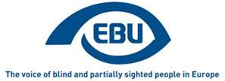

EBU Members' Newsletter 2022

Number two, February.

OUR CAMPAIGNS

Accessibility

Books - Marrakesh Treaty
News from European Commission’s DG CNECT: the assessment of the availability of printed works for persons with disabilities in light of the Marrakesh Treaty Directive will take place by October 2023. It will include an assessment of “the impact of compensation schemes (provided for by Member States pursuant to Article 3(6) of the ‘Marrakesh’ Directive) on the availability of accessible format copies for beneficiary persons and on their cross-border exchange." The Commission took note of our request to have sufficient time to prepare a meaningful contribution. Nevertheless, we will start collecting feedback from our members in the EU already in 2022, to be ready with a draft report in 2023.

Accessible e-books – Implementation of Accessibility Act
We had a meeting with the Federation of European Publishers, Fondazione LIA, the Daisy Consortium and EDF to discuss whether the Act should cover the backlist of previously published e-books. We firmly expressed the position that the EAA is clear in requiring retrofitting and that there should be no blanket exemption based on disproportionate burden; but that we are willing to assist with criteria to prioritise retrofitting (we already mentioned profitability, popularity and date).

Accessible films
We carried out a first analysis of the first five MEDIA calls for tenders in 2022 and issued a statement to express disappointment that the ambitions of the Disability Rights Strategy have not materialised.
In Disability Platform, in reply to our question about the use of EU funding, the Commission confirms that, contrary to the regulation applying to cohesion funds (ESF+, ERDF…), there is no obligation for Creative Europe funding to have measurable goals, data collection and monitoring mechanisms on disability.

Accessible lifts
We responded to the ANEC request for comments on draft EC standardisation request on lifts. In particular we welcomed the repeated stressing of the relationship between EN 81-20 (general safety standard on passenger and goods lifts) and EN 81-70 (accessibility to lifts standard).

Accessible web
Montenegro and Serbia have responded positively to our call for expression of interest to engage on promoting web accessibility rules at national level with the EU Directive as a role model.

Accessible payment – implementation of Accessible Act
So far 10 of our members have nominated experts to participate in an EBU taskforce on accessible payment terminals. Our Commission for Liaising with EU confirmed the creation of a taskforce, with a core-group of leaders. A call was sent to other would-be leaders (besides our Ducth member) to come forward.
We started to do some desk research on the relevant EU standard (EN 301 549 on the accessibility of ICT products and services) which is common to payment terminals, ATMs, ticketing services and other self-service terminals. The taskforce will need to accompany the revision of version 3.2.1 of this standard which the Commission’s standardisation request to European standardisation bodies will call for.

Equality

EU package to improve labour market outcomes of persons with disabilities
At an EDF-ENGO meeting we shared our priorities in this area and called our partners to act consistently with the European Parliament resolution 2021, to which we all extensively contributed.
At the Disability Platform meeting, we learned that the package will not take the traditional form of a Commission initiative. The work will divide in 6 key themes to improve labour market outcomes for PWDs: (1) strengthening capacities of employment and integration services; (2) promoting hiring perspectives through affirmative action and combating stereotypes; (3) ensuring reasonable accommodation at work; (4) securing health and safety at work contributing to prevent disabilities; (5) securing vocational rehabilitation schemes in case of chronic diseases or accidents; (6) exploring quality jobs in sheltered employment and pathways to the open labour market. The French Presidency disability conference of 9 March and then the Czech Presidency’s in September will be geared toward EU Council Conclusions.

Social security and welfare

EU Disability Card
At the Disability Platform meeting, the Commission indicated the key questions: Which services covered? The nature of the measures (i.e. regulated or voluntary)? Which instrument of EU law? What Member State coverage? A separate card or one single card with the Parking Card for persons with disabilities?

Benefits
The Commission announced a proposal for a Recommendation on minimum income, scheduled for September 2022, with targeted stakeholders' consultation in February-March.

Mobility
We had a bilateral meeting with the International Transport Forum’s Secretariat. The principle of a slot in the 2022 edition to bring the perspective of blind and partially sighted people on CAVs seems to be agreed. We are waiting to hear back from them on which specific angle interests them more and where it would be fit in the program. We were also invited to contribute to the ITF blog before the forum.

Representation

European Disability Platform
At the first plenary meeting of 2022 (18 February) we intervened to deplore that the Equal Treatment Directive is not mentioned in the Work Programme 2022. Commission reassured us that it is "still very much on their map" and that we should feel free to use the AOB slot of meetings to raise it. The Czech representative added that the Czech Presidency will continue if some progress is made under French Presidency.
Regarding statistics, the Eurostat representative confirmed that there will progressively be a disability breakdown in all existing data collections, and in particular in the EU Labour Force Survey from 2023. He said that it would be possible to have different harmonised definitions of disability depending on the type of survey, using to the Washington Group set of questions; but that disaggregation by type of disability was impossible in the current setting, other than from the health approach, and only every three years.
The Platform decided to create three thematic sub-groups (so far) for the delivery of the following ‘flagship initiatives’ of the Disability Rights Strategy: the Employment Package, the Disability Card and the resource centre Accessible EU. We have expressed interest to participate in all three of these sub-groups.

Other meetings and events
A first ad hoc online thematic meeting of our Commission for Liaising with the EU was held on 22 February, to discuss the implementation of the European Accessibility Act—with a presentation from EDF representative Alejandro Moledo and a focus on payment terminals—and the introduction of new Euro notes.
Our Head of Advocacy and Campaigning gave a presentation at the NCBI Advocacy Talks on 17 February, to present the EBU campaigning activities

Review of the EU by the UN CRPD committee
The private meeting with the CRPD is set for 16 March. We are still waiting for confirmation from the CRPD Secretariat that we will be allowed to attend even if we are not presenting an alternative report.

The EBU 2022 Action Plan
The EBU 2022 Action Plan sets out actions to be conducted in 2022 to implement the Strategic Orientation Plan agreed by the 11th EBU General Assembly.
The document also identifies the bodies responsible for implementing the action, as well as the source of their funding. You can thus see the ten key points which will guide the work of EBU for 2022 and how they will be carried out.
We hope you find this document useful and we look forward to working with many of you in the implementation of these actions over the course of 2021 to further advance the inclusion of blind and partially sighted people throughout Europe.

EBU is looking for an External Communications Officer! (February 2022)
In order to broaden, develop and promote its work to external audiences, the European Blind Union (EBU) is looking for an External Communications Officer.
APPLICATION DEADLINE: 13/03/2022
ANTICIPATED START DATE: As soon as possible.
JOB TITLE: EBU External Communications Officer
TYPE OF CONTRACT: Full-time (35h per week) and permanent, French-law.
LOCATION: Paris, France; other arrangements like home-based work are open for discussion.
MOBILITY: Regular foreign trips will be required.
REPORTING: The External Communications Officer reports directly to the EBU Executive Director.
SALARY: €2600 monthly gross + 13th month + lunch vouchers and complementary health insurance.
SUMMARY OF POSITION: Job description for External Communications Officer (pdf file)
Willing to join our organization and help change the lives of millions of blind and partially sighted persons? Send your CV and cover letter in English to eburecruitment@euroblind.org by the above dates. Applications by persons with disabilities are encouraged. Applicants must have a valid work permit for working in France. Please note that only shortlisted candidates will be notified.
Please note that a written exercise and an interview will be carried out for this position; Both will take place beginning the 21/03/2022.

New EBU materials coming through!
2021 is behind us and it is now time to share recent news dealing with the many activities implemented by EBU and its members. A more comprehensive overview of our work last year will be available in our annual report.

Braille
The EBU Working Group on Braille put together a list of national Braille authorities in European countries as well as a statement, which will serve as a solid basis for our position paper in 2023. WG members also worked on the synopsis of an awareness-raising video to be produced in 2022. Finally, the www.livingbraille.eu web forum is being finalised and will enable braille experts to exchange and discuss braille use, teaching, literacy in the 21st century.

Culture
Culture is not forgotten! Following last year’s call, a publication compiling good practices on access to museums and cultural heritage sites was produced. A video on access to culture and sports is also available and important work on audiodescription will be formalised in 2022.

Low vision
New Low Vision Focus Group Meetings (LVFGM) were held in Hungary, Ireland and Sweden. Attended by 51 partially sighted persons, they highlighted both external and internal awareness raising on low vision as the most pressing actions. The 2021 LVFGM report is available upon request.

Translations
Finally, the following EBU materials are available in an increasing number of languages:
- The UNCRPD - A New Look At Our Human Rights – 13 languages
- Gender Equality Toolkit “The Future We Want” – 7 languages
- How to memo on Twitter – 17 languages (upon request)

What next?
New activities will be initiated in 2022. They will again benefit from financial support from the European Commission, in particular under its new CERV programme (Citizens, Equality, Rights and Values). Activity leaders will start their work very soon, so watch your mailboxes!

For more information on EBU activities, please contact Romain FERRETTI, EBU Project Manager, at ebuprojects@euroblind.org.

Join in the Gender equality awareness raising, GEAR 2022!
Each year, starting from 2020 funds are available from the EU to improve and increase gender equality in the EBU member organizations.
Up to three member organizations per year can apply for and participate in this project. In doing this you have to conduct activities in your organization to increase the awareness of extended gender in all decision-making bodies, train and promote members, most often women to participate to a greater extent and make their voices heard. A general outcome that EBU would like to see when the project is terminated in each country is that there are plans and actions decided on how the organizations shall continue to work with gender.
In 2021 GEAR was conducted in Germany, Iceland and Montenegro.
Reports of what has taken place in 2021 and 2020 are available upon request to Romain FERRETTI, EBU Project Manager, at ebuprojects@euroblind.org.
In this article we will quote information from Iceland. In spite of the late start of their activities they have managed to do a lot and they have a substantial number of insights useful for others.
We hope that this will inspire other EBU members to join this project!
Eva Nilsson
GEAR project leader
Swedish association of the visually impaired, SRF
Eva.nilsson@srf.nu
Iceland joined the GEAR project first in the middle of the year and started the activities in the autumn. Rhetoric training and coaching were the activities valued most. The self-confidence of the participants has grown and therefore they have formed a group of women in different ages who are eager to keep on working together in the future. They can support each other and inspire each other. This is important even though we already have a gender equality committee.
We managed to arrange all the activities face to face and asked the participants to take a rapid antigen test at home. In that way everybody felt safe.
The fact that men hardly participated in this project even though they were encouraged to do so shows that gender equality is women´s issue. It is a pity since it reveals the real situation in these matters: specially in the Nordic countries we have reached a lot – we have a good gender balance in the boards in our organizations – but that is not enough. We need to get both men and women involved in these matters to continue this work.

Portugal - If you want to vote, ask for it in Braille!
Recently, on 30th january, Portugal celebrated its elections to parliament. All voters registered in the national territory could choose to register for the early voting that took take place one week before, on January 23rd.
The registration for early voting must be done between the 16th and 20th of January, through the public website www.votoantecipado.mai.gov.pt. When accessing this electronic platform, voters simply had to enter their personal data as full name; birth date; civil identification number; address; polling station in the municipality where they intend to exercise the right to vote early, and contacts
After concluding this operation, on January 23, voters simply had to present themselves at the chosen polling station, in possession of a valid identification document, and indicate the local in which were registered in the voter registration.
The problem for visually impaired voters begun with the need to introduce a security code presented in images. This detail prevented the full accessibility of the electoral process, a commitment assumed by the Portuguese State, and kept the visually impared voters in disadvantage compared to other citizens.
After the complaint filed by ACAPO in September, regarding the inaccessibility of the Electoral Census website, where it was mandatory to introduce a security code, present in an image and, as such, inaccessible for reading by screen readers used by visually impaired persons, ACAPO once again presented a new complaint, this time concerning access to the early vote request website, which is currently inaccessible to these persons.
As a protest, ACAPO challenged its members who wish to request the anticipated vote to do so by sending a letter, with their name, civil identification, address and municipality where they intend to vote in advance, for the General Secretariat of the Ministry of Internal Administration, but sending this letter in Braille – it is our right to correspond in Braille with public entities, a right that we must enforce.

Scotland MSPs understand what is like to vote as a visually impaired citizen
MSPs in the Scottish Parliament will get a chance to find out what it's like trying to vote in secret at the ballot box if you're blind or partially sighted.
They will be invited to cast their ballot in a mocked-up polling booth in the Parliament building in Edinburgh wearing special spectacles that simulate different sight loss conditions.
To help them, they will have use of a Tactile Voting Device, a thin transparent plastic template that fits over the ballot paper, available on request in polling stations.
The event - organised by national sight loss charity RNIB Scotland, and sponsored by Greenock and Inverclyde MSP Stuart McMillan - aims to underline just how difficult it can still be to vote in private and with confidence if you have a visual impairment.
Currently, around 178,000 people are living in Scotland with a significant degree of sight loss.
A UK-wide survey by RNIB last year found that just 19 per cent of blind voters, and 44 per cent of partially sighted voters, said they felt they could vote independently and in secret under the current voting system. Nine out of ten (91 per cent) of blind people and 54 per cent of partially sighted people said they had to get another person to help them to vote.
The existing voting arrangements in the UK were declared unlawful by the High Court in 2019. In his judgement, Mr Justice Swift said: “Enabling a blind voter to mark ballot papers without being able to know which candidate they are voting for is a parody of the electoral process”.
James Adams, director of RNIB Scotland, said: "Voting independently and confidentially is one of the basic rights of our democracy. But we know that blind and partially sighted people still experience problems doing so. One person, for instance, told us the ballot paper for his Scottish Parliament regional list had 16 entries and was too long for the standard 12-box Tactile Voting Device template to cover.
"RNIB Scotland has been working with the Scottish Government Elections Team and the Electoral Commission in Scotland to explore alternative voting methods and how polling stations can be made better."
Terry Robinson from Glasgow who is registered blind said: "Having been theoretically enfranchised since 1968 when I was 18 years old, I've yet to realise my democratic right to cast a totally independent vote. At worst, I've had to ask a stranger to mark the paper for me. By default, I get my vision impaired partner to use what sight she has to mark the paper.
"In between these options, I've been offered a template and been told the order of candidates on the paper. So, whilst I can mark this paper, I still have no guarantee that the paper has been put into the template the right way up, or that the correct order of candidates has been explained to me.
"At the age of 71, I'm still looking forward to the day, which should have arrived some time ago, when I can cast a totally independent vote - a basic right which is afforded to the vast majority of others."
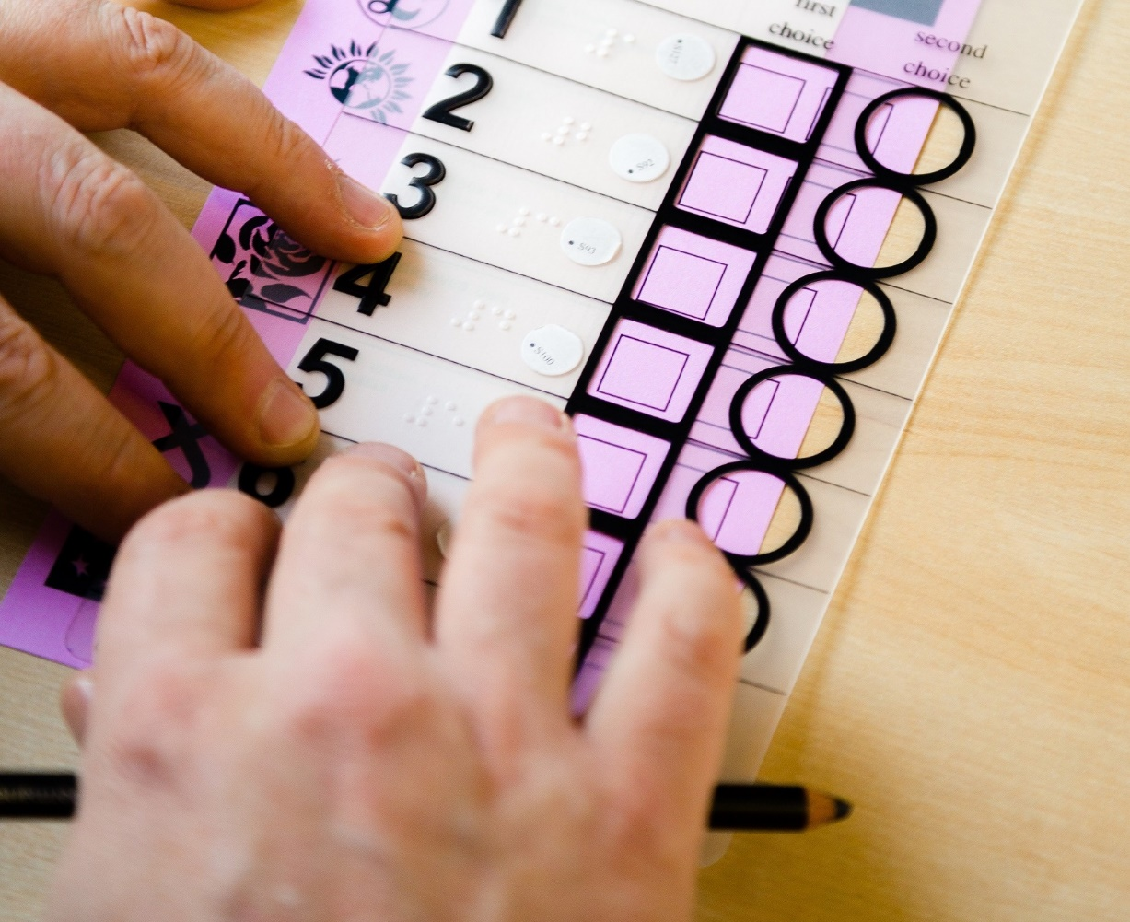
The tactile voting device in use
For further information, please contact Ian Brown at RNIB Scotland.

Migrants Support Service of the Oogvereniging (Eye Association Netherlands).
For blind and visually impaired people with a non-Western European background it is often difficult to get settled in the Netherlands. For newcomers learning the language, getting the right support and advise, obtaining assistive devices, finding their way around and building a network may prove insurmountable hurdles. For both newcomers and people who have been living in the Netherlands for a while, cultural differences may prove an additional hinderance. In non-Western cultures it is often believed that a visual impairment makes an independent life impossible.
The Migrants Support Service targets both migrants with a visual impairment and the organizations that can help them, provided they have the right expertise to do so. The Service trains and advises language-buddies, volunteers who can support migrants in their own neighborhood. Not only can they help the migrant to practice the language, they can also guide the migrant on a walk or social event. In addition the Service offers training to professionals.
The service is run by Amany Shalha, who arrived in The Netherlands in 2015, an expert by experience, fluent in Dutch and Arabic and familiar with both the Dutch and Arabic cultures. www.oogvereniging.nl/steunpuntmigranten

Let’s be together at REHA for the blind in Poland 2022
Chance for the Blind Foundation from Poland would like to invite you to take part in the conference called REHA for the blind in Poland.
What is it?
REHA is a multi-threaded event during which we manifest solidarity with our guests and present ideas for a world as open as possible to our community and all people who are weak, disadvantaged, elderly, lonely, or have any disability at all. Together with our guests and supporters we strive to change the perception of disability and its consequences, as hindering everything, but nevertheless not forbidding or blocking anything. During the meeting we promote the most modern ideas on how to arrange the world in order to achieve the long-unattained goal of real equal life opportunities for people who are still largely excluded. To the guests gathered in conference venues as well as to the online viewers and listeners in many countries we present the achievements of scientists, engineers, rehabilitation specialists, organizations and institutions working for the benefit of the blind and visually impaired, especially the Polish ones. The aim of the Conference and accompanying exhibitions is to provide an opportunity to learn about the latest technical and methodological solutions created for this group of citizens.
The first REHA conference was organized in 1999 and since that time it has developed to the WORLD meeting of the blind, partially sighted, their families and friends. Every edition of the event brings new attractions and special elements, e.g. concerts of disabled and non-disabled artists performing together on one stage, chess tournaments and many more. We have been organizing our conference with important institutions and organization of and for the blind, e.g. Center for the Blind in Israel, local and central authorities of Poland.
Thanks to these collaborations, REHA grows year by year and is visited by hundreds of attendees.
REHA for the blind in Poland 2022
This year’s REHA for the blind in Poland is to be held from 15th to 18th September in Warsaw and online. We would like to invite you to take part in it, as we are preparing unique attractions for our guests. There will also be a special discussion panel devoted to the situation of the blind and partially sighted in the world. Therefore, if you want to give a speech and share your country’s experiences with others, contact international department manager of the Chance for the Blind Foundation – Milena Rot: Email address – milena.rot@szansadlaniewidomych.org; mobile phone - +48 664 101 900, who is our contact person for any international matters, connected with the conference. If you want to find out more about the past edition of the event, please visit: www.szansadlaniewidomych.org.
We encourage you to join us. The main parts of the conference will be interpreted into several languages, including: Georgian, Arabic, Hebrew, Romanian, Spanish, and others.
The official partner of the event is European Blind Union, which is a great honor for our Foundation.
Let’s meet in Warsaw!
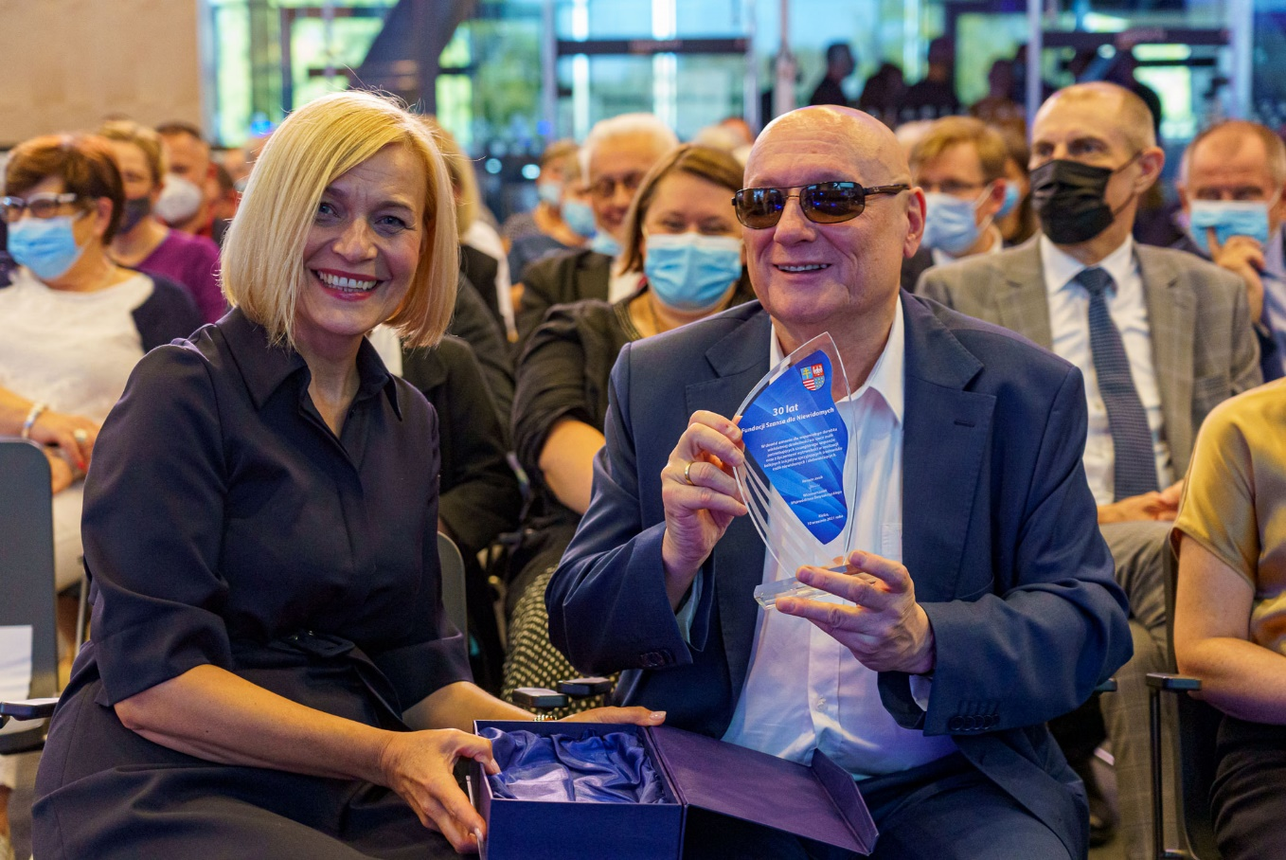The Honorary President of our organization with the statuette commemorating 30 years of the Foundation.
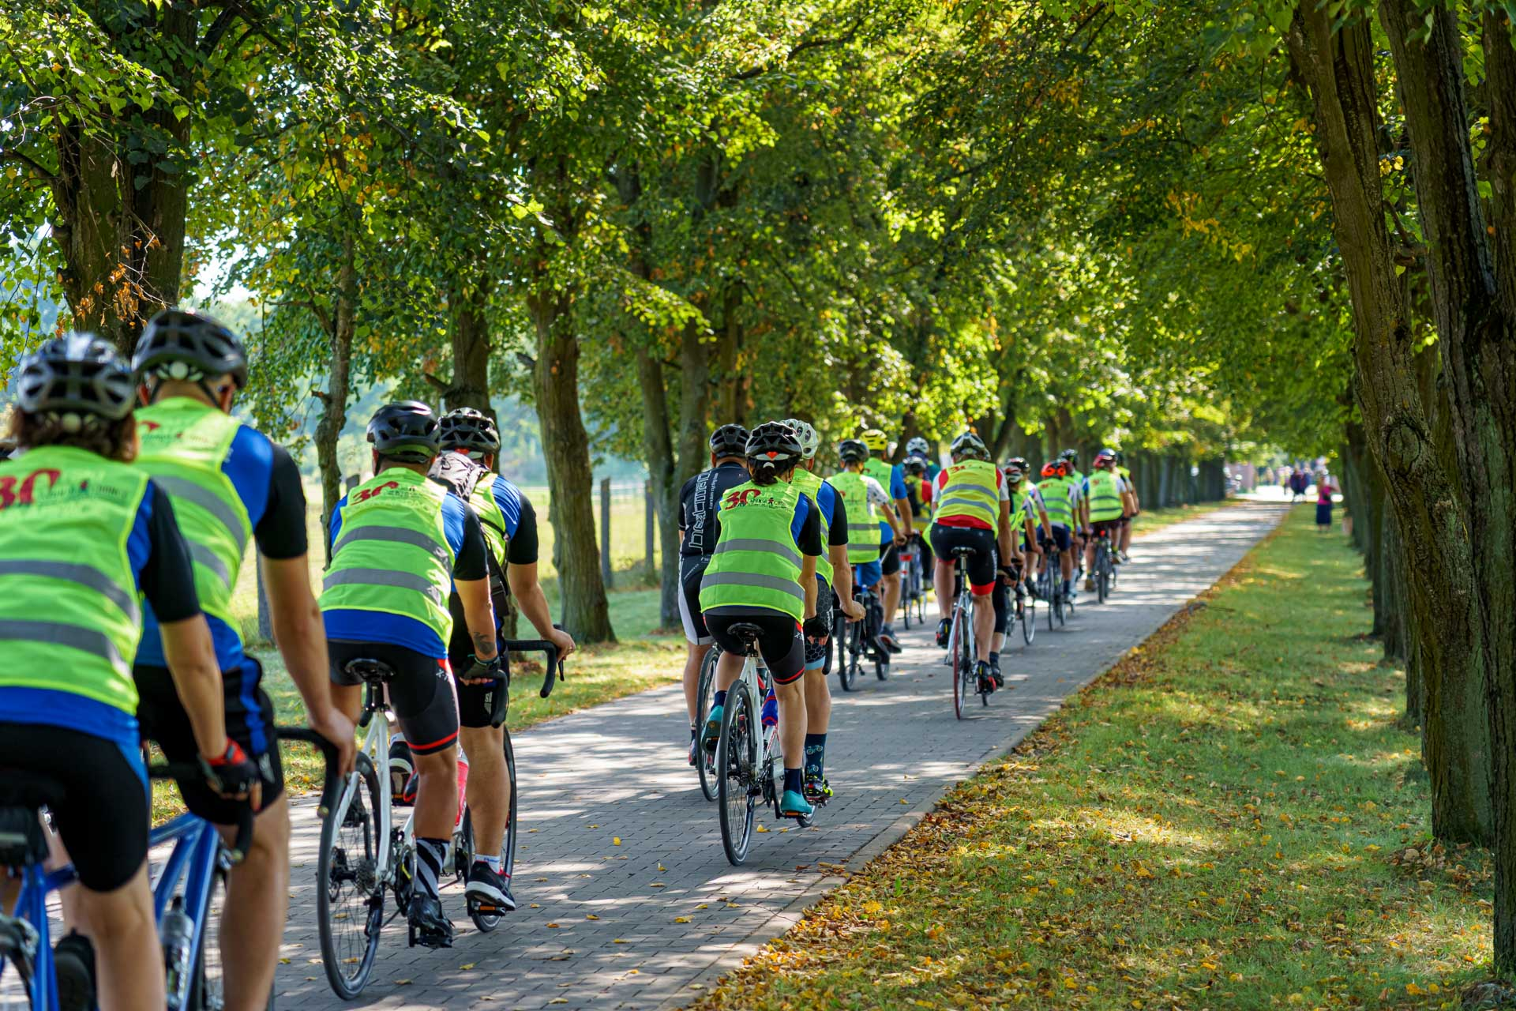
A cycling race with participants displaying the logo of the Chance for the blind Foundation.

Job opportunities in the European Parliament
For the 8th consecutive year, the European Parliament has launched the 2022 positive action scheme to enable persons with a disability to work in this EU institution. It offers a number of one-year contracts to individuals with a disability who are successful in the selection procedure organised by the European Parliament and have never previously worked for an EU institution (EU traineeships are not included in this case). For the purpose of this programme, the category of persons with a disability includes those who have a long-term physical, mental, intellectual or sensory impairment of minimum 20%, which, in interaction with various barriers, may hinder their full and effective participation in society on an equal basis with others.
Information is available in all EU languages, here are the links to some language versions, and from those pages you will find other versions.
- English
- French
- German

ENDS.
European Blind Union
6 rue Gager Gabillot, 75015 Paris, France
+33 1 88 61 06 60 | ebu@euroblind.org | www.euroblind.org

