Online services - from crisis to challenge and opportunity
at Migdal-Or (Lighthouse)
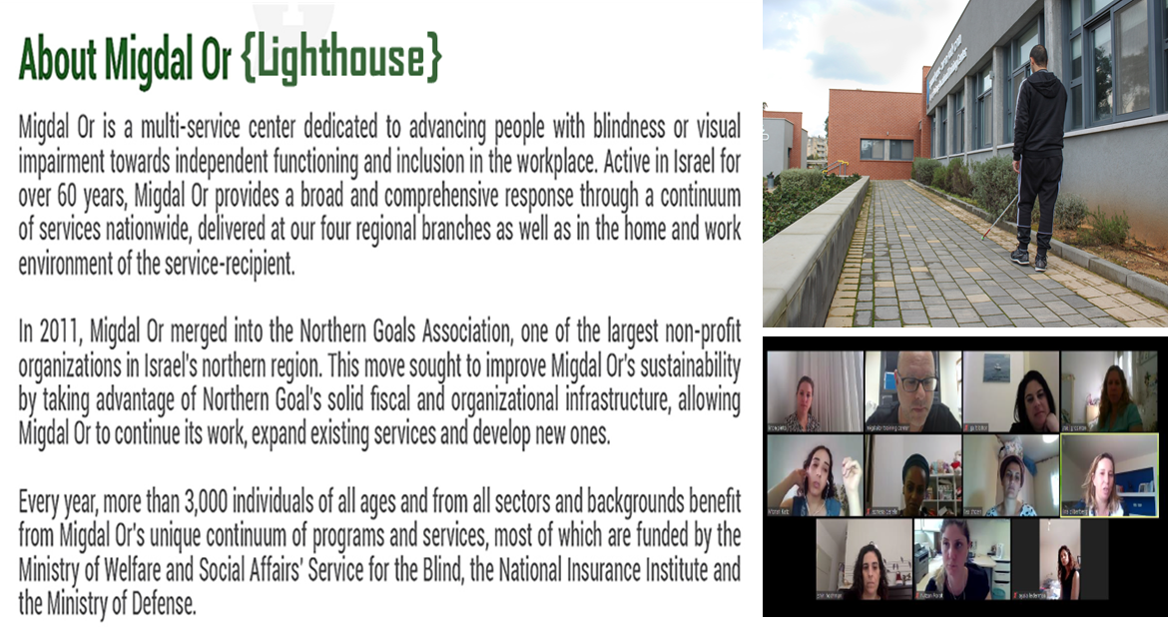

- Migdal-Or’s vision is that every person with vision loss in Israel should be able to fulfill themselves.
- Our mission is to develop and provide professional services that are relevant and innovative, improve functionality, support professional advancement for people with vision loss and provide an information service for those involved with their lives (e.g. family, employers, IDF as well as the general public).

Challenges arising from the COVID-19 Crisis
COVID-19 has interrupted our daily lives. We are faced with uncertainty and have had to make great changes in the way we manage every aspect of our lives. The family framework is changing: everyone is at home and we need to adjust to a new reality. Working conditions vary – mostly now online, rules on public transportation are changing. In fact, the familiar routine has been undermined and it is necessary to create a new one, adopt new strategies and tools in order to function in the new reality.

However, challenges for people with visual impairment are compounded during this period, way beyond those of sighted people. These challenges accentuate feelings of loneliness and difficulties in accessing services as are illustrated in the following examples:

A person with visual impairment needs to draw close to objects in order to see, however today, government rulings require distancing. This is difficult for the person with low vision. The need for social distancing makes it problematic for the population with visual impairment to obtain assistance to walk in public spaces. Mobility outside the home is challenging. A large number of people with visual impairment use public transport to travel from place to place. During COVID-19, public transport has been reduced and where it does exist, there is fear of infection. As a result, may shut themselves in their home and feel lonely.

Moreover, a large percentage of people who have decreasing vision are over 65 years. This population is in the high risk category for COVID-19. Sometimes, they are isolated in their homes and it is difficult to find support. The general feeling of loss and loneliness is intensified among people who have only recently experienced significant deterioration in their vision and are still trying to cope with the loss. This intensifies feelings of helplessness, incompetence and fear.

These and other challenges during the COVID-19 crisis required Migdal-Or - as a leading organization in Israel – to respond in accordance with our vision and mission. We had to quickly develop a variety of responses to the new needs and demands whilst maintaining regular operations. We were also required to make adjustments to the routine face-to-face services and to train the service providers, in order to provide an effective and safe online service.

The Needs
The needs were examined from two perspectives:
- Telephone contact with service recipients in order to assess the needs and capabilities of continuing with services online in light of the new situation
- Assessment of online needs for people with blindness or visual impairment in Israel. The link to a survey was posted on Migdal-Or’s website and sent to past users. Likewise, in order to access the population who have difficulties with digital systems, volunteers were recruited to contact past users and review the questionnaire with them.

What needs were identified?
- Functionality and information: People with visual impairment raised the need to become familiar with online tools which would enable them to function independently on a daily to access various services and support their personal well-being. For example, use of Zoom for working online instead of help with orientation and mobility on route to their workplace; ordering groceries online; accessible games for children; use of assistive technological online applications; adjustments of supporting methods such as walking guidance while maintaining distance; adjusting the setting to provide an online service when it is difficult to concentrate for long periods; suitable tools for camera-dependent platform such as use of the background, aiming the camera at the target etc; internet connection and troubleshooting smartphone/computer problems.
This information was also requested by family members and professionals that support an individual with visual impairment.
- Social needs: difficulties in receiving occasional help in the public arena, use of public transport and the fact that leisure services such as enrichment activities, leisure time etc., were reduced and on the other hand family members and children were continuously at home raised the need for leisure services and social interaction.
- Emotional needs: social isolation, inability to be move freely and uncertainty as a result of the COVID-19 situation significantly heightened the emotional status. People felt apprehensive, lonely, depression, sense of helplessness, inability to function independently raised the need to bring social workers experienced in the field of visual impairment and also a need for group support with other peers.

Mapping identified needs and segmenting services provided
In order to respond to the changing needs that arose during the COVID-19 crisis, routine services generally provided face-to-face have been adapted to online. In addition, new online services have been developed. Funding, for the most part, is provided in Israel by the Administration for People with Disabilities at the Ministry of Social Services and the National Insurance Institute.
- Functionality needs: functional rehabilitation was adapted online carried out by Migdal-Or’s Units for Rehabilitation Training Services and the Training Apartments for Independent Living
- Emotional support: This was led by the staff of the Institute for the Rehabilitation of Low Vision who adapted to online support groups. In addition, a new helpline opened for individual support
- Vocational rehabilitation: training and preparation for employment has been adjusted to online
- Social and leisure: Online leisure services were provided by Migdal-Or. In this framework, we began a variety of new activities such as yoga and exercise, Mindfulness and Guided Imagery, therapeutic gardening, crossword puzzle groups, Science for children and enrichment lectures on a variety of topics
- Information/knowledge: Distribution of information to people with visual impairment, their families and professionals were adapted for online and via Migdal-Or’s Training Center. Subjects included tools for using online platforms, digital accessibility, assistive technology. In addition, webinars and related materials were saved for practice and further reference in an online resource page on Migdal-Or’s website
- The increased need for technical support was accommodated by reinforcing the existing technological support Call center.

What are the Online Services?
Migdal-Or’s online services began in mid-March during the first wave of COVID-19 and some continue today.

Below is a chart showing online service needs during the first three months (mid-March to end of July)

In total, 2,896 people with visual impairment received online services: 2257 people with visual impairment and 639 people in their lives (family members, care givers, social workers etc.) who wanted to enrich their skill set of working with people with blindness or visual impairment.
Some people participated in one activity, some participated in weekly sessions. For example, a person who participated in 10 sessions of the online support group was counted only once in the chart. Meaning, people enjoyed more hours of activities than in the chart above.

Insights
Following our experience with providing online services in a variety of areas, we learned services can be improved based on a number of principles.
- Principles to improve online services
- Adaptation of online platform to the individual. It is important to offer a number of platforms to enable the user to participate in the selection of one most suitable for them. Those utilized included Zoom, regular telephone, WhatsApp video, Skype, distribution of materials (pictures, files and short films) via email and WhatsApp.

- Length of sessions: Shorter sessions than face to face. It is difficult for most people to concentrate for long periods during online meetings.
- Guide/Companion: For specific issues, it is important to enlist a companion and determine their role in advance. Their role can help the recipient to practice skill acquisition, with video recording so that the service provider is able to view how learning is carried out, for technical solutions and to ensure the safety of the recipients. When the rehabilitation teacher who is not in the vicinity teaches skills that involve risk such as learning to pour, cutting with a knife. The recipient could make a mistake and the supervision of the guide is critical in preventing accidents. The guide needs to understand their role and accept it. Coordinating expectations is important.
- New ethical issues: Online services bring ethical issues which need attention for example recording a session with knowledge of the participants. It is recommended to discuss this with the recipient in advance and reach clear agreement.
- Verbal guidance: Online services involve a significant amount of verbal guidance. Open questions should be frequently asked. This is to compensate for the fact that the service provider often does not acquire the complete picture even on Zoom.
- Setting goals for sessions: Clear and limited goals should be set for each session in order to record success. Marking goal successes will raise self-esteem and sense of capability for recipients and service providers alike. In addition, it will also provide clear information as where to proceed and where there is still difficulty. To do this correctly, it is necessary to base every activity on task analysis.

- Challenges and Dilemmas
In online service provision, there are challenges which raise professional dilemmas which should be considered:
- Absence of complete and immediate picture: One needs to take into consideration that the service provider does not have a complete and immediate picture when the service is being rendered with regards to the technique offered and the implementation carried out by a person with visual impairment. The guide and use of pictures resolve this in part.
- Blurred boundaries: when the service provider uses Zoom from their home, in effect, they enter the home of the recipient. Therefore, a quiet room should be maintained that preserves the privacy of the service recipient with a respectful and appropriate Zoom backdrop. For example, a bedroom is not appropriate but if it is the only option, appropriate background images can be used that do not attract attention.
- Fatigue: Online services often makes the service provider and service recipient very tired. It is advisable to take this into account in order to schedule breaks between the sessions in advance.
- Technology: Consideration must be given to people’s comfort with technology and internet interruptions.
- Changing perception: change usually arouses fear and skepticism in most people. Many services, in particular a rehabilitation training service for people with visual impairment, have for many years been provided face-to-face. Learning techniques enabling functional independence are often learned through demonstration and touch. The adjustment to providing services online requires a change in belief and perception that this is indeed possible, efficient and effective. Moreover, it requires creativity in resolving new dilemmas, making adjustments and support for future research.

SUMMARY
Online services remain with us in part. The question is if it is as an efficient and effective medium as face to face services. In order to respond to this, we need to understand the difference between the two concepts ‘efficiency’ and ‘effectiveness’.

‘Efficiency’ measures the ratio between outputs and resources i.e. whether the same output is achieved faster with fewer resources. That is: efficiency refers to maximum effort within a minimum time.

Within these parameters, online services are indeed efficient as part of our services in Israel (such as rehabilitation counselling). They are provided in the recipient’s natural surroundings and save travel time of the counsellor. It is also possible to save waiting time for services. At the same time, online services are less efficient when demonstrating a new topic. Sometimes, verbal explanations, short films etc. take longer to understand than face to face demonstrations. In addition, there are people who, because online service takes longer to understand a topic, feel confident, develop independence and increase their sense of competence. Therefore, sometimes with certain service recipients, online services will require more time to achieve the same results as face-to-face.

‘Effectiveness’, however, measures whether the activity achieves the desired results. The degree of effectiveness is measured against the desired results for short, medium and long-term impact. It measures the degree of achievement of goals and objectives.

Online services are effective from a number of perspectives. The service encourages the recipient to problem-solve independently, due to the fact that the service provider is not physically present during the learning process. The approach is based on the personal strengths of the recipient and encourages drawing on these inner resources which raises their sense of capability. It also requires significant participation on the part of the recipient which raises self-worth. It requires precision in setting limited goals for each session so that the recipient is able to clearly see progress and feel empowered.

In addition, some people, do not utilize services if they are required to leave home and sometimes travel long distances (such as leisure and social activities). There are many reasons for this such as fear to leave home with visual or other disabilities, general health, lack of accessibility in outside surroundings, frequency of public transport, geographical distance. Online services make activities accessible and allows anyone who is interested to access them at home.

At the same time, online service is less effective for certain service recipients when personal connection is critical to success, when body language and touch are especially important, when proximity is critical for maintaining safety such as learning to cross at a junction.
Sometimes, online services are not possible when a recipient does not have access to technology and/or an companion who accompanies them to sessions and/or in cases where the recipient is unable to cooperate using this method.

Our recommendation is to examine the method of service in accordance with the content and character traits of the recipient and in cooperation with them. We also recommend to balance between online and face to face services depending on the type and topic of service.

Oded Bashan Rita Lapid
CEO, Migdal-Or Manager of professional quality
and development

