(re) Elections for ICEVI-Europe

National Representatives

Baltic and Nordic Countries
Denmark
Mrs Marie Fasmer,
mf@ibos.kk.dk
Estonia
Mrs Monica Lõvi,
kool@tek.tartu.ee, monsalovi@gmail.com

Finland
Mrs Tarja Hännikäinen,
Tarja.Hannikainen@valteri.fi
Iceland
Mrs Huld Magnúsdóttir,
huld@midstod.is
Latvia  Mrs Ligita Geida,  ligitageida@apollo.lv | 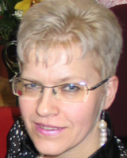
Lithuania  Mrs Grita Strankauskiene,  kaunosim@gmail.com or grita.stran@gmail.com | 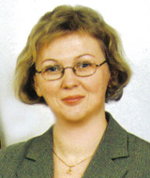
Norway  Mrs Beate Heide,  beate.heide@ statped.no | 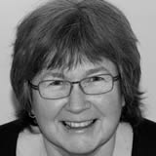
Sweden
Mr Anders Rönnbäck,
anders.ronnback@spsm.se

English speaking Countries
Ireland
Mrs Audrey Farrelly
audrey.farrelly@gmail.com
United Kingdom, Wales vacancy
United Kingdom, England  Mrs Maha Khochen  mahakhechen@hotmail.com | 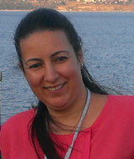
United Kingdom, Scotland
Mr John Ravenscroft
John.Ravenscroft at ed.ac.uk
Israel
Mrs Nurit Neustadt-Noy
nuritnoy@macam.ac.il

French speaking Countries
Belgium  Mrs Juliette Boudru,  triangle.bruxelles@gmail.com | 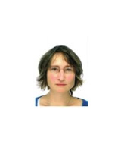
France  Mr Francis Boé,  francis.boe@free.fr | 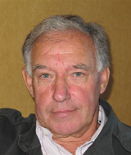
France
Mrs Marie Renée Hector,
mrhector@noos.fr
France
Mrs Michelle Collat (French speaking),
michele.collat@orange.fr

Switzerland
Mr Frédéric Schütz
frederic.schuetz@fa2.ch

South European Countries
Italy  Mrs Maria Mencarini,  mencarinimaria at gmail.com copy to archivio at irifor.eu | 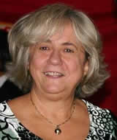
Italy vacancy
Portugal vacancy
Spain  Mrs Elena Gastón López,  egl@once.es | 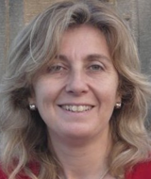
Spain
Mrs Ana Isabel Ruiz López,
airl at once.es
Andorra  Mrs Mariona Carbonell del Castillo,  mariona.carbonell@gmail.com,  school: eensm@andorra.ad | 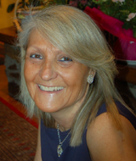
Malta  Mr. Francis Tirchett  socblindmalta@gmail.com | 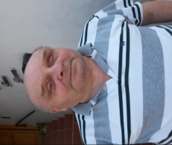
Monaco vacancy
San Marino vacancy

German and Dutch speaking Countries
Austria
Mrs Gertrude Jaritz,
vsbp@gmx.at
Belgium  Mrs Eliane Bonamie,  Eliane.bonamie@de-kade.be | 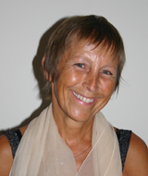
Germany  Mrs Elke Wagner,  elke.wagner@nikolauspflege.de | 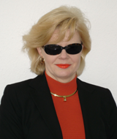
Germany vacancy
Germany vacancy
The Netherlands vacancy
Switzerland  Mr Christian Niederhauser,  c.niederhauser@blindenschule.ch | 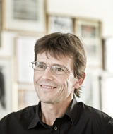
Lichtenstein vacancy
Luxembourg  Mr Frank Groben,  frank.groben@ediff.lu | 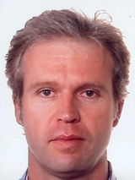
South Tirol (Italy)  Mrs Elisabeth Gitzl,  info@blindenzentrum.bz.it | 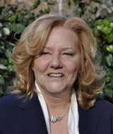

Central European Countries
Czech Republic
Mrs Marketa Skalicka,
marketa.skalicka@ranapece.eu

Hungary  Mrs Krisztina Kovacs,  kkovacs.sza@gmail.com  kkovacs@barczi.elte.hu | 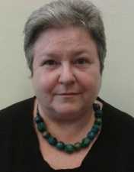
Poland  Mrs Graszyna Walczak,  grawal@aps.edu.pl  grawal20@wp.pl | 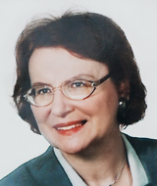
Poland vacancy
Slovak Republic  Ms Tímea Hóková,  dkhokova@fedu.uniba.sk  hokova@unss.sk | 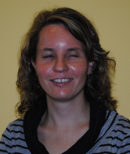
Slovenia  Mrs Marija Jeraša,  marija.jerasa@guest.arnes.si | 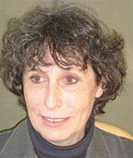

East European Countries
Armenia  Mr Aleksan Aharonyan,  specschool14@yandex.ru | 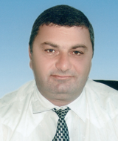
Azerbaijan  Mrs Melahet Haciyeva,  melahet.haciyeva@gmail.com | 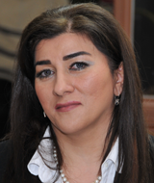
Belarus  Mr George Losik,  georgelosik@yahoo.com | 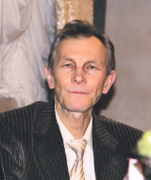
Georgia
Mrs Mariam Mikiashvili
Mariam.miki@gmail.com

Kazakhstan  Mrs Karlygash (Klara) Rakisheva,  suarez1992@yandex.ru | 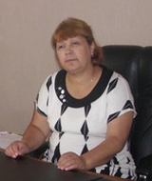
Moldova
Mr. Stefan Oprea
Russia - Central Region, North-West Federal District
vacancy
Russia - Ural Federal District, Siberian Federal District, Far-Eastern Federal District  Mrs Tsyndyma Boyko,  imna2002@rambler.ru | 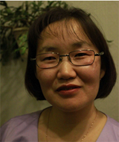
Russia - Southern Federal District, North-Caucasian Federal District, Volga Federal District
Mrs Irina Sumarokova,
irasu@list.ru
Ukraine
Mrs Evgeniya Synyova,
ev_sineva@hotmail.com
Ukraine  Mrs Vira Remazhevska,  lewenia@hotmail.com | 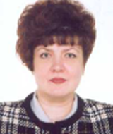
Tajikistan  Mr Tengniev Kholmakhmad Аhmadovich,  tbu-tajiknet@mail.ru  tengniev@уandex.ru | 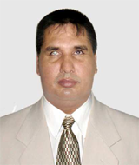

Balkan Countries
Albania
Mrs. Zhaneta Muca
shvsh@shvsh.org.al

Bosnia and Herzegovina  Mr. Azur Kuduzović  azurkuduz@gmail.com | 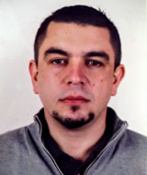
Bulgaria
Mrs. Mira Tzvetkova-Arsova
miratz@abv.bg

Croatia  Mrs Marijana Konkoli Zdesic,  marijana@malidom.hr | 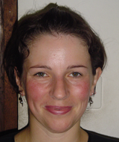
Cyprus  Mrs Maria Kyriacou,  m.kyriacou@cytanet.com.cy | 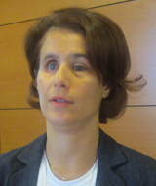
FYROM Former Yugoslav Republic of Macedonia
Mrs Elena Hristova,
hristova_e@yahoo.com

Greece
Mr Vassilis Argyropoulos,
vassargi@uth.gr
Montenegro vacancy
Romania  Mrs Andrea Hathazi,  ahathazi@yahoo.com | 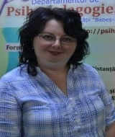
Romania vacancy
Turkey  Mrs Songül Atasavun Uysal,  songula@hacettepe.edu.tr | 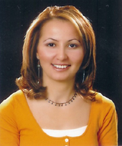
Turkey  Ms. Emine AYYILDIZ  ayyildizemine@yahoo.com | 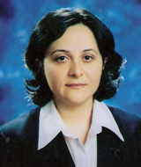
Turkey
Mr. Onder Islek
islekonder@hotmail.com

Serbia  Mrs Aleksandra Grbović,  sgrbovic@ptt.rs | 