(re) Elections for ICEVI-Europe

Members of the Board

President, Vacancy
Mrs. Nathalie Lewi-Dumont, representing the French speaking countries  nathalielewi@gmail.com | 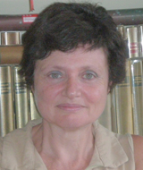
Ms. Tarja Hännikäinen
representing the Baltic and Nordic countries
Tarja.Hannikainen@valteri.fi

Mr. Steve McCall,
representing the English speaking countries
s.mccall@bham.ac.uk

Vacancy
representing the Central European countries

Mrs. Ana Isabel Ruiz López
representing the South European countries
airl@once.es
Vacancy
representing the German and Dutch speaking countries

Mr. Vladimir Ruchin
representing the East European countries
r-vl@yandex.ru
Mrs. Andrea Hathazi
representing the Balkan countries
ahathazi@yahoo.com

