Special Newsletter

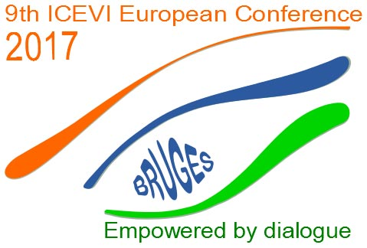

9th ICEVI European Conference: Empowered by dialogue

2 July – 7 July 2017

Bruges, Belgium

www.icevi-bruges2017.be/

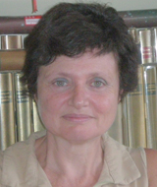

1 Welcome

You are cordially invited to the 9th ICEVI European Conference, which will be held from July 2 to July 7, 2017 at the Sint-Lodewijkscollege in Bruges, Belgium.

The 9th ICEVI European Conference is organized by International Council for Education and Rehabilitation of People with Visual Impairment, European Region (ICEVI-Europe) in cooperation with the Belgian Organizing Committee, BLL (Blindenzorg licht en liefde), Spermalie and Centrum Ganspoel.

The theme of the conference is “Empowered by Dialogue,” centered on the Quality of Life Framework by Dr. Robert Schalock. The program of the conference will be based on the Quality of Life Framework and its eight domains that provide an indication of an individual’s quality of life in three broad yet related areas: Independence, Social participation and Well-being. Each domain of the framework will function as an invitation for lectures, workshops or dialogue sessions and serve as a classification topic for Papers. For further information regarding the abstract submission deadline and procedure, program, registration etc. please visit our conference website at www.icevi-bruges2017.be/

With this announcement, we have the pleasure of inviting you to join us and urge you to forward this information to other people and professionals in the field of visual impairment interested in its content. Take advantage of the opportunity to become an active part of the exchange of knowledge and expertise and sharing of best practises within a network of people and institutions promoting the social inclusion of people with visual impairment.

The conference will also offer various professional interest groups the opportunity to organize meetings and share experience.

We promise this conference will be an interesting and inspiring one, as you will have the opportunity to meet and listen to Keynote Speakers, who are well-known experts throughout Europe, as well as, listen to very interesting and special presentations during the plenary, parallel, workshop and poster sessions.

The following Keynote Speakers will give a presentation on the theme of the conference, focusing their presentation with respect to an age category:

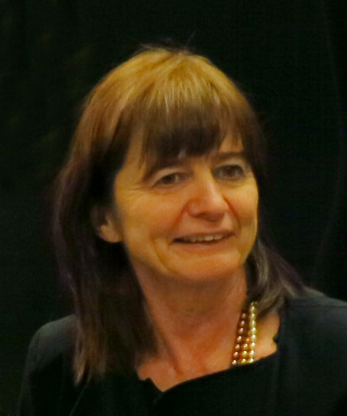 Prof. Dr. Claudia Claes, Dean of the Faculty of Education, Health and Social Welfare Studies, Ghent University, Belgium will give a Keynote Presentation on the introduction of the theme and model, Quality of Life.

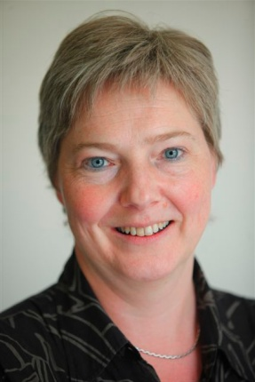 Prof. Dr. Bea Maes, Dean of the Faculty of Psychology and Educational Sciences University of Leuven, Belgium will give a Keynote Presentation on the theme of the conference, Quality of Life, and quality of support for persons with a disability, focusing her Keynote Speech on a specific topic/ aspect of service providing with respect to the age category of early childhood.

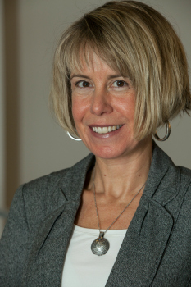 Mrs. Kristen Layton, Director of Strategy, Innovation and Learning Perkins International will give a Keynote Presentation on the theme of the conference, Quality of Life, focusing your Keynote Speech on a specific topic/ aspect of service providing with respect to the age category of school age children.

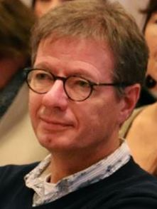 Mr. Peter Verstraten, Programme Manager Knowledge & Expertise Robert Coppes Foundation will give a Keynote Presentation on the theme of the conference, Quality of Life focusing his Keynote Speech on a specific topic/ aspect of service providing with respect to the age category of adults and elderly.

Dr. Elke Wagner, Vice-Principal of Tilly-Lahnstein-Schule - Vocational Schools at the Nikolauspflege in Stuttgart, Germany will give a Keynote Presentation on the theme of the conference, Quality of Life focusing her Keynote Speech on a specific topic/ aspect of service providing with respect to the age category of youth.

We look forward to having you join us at the 9th ICEVI European Conference in Bruges, Belgium!

On Behalf of the Board of ICEVI-Europe,
Nathalie Lewi-Dumont

www.icevi-europe.org

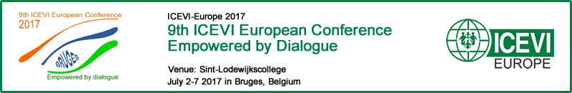

2 Meetings of the regions of ICEVI-Europe

The conference also offers a good opportunity for a meeting of the regions.
Despite occasional sub regional conferences it is not always possible to meet each other.

A meeting during the conference offers the opportunity:
- To meet and exchange knowledge and information
- To make proposals to the Board of ICEVI-Europe
- To nominate national representatives

These meetings will be chaired by the Board member of the region and will be held on Thursday, July 6, 2017.

Baltic and Nordic countries: Tarja Hännikäinen
English speaking countries: Steve McCall
French speaking countries: Nathalie Lewi-Dumont
South European countries: Ana Isabel Ruiz López
German and Dutch speaking countries: Patrick Temmesfeld
Central European countries: Hans Welling (in absence of Krisztina Kovacs)
East European countries: Vladimir Ruchin
Balkan countries: Andrea Hathazi

Proposal for Agenda of ICEVI-Europe Regional Meetings

- Opening and welcome
- Short acquaintance. If possible, it depends on the number of participants
- Sharing information about the development in the countries
- Nomination of board member and national representatives
- The use of newsletter and website of ICEVI-Europe
- Suggestions of points of interest for the Board of ICEVI or for regional conferences
- Closing

3 Invitation to Attend the General Assembly

During the conference, the General Assembly will take place on Thursday, July 6, 2017. Due to the fact that the General Assembly occurs once every four years, your attendance at this event is greatly important because this is the time the elections/re-elections of the new Board of ICEVI-Europe will be held and everyone comes together in order to discuss improving the policy of the newly elected Board. The General Assembly is open for all conference participants who would like to attend and is the meeting place for developing the strategy of ICEVI-Europe for the coming years.

Agenda General Assembly Bruges, Belgium 6 July 2017

- Opening and welcome.
  - In memoriam Betty Leotsakou, the former president.

- Presentations
2.1 Short presentation of the outcomes of the professional interest group meetings of ICEVI-Europe

- To decide

3.1.Annual report 2016 attachment
3.2.Estimate 2017 You will receive later

- Presentation of ICEVI European Awards 2017

- ( re) Election

  - The president
  - Members of the board attachment
  - Confirmation of the national representatives attachment

- First announcement of the ICEVI European Conference 2021

- Welcome speech of the new president and farewell of the board members

- Any Other business

- Closure

Elections for ICEVI-Europe

An important part of the 2017 General Assembly of ICEVI-Europe will be the elections of the new President and the Members of the Board and the confirmation of the National Representatives. The coming month is important for the preparations of these elections in regional and national meetings. In the respective attachments, you may find a list of all available positions within ICEVI-Europe. We kindly ask that you pay attention to the vacancies of the positions for Board Members and National Representatives that are listed in the attachments. Please be advised that you can find a Job Description of the National Representatives on the website of ICEVI-Europe. It is with great pleasure that you are invited to submit your nominations.

Membership

We would like to take this opportunity to invite you to become a member of ICEVI-Europe and part of a network of professionals that will allow you to build strategic relationships with organizations and professionals across Europe.

As a member of ICEVI-Europe, you will be given the opportunity to:

- Work with governments and other relevant partners to improve special needs and inclusive education and rehabilitation
- Share knowledge and expertise with professionals in the field
- Organize training courses, seminars and conferences
- Support the global program for the prevention of blindness

Please use your membership of ICEVI-Europe:
- It gives you voting rights
- It gives you a discount on the conference fee

But please pay your membership fee on time.

Your membership fee is crucial to the work of ICEVI. Membership fees are the organization’s only income and they enable us to continue to promote international cooperation in broadening the knowledge and skills of professionals working in the education and rehabilitation of persons with visual impairment.
ICEVI-Europe cannot exist without your financial support.
Therefore, here is a reminder for membership 2017 and the following years.

The membership fees are:
- Individual member 25 Euro per year / 100 Euro for 4 years
- Individual member from Eastern Europe and from the Balkan countries 10 Euro per year / 40 Euro for 4 years
- Member Organization without own budget 200 Euro per year
- Member Organization with less than 100 employees 350 Euro per year
- Member Organization with between 100 and 200 employees 500 Euro per year
- Member Organization with more than 200 employees 800 Euro per year

The NEW international bank account number of ICEVI-Europe in Huizen, The Netherlands is:
ING, account number: 4890207
BIC: INGBNL2A
IBAN: NL90 INGB 0004 8902 07
Contributions can be made by Internet via the PayPal Account or via a payment to the ING Bank Account of ICEVI-Europe. There is also a possibility to pay your membership fee during the European Conference in Bruges.
Please be aware that the conference fees for workshops and the European Conference are considerably less expensive for members.
For further information regarding the Benefits of Membership in ICEVI-Europe, the application form for membership in ICEVI-Europe, as well as, the payment details and payment methods, please visit the website of ICEVI-Europe.

Bruges
- An attractive unique pedestrian medieval town listed as a UNESCO World Heritage and often called the "The Venice of the North."

