Candidate Contact persons
16 June 2009

Baltic and Nordic Countries 1
English speaking Countries 2
French speaking Countries 3
South European Countries 4
German and Dutch speaking Countries 5
Central European Countries 6
East European Countries 7
Balkan Countries 8

Baltic and Nordic Countries
- Denmark Mr Peter Rodney-Jensen 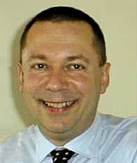
- Estonia Mrs Anne Koiv 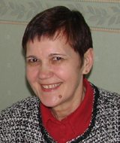
- Finland Mrs Tarja Hännikäinen
- Iceland Huld Magnusdottir
- Latvia Mrs Ligita Geida 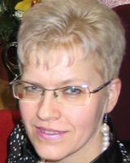
- Lithuania Mrs Grita Strankauskiene 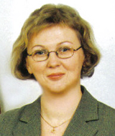
- Norway Mrs Toril Loe 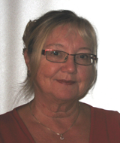
- Sweden Mr Anders Rönnbäck 

English speaking Countries

- Ireland Mrs Audrey Farrelly 
- United Kingdom Mrs Nicola J. Crews 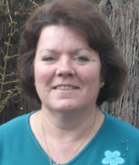
Mr Steve McCall 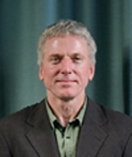
1 Vacancy
- Israel Mrs Nurit Neustadt-Noy 

French speaking Countries

- Belgium Mrs Violaine Van Cutsem
- France Mrs Michele Collat
Mrs Annie Lamant
Mr Francis Boe
- Luxembourg Mr Frank Groben 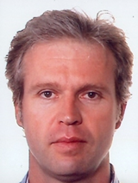
- Switzerland (francophone) Mrs Isabelle MATHIS 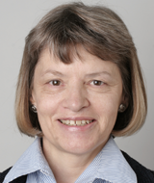

South European Countries

- Italy Vacancy
- Malta Carmen Cascun
- Portugal Mrs Leonor Moniz-Pereira 
- Spain Mrs Ana Isabel Ruiz López 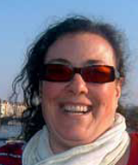
Mrs Elena Gastón López 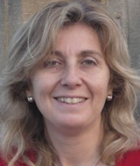
- Andorra Mrs Mariona Carbonell del Castillo 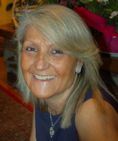
- Monaco Vacancy
- San Marino Vacancy

German and Dutch speaking Countries

- Austria Mrs Gerti Jaritz-Tschinkel 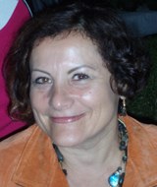
- Belgium (Dutch speaking) Vacancy
- Germany Vacancy
- The Netherlands Vacancy
- Switzerland (German speaking) Vacancy
- Lichtenstein Vacancy

Central European Countries
- Czech Republic Mrs Ema Gallová 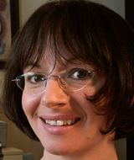
- Hungary Mrs Krisztina Kovacs 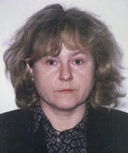
- Poland Mrs Grazyna Walczak
- Slovak Republic Mrs Elena Mendelova
- Slovenia Damijana Dusak

East European Countries

- Armenia Vacancy
- Azerbaijan Vacancy
- Belarus Mr Vladimir Gordeiko 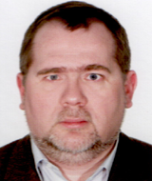
- Georgia Vacancy
- Kazakhstan Mrs Klara Rakisheva 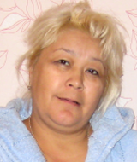
- Moldova Mrs Larisa Celan 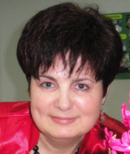
- Russia Mrs Natalia Belyakova 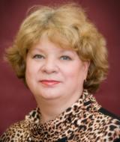
Mrs Irina Zarubina
- Ukraine Mrs Evgeniya Synyova 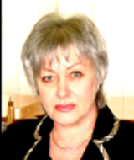
Vira Remazhevska

Balkan Countries
- Albania Mrs Tatjana Cadri
- Bosnia and Herzegovina Vacancy
- Bulgaria Mr Vladimir Radoulov 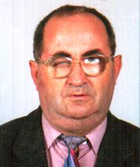
- Croatia Mrs Marijana Konkoli Zdesic 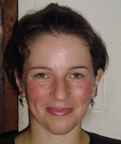
- Cyprus Andreas P. Hapoupis
- FYROM Former Yugoslav Republic of Macedonia
Mrs Daniela Dimitrova-Radojicik
- Greece Vassilis Argyropoulos
- Montenegro Vacancy
- Romania Mr Vasile Liviu Preda 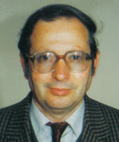
Andrea Hathazi
- Turkey Mrs Hale Aksuna (Ergenc) 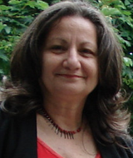
Mrs Emine Ayyildiz 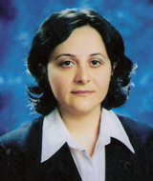
- Serbia Mr Tihomir Nikolic

