Diane Stacey, Assistant Director
Lesley Talbot-Strettle, Distance Learning Project Manager
Royal London Society for the Blind, UK

‘DORTON AT A DISTANCE’

VITA – an innovative new open and distance learning service

The Royal London Society for the Blind has been providing education, training and employment for children and adults who are blind or partially sighted for over 160 years. Dorton House School and Dorton College of Further Education are specialist providers of education and training for children and adults who are visually impaired. Dorton College has an international reputation in the provision of ‘inclusive’ education as well as seeking solutions to accessible communications for this cohort of students. Eyecue Limited is a company that specialises in designing software for the Internet that meets the needs of disability groups and the adaptive technology that they depend on. Working in partnership with Eyecue Ltd., the RLSB have developed an innovative and effective open and distance learning system which addresses Visual Impairment specific training needs.

Why Develop Open and Distance Learning for the Visually Impaired?

A committee led by Professor John Tomlinson in 1996, explored educational provision for those people with learning difficulties and/or disabilities. This was primarily concerned with those students accessing further and higher education. Professor Tomlinson quotes within the report (Inclusive Learning) on his meeting with a man who had been blind from birth, who said:

“I am blind, I have always been blind and always will be. I don’t mind people knowing that: in fact I want them to know it. What I do not want is their pity or condescension. And what I do want is to be able to learn the same kinds of things as sighted people learn.”

This example emphasises the need for educators to focus not on the disability but on the way a person may learn or be helped to learn more effectively. The ideology of ‘inclusivity’, that is, creating the match between an individual’s specific needs and their education or training programme, is not unique to the United Kingdom. In many countries throughout Europe and beyond, the number of children and adults with disabilities accessing mainstream education and training is rising. It has now become a global issue.

While Multimedia and Internet education is developing at a significant rate in mainstream education the needs of the visually impaired people are not always being met effectively. The adaptive technology that blind and partially sighted people use to access computers is in conflict with the visual emphasis of this new media.

The collaborative venture between RLSB and Eyecue provides the basis of a new open standard for distance learning that meets the needs of, the visually impaired, sighted students, and other pan-disability groups.

This standard will ‘level the playing field’ for distance learning technology at a time when the needs of the disabled and their inclusion into the mainstream of society is a political priority and the probability of an inaccessible de facto ODL standard is in danger of emerging in mainstream education.

VITA (Visually Impaired Training Archive)

The Dorton at a Distance project is based on a client/Webserver hybrid application called VITA. As the terminology suggests, this is system of two parts. The Webserver hosts a database application to allow the controlled delivery of course materials, and an accessible Website to promote the courses, and handle registration. The client application allows the course materials to be presented in an accessible format to the VI student, as well as providing a control interface for communicating with the tutor, other students, and browsing the Web.

As the more ‘visible’ of the two components, the client application is described first.
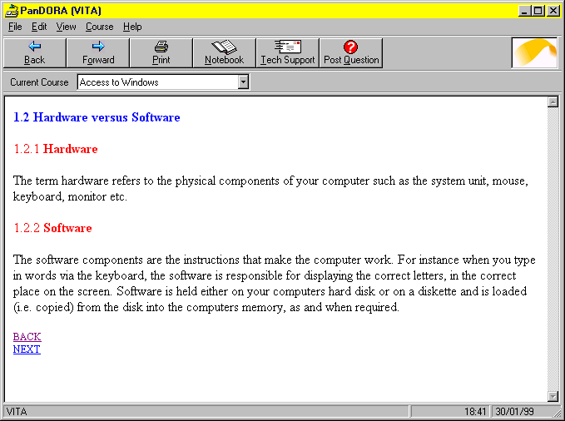
VITA is an application interface designed to meet the ODL needs of the Visually Impaired on an equal footing with their sighted peers. It contains a basic text enlargement system, but its principle strength is that it is designed to work seamlessly with the adaptive technology that Visually Impaired people use with PCs. These technologies fall into two broad categories:
Screen Magnifiers – to enlarge the size of the screen display Windows and fonts;
Screen Readers – to interpret the visual screen information and present it in voice synthesis or Braille form.

All Blind and partially sighted computer users will use one or both of these systems. There are many different systems available, each with its loyal devotees. Instead of developing a system with its own speech or Braille output that forces the VI user to learn yet another adaptive technology beyond the one that they are familiar with, VITA takes account of how these adaptive technologies achieve their results, and meets their requirements to function correctly. The vast majority of multimedia education systems on both CD-ROM and the Web endeavor to have a unique ‘look and feel’ to distance them from their competition. Unfortunately, this makes the task of the adaptive technology to interpret their status much harder, and in most cases impossible. The VITA interface guarantees that adaptive technology designed to work with Windows applications will be able to interact with it to achieve full functionality.
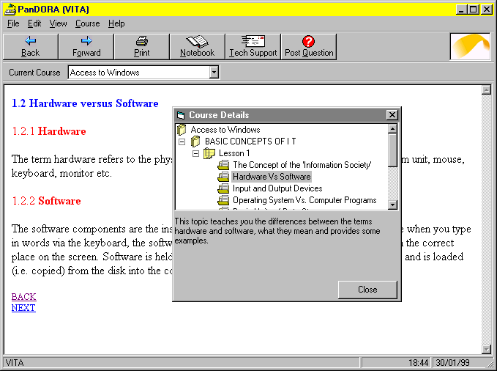
The basic layout of the VITA interface is similar to a Web Browser. Navigation through a course is achieved via keyboard accessible ‘buttons’, menus, daughter windows or hypertext links. All functionality can be accessed via the keyboard as a Blind user cannot use a mouse. The course can be annotated by the student via context sensitive ‘Notepad’ application that stores comments about specific sections for reference, in order to address the handwriting issues that VI people face. The ‘View’ menu allows high-contrast, large-font presentation of the course. The ‘Print’ options allow the course to be printed conventionally, or output in Braille without the need for processing the text (assuming the PC is connected to a Braille Embosser).
The ‘Technical Support’ option connects the student to the Tutor via email, and a range of group interaction is possible with other students taking the same course at the same time.

The Webserver hosts the ‘Dorton at a Distance’ Website, and the teaching database. The Website contains descriptions of the courses on offer, technical support pages, ‘frequently-asked-questions’ pages and course registration forms. Courses can be ordered via e-commerce or more conventional payment methods.

When a student signs-up for a course, the database system alerts the tutor that a new student is taking the course, allowing him/her to open a dialogue with the student to assess the speed at which they want to study, their background, and any further special needs. This process can be automated by the initial delivery of a preparatory questionnaire that is processed by the Web database. This information allows the tutor to place the student in a relevant ‘virtual class’ suitable for their learning needs. Meanwhile, the student can download the VITA application, or order it to be delivered on CD-ROM/floppy disks. Courses are delivered from the Webserver to the client application in a time-controlled manner. The student can elect to ‘go at their own pace’, initiating new course downloads themselves, or follow a more structured delivery with the tutor specifying time periods between course module delivery to improve ease of administration. The tutor is made aware of the progress of the student via the Webserver, and can move students from one ‘virtual class’ to another if they are moving too fast or slow. This means that group discussion is kept relevant, and students taking the final modules of the course do not need to read email queries from those just starting. This ‘virtual classroom’ approach helps to create a sense of community for the student, and reduces the isolation that ODL can create.

‘Dorton at a Distance’

‘Dorton at a Distance’ has developed specific courses to meet the needs of people who are visually impaired which are accessible through the Internet. It is planned that further course development will continue through negotiation with other specialist education providers. The aim for the future is to create an extensive database of courses that are truly accessible to Visually Impaired students and to those people who support them.

The VITA ECDL (European Computer Driving Licence)

The ECDL qualification is fast becoming a pan-European (and International) standard for computer skills which can open the door to career opportunities; prepares individuals for full participation in today’s Information Society and enables mobility within businesses and throughout the world.

The VITA ECDL course maintains the standard syllabus with a modified presentation of course content to ensure accessibility with adaptive software. ‘Dorton at a Distance’ students have access to the VITA functions as well as review questions and models answers after each lesson; self-assessment and group discussion a the end of each module and mock exams marked by their ‘distant’ tutor a the end of the course.

Within the UK approximately 75% of people who are blind or partially sighted and who are of working age are unemployed. This percentage is similar to that of other European countries. Those visually impaired people who are fortunate to be in employment are increasingly in danger of falling behind in accessing staff development and training initiatives to enable them to keep up to date with new computer competencies. The ECDL open and distance learning course allows for upgrading of these competencies at an appropriate time and place to suit their individual needs.

Certificate in Visual Impairment Studies

The VITA application can be similarly used to deliver training to teaching and support staff working with visually impaired pupils in the mainstream classroom. It can be further enhanced through the development of the client application to include context sensitive links to all relevant web based resources and seamless connection to specialist support equipment, such as Braille embossers.

A certificate level course, validated by the Open College Network (UK) is now on-line and available for developing the knowledge base of mainstream school educators to meet the needs of pupils who are blind or partially sighted. This course is delivered through the ODL platform referred to earlier.

Based on a modular delivery system, the course units will cover:
- Basic concepts of working with the Visually Impaired
- Understanding the Eye
- Mobility and Orientation
- The Learning World
- Independent Living

A further identified need for different level courses has also been addressed. Two Introductory courses in Visual Impairment Studies will soon be available on-line. A Certificate in Higher Education course is also currently being developed and accreditation will be from a UK University which will ensure the standardisation of quality together with a credible qualification. It is envisaged that the Introductory and Certificate level courses will encourage teaching/support staff into further subject-specific higher level studies.

Conclusion

The debate on inclusivity and related issues for all people with disabilities is current and ongoing. Technology can empower and enrich but there is a danger in assuming that technological availability is all embracing. This paper has concentrated on highlighting the need to address the accessibility developments and solutions for the visually impaired person and those who work with them.

References

1 Professor John Tomlinson, Inclusive Learning, Further Education Funding Council, 1996

