Feeling Van Gogh makes art accessible for visually impaired visitors

Amsterdam, March 2015 –Vincent van Gogh’s artworks can now also be ‘seen’ through touch: the Van Gogh Museum has launched a special programme for blind and partially sighted visitors. Feeling Van Gogh consists of an interactive guided tour and a multi-sensory workshop. Feeling Van Gogh makes Vincent van Gogh’s paintings accessible for visually impaired visitors, as well as their sighted friends, family and guides.
Stimulating the senses
Four times a year, specially trained guides take the visitors on a tour through the museum, explaining Van Gogh’s story by means of the paintings from the permanent collection. Next, a workshop will take place in a studio, equipped for this purpose: Van Gogh’s works can be explored with simplified relief prints and a model of The Bedroom. Furthermore, the senses are stimulated by the scent of lavender from the south of France and quotes from Van Gogh’s letter, that are read out loud.

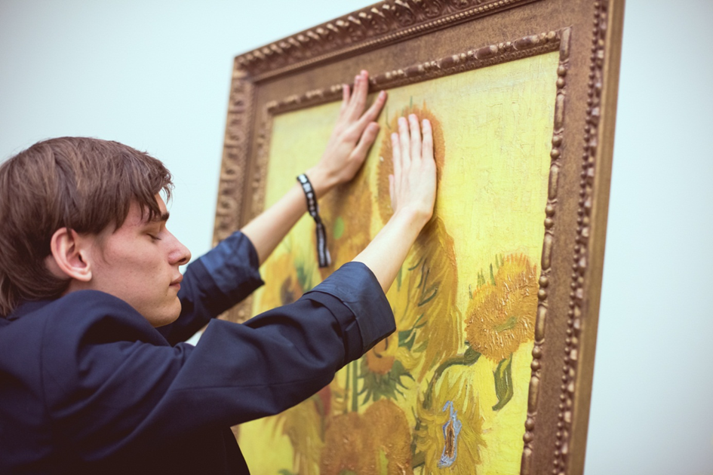

Photo: Nina Albada Jelgersma

Van Gogh Museum Relievo Collection
The Van Gogh Museum Relievos – premium quality 3D reproductions of Van Gogh’s paintings – are the main focus of this workshop. These Relievos were developed by the museum at an earlier stage and they have proved to be very suitable for this programme. Vincent van Gogh is known for his thick, impasto brush technique and the Relievos now offer those who are blind or partially sighted the opportunity to experience his paintings through touch. Touching these paintings is also a unique experience for sighted participants.
A museum for all
One of the main objectives of the Van Gogh Museum is making the Vincent van Gogh’s life and art accessible to as many people as possible. Feeling Van Gogh is an important step forward in achieving this. Connecting with the artworks by appealing to various senses, and discussing Van Gogh’s art together, results in a very positive effect on how visually impaired visitors experience the museum.
‘I had visited the Van Gogh Museum before, but it was mainly something that the other members of my family enjoyed and I was simply dragging my feet. This time I felt I was also participating and that was fun, because you really experience the museum a lot better.’ Robert –partially sighted participant

Cooperation
Feeling Van Gogh was developed by the Van Gogh Museum in close cooperation, from an early stage, with blind and partially sighted representatives of Dutch organizations in the field of visual impairment: Kubes (art for the blind and partially sighted),Oogvereniging (association of the blind and partially sighted) and of the EBU. The programme was co-funded with a substantial financial contribution from the Oogfonds (The Dutch Eye Fund)

Booking for foreign groups
Please contact us at vangoghopgevoel@vangoghmuseum.nl

Note to the editors/not for publication:
For further information, please contact the Press Office of the Van Gogh Museum, T +31 (0) 20 570 52 92, pressoffice@vangoghmuseum.nl

